Contents
Section 3 Appendix 2
Conversation Script: 2
Images of lab administrators: 4
Survey measures: 4
Robustness check analyses: 15
Multilevel models: 21
Previous contact: 22
Section 4 Appendix 23
Experiment 2: 23
Conversation Script: 23
Images of pollsters: 24
Alternative analyses and robustness checks 25
Experiment 3: 29
Scripts and treatments in the video clips: 29
Coding of open-ended responses: 30
Instrument and question wording: 30
Nonresponse on wave 2 46
Additional analyses on partner rejection/acceptance task 48
Additional analyses 50
Experiment 4: 50
Survey instrument 50

Section 3 Appendix

Conversation Script:
The administrator goes out of the lab to get the subjects.
Thanks for waiting. Come on in, and I’ll get everything all set up. Sit down at any computer, read over the paper on the computer, and then we’ll get started. Please wait for me to come talk to you before getting started on the computer.

Subjects then read the consent forms at the computer

In the mere presence condition, the administrator simply goes to each person, asks if they read the paper, and says:
Go ahead and start the survey whenever you’re ready.

In the interaction conditions, the administrators use the following script. They go to each individual, sit down next to them, and say the following (one at a time).
Hi. My name is [white administrators: Shelbi or Dalton/black administrators: Eboni or Jabari], I’m helping in the research lab today. Did you read the paper?

If the answer is no, ask them to read it and move on to another subject. Return to them after all of the other subjects have been treated.

If the answer is yes, proceed with the following:
There’s a couple of things they ask me to run through with everyone. You’re going to be asked some questions about government and politics, and you’ll take the survey on this computer. It should be pretty quick, about 5 minutes once you get started. If you have any problems while you take it, let me know – I can help you if the computer freezes or something.

One thing – they asked me to do is ask everyone where they’re from – this is just to make sure everyone is a U.S. Citizen. For confidentiality purposes, I just need to know the state. This wasn’t included on the survey. So, for example, I’m from [black administrators say: Baltimore/ white administrators say: Portland] so I’d say [Maryland/Oregon].

No matter how the subject answers, the administrator says:
Thanks, just had to check.

Note that if the subject says they are from the same city as the administrator, the administrator should simply say something like – “cool” or “nice!” without providing a lot of other detail. If the subject seems to want to talk about their city more, administrators should gently say something like: “Sorry, but they ask us to do this kinda quickly so everyone can get started. Could I ask you a couple other of things before you begin?”

If the subjects ask why the survey is only for citizens, the administrator should say something like the following: “Some of the questions ask about the role of government or different policies. These things might mean something different in different countries. Basically, it’s to make sure everyone understands the questions in the same way”. If the subject pushes for more, the administrator should tell them to contact me, with something like the following: “I actually was just hired to help – I didn’t design the project. If you’d like to know more, feel free to email busby@u.northwestern.edu to get more details”.

Administrator pulls out a piece of paper and a pen, then says.
The last thing we need to do is make sure we give you credit for participating. What’s your name?

Administrator then checks against the names of the people who were slotted for that time. If the person’s name is on the list for that time, say the following:
Great, got your name right there. Also, could you write down your name on this sheet? It’s our backup list just to be completely sure that you get credit for coming into the lab.

If the subject is not on the list of people who were supposed to come to the lab during that time, administrator says the following:
Hmm. I’m not seeing your name on here. That isn’t a big deal – could you write down your name on this sheet? That way we can be sure you get credit for coming into the lab.

Hands the paper to the student. After the student writes down their name, the administrator says
Thanks. This way you’ll for sure be marked as having taken this study.
The first thing the survey will ask you to do is enter your NetID, so make sure that’s what’s on the screen. If not, just hit refresh. Go ahead and start the survey whenever you’re ready.

The administrator maintained the same speaking style throughout, even after the script.

Once the subject finishes with the survey, administrator says,
Thanks! You’re done.
Before going out to get the next subject, the administrator checks the list to determine the treatment for the next group of subjects.

Images of lab administrators:
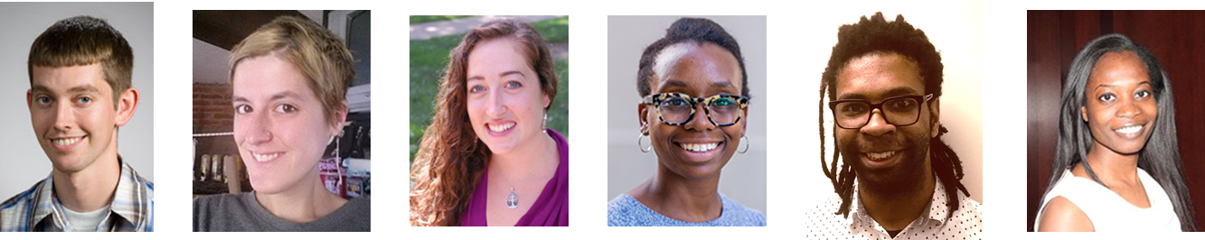

Survey measures:
(Bolded names at the start of each question is the variable name in the data)

Pre-lab instrument:

Gender What is your gender?
- Female (1)
- Male (2)
- Other (3) ____________________

Race Please choose one or more races or ethnicities that you consider yourself to be (mark all that apply).
- White (1)
- Black or African American (2)
- American Indian or Alaska Native (3)
- Hispanic/Latino (a) (4)
- Asian or Asian American (5)
- Hawaiian or Pacific Islander (6)
- Other (7) ____________________

Race_imp On a scale from (1) not at all important to (7) very important, how important is being a member of your racial/ethnic group to your identity?
- Not at all important 1
- 2
- 3
- 4
- 5
- 6
- Very important 7

Year Counting this quarter, what is your year in school?
- First year (1)
- Sophomore (2)
- Junior (3)
- Senior, graduating this year (4)
- Senior, not graduating this year (5)
- Other (6) ____________________

PID Generally speaking, do you consider yourself to be a(n)
- Strong Democrat (1)
- Not so strong Democrat (2)
- Independent leaning Democrat (3)
- Independent (4)
- Independent leaning Republican (5)
- Not so strong Republican (6)
- Strong Republican (7)
- Other (8)

Ideo Where would you place yourself on this scale, or haven't you thought much about this?
- Extremely liberal (1)
- Liberal (2)
- Slightly liberal (3)
- Moderate; middle of the road (4)
- Slightly conservative (5)
- Conservative (6)
- Extremely conservative (7)
- Haven't thought much about this (8)

Econ1 Q14 Thinking about the economy in the country as a whole, over the next year, do you expect the nation's economy to get worse, stay the same, or get better?
- Much worse (1)
- Worse (2)
- About the same (3)
- Better (4)
- Much better (5)

Econ2 How sure are you that the nation’s economy will [get worse/stay the same/get better based off of Econ1]?
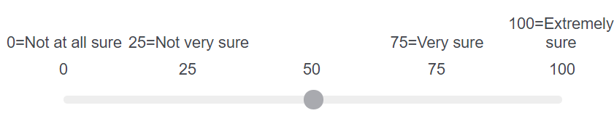
Econ3 Q16 Think back to how you came to your answer about whether you expect the economy to get worse, stay the same, or get better. What were you thinking about that made you give the answer you selected? What particular thoughts did you base your answer on?

Lab instrument:
Note that based on subjects’ racial self-identification, items referring to the racial outgroup will be presented first. This is true of the demonstration items as well as of the answer choices that reference specific groups.
On a scale from (1) nothing at all to (7) a great deal, how much do you think the federal government should do to make sure members of the following groups are treated fairly when it comes to education and employment opportunities?
 | Nothing at all 1 | 2 | 3 | 4 | 5 | 6 | A great deal 7
ee_minority Racial minorities (1)
ee_white Whites (2)
ee_lgbt LGBT individuals (3)
ee_muslim Muslims (4)

On the same scale from (1) nothing at all to (7) a great deal, how much do you think the federal government should do to make sure members of the following groups are treated fairly when it comes to the criminal justice system?
 | Nothing at all 1 | 2 | 3 | 4 | 5 | 6 | A great deal 7
cj_minority Racial minorities (1)
cj_white Whites (2)
cj_lgbt LGBT individuals (3)
cj_muslim Muslims (4)

For each of the groups below, do you oppose or favor college admissions programs that give preferential treatment to members of that group?
 | Strongly oppose | Oppose | Neither oppose nor favor | Favor | Strongly favor
pt_minority Racial minorities (1)
pt_white Whites (2)
pt_lgbt LGBT individuals (3)
pt_muslim Muslims (4)

Next, imagine an organization wants to hold a demonstration advocating for greater government protection for racial minorities. On a scale from (1) definitely oppose to (7) definitely support, would you oppose or support the demonstration if it were to...
 | Definitely oppose 1 | 2 | 3 | 4 | 5 | 6 | Definitely support 7
rmd_nu
Take place at Northwestern (1)
rmd_traffic
Block traffic around campus (2)
rmd_police
Result in conflict with local police (3)
rmd_charity
Raise money for a local charity (4)

rmd_interest Consider demonstrations advocating for greater government protection for racial minorities. On a scale from (1) definitely uninterested to (7) definitely interested, how uninterested or interested would you be in learning more about this kind of demonstration?
- Definitely uninterested 1
- 2
- 3
- 4
- 5
- 6
- Definitely interested 7

rmd_email If you would like, we can email you additional information about these kinds of protests. If you are interested, please enter your email address below. [novel item]
___________________________________

rmd_join How unwilling or willing would you be to join this kind of demonstration? [novel item]
- Very unwilling (1)
- Unwilling (2)
- Neither unwilling nor willing (3)
- Willing (4)
- Very willing (5)

Now, imagine an organization wants to hold a demonstration advocating that affirmative action disadvantages deserving whites. On a scale from (1) definitely oppose to (7) definitely support, would you oppose or support the demonstration if it were to...
 | Definitely oppose 1 | 2 | 3 | 4 | 5 | 6 | Definitely support 7
wd_nu
Take place at Northwestern (1)
wd_traffic
Block traffic around campus (2)
wd_police Result in conflict with local police (3)
wd_charity
Raise money for a local charity (4)

wd_interest Consider demonstrations advocating that affirmative action disadvantages deserving whites. On a scale from (1) definitely uninterested to (7) definitely interested, how uninterested or interested would you be in learning more about this kind of demonstration?
- Definitely uninterested 1
- 2
- 3
- 4
- 5
- 6
- Definitely interested 7

wd_email If you would like, we can email you additional information about these kinds of protests. If you are interested, please enter your email address below.

______________________________________
wd_join How unwilling or willing would you be to join this kind of demonstration?
- Very unwilling (1)
- Unwilling (2)
- Neither unwilling nor willing (3)
- Willing (4)
- Very willing (5)

In the United States today, how much discrimination is there against each of the following groups?
 | None at all (1) | A little (2) | A moderate amount (3) | A lot (4) | A great deal (5)
dis_minority Racial minorities (1)
dis_white Whites (2)
disc_lgbt LGBT individuals (3)
dis_muslim Muslims (4)

The order of the racial groups in the next three questions is randomized
The next few questions are about the types of people you interact with. By interact, we mean speak to, visit, or otherwise meet with. Please indicate if today you interacted with someone who was...
 | Yes (1) | No (2)
today_white White (2)
today_black Black (3)
today_hispanic Hispanic/Latin@ (4)
today_asian Asian (6)
today_muslim Muslim (7)
today_lgbt LGBT (8)

Next, please indicate if this week you interacted with someone who was...
 | Yes (1) | No (2)
week_white White (2)
week_black Black (3)
week_hispanic Hispanic/Latin@ (4)
week_asian Asian (6)
week_muslim Muslim (7)
week_lgbt LGBT (8)

How often in the last week did you interaction with someone who was...
Subjects only see the items in the table that they say yes to in the previous question
 | Once (1) | Two or three times (2) | Four or five times (6) | Six or seven times (4) | More than seven times (5)
times_white White (1)
times_black Black (2)
times_hispanic Hispanic/Latin@ (3)
times_asian Asian (4)
times_muslim Muslim (5)
times_lgbt LGBT (6)

admin_race As part of this survey, you spoke with a study administrator. What racial or ethnic group best describes that study administrator?(Mark all that apply)
- White (1)
- Black or African American (2)
- American Indian or Alaska Native (3)
- Hispanic/Latino (a) (4)
- Asian or Asian American (5)
- Hawaiian or Pacific Islander (6)
- Other (7) ____________________

admin_represent On a scale from (1) not at all representative to (7) very representative, how representative would you say that study administrator is of their racial or ethnic group?
- Not at all representative of their racial or ethnic group 1
- 2
- 3
- 4
- 5
- 6
- Very representative of their racial or ethnic group 7

Post-lab instrument
Thank you for participating in the follow up for this study. Please complete the following survey questions - note that you may have seen these items before; we ask that you complete them again even if they look familiar to you.

On a scale from (1) nothing at all to (7) a great deal, how much do you think the federal government should do to make sure members of the following groups are treated fairly when it comes to education and employment opportunities?
 | Nothing at all 1 | 2 | 3 | 4 | 5 | 6 | A great deal 7
ee_minority2 Racial minorities (1)
ee_white2 Whites (2)
ee_lgbt2 LGBT individuals (3)
ee_muslim2 Muslims (4)

On the same scale from (1) nothing at all to (7) a great deal, how much do you think the federal government should do to make sure members of the following groups are treated fairly when it comes to the criminal justice system?
 | Nothing at all 1 | 2 | 3 | 4 | 5 | 6 | A great deal 7
cj_minority2 Racial minorities (1)
cj_white2 Whites (2)
cj_lgbt2 LGBT individuals (3)
cj_muslim2 Muslims (4)

For each of the groups below, do you oppose or favor college admissions programs that give preferential treatment to members of that group?
 | Strongly oppose | Oppose | Neither oppose nor favor | Favor | Strongly favor
pt_minority2 Racial minorities (1)
pt_white2 Whites (2)
pt_lgbt2 LGBT individuals (3)
pt_muslim2 Muslims (4)

Next, imagine an organization wants to hold a demonstration advocating for greater government protection for racial minorities. On a scale from (1) definitely oppose to (7) definitely support, would you oppose or support the demonstration if it were to...
 | Definitely oppose 1 | 2 | 3 | 4 | 5 | 6 | Definitely support 7
rmd_nu2
Take place at Northwestern (1)
rmd_traffic2
Block traffic around campus (2)
rmd_police2
Result in conflict with local police (3)
rmd_charity2
Raise money for a local charity (4)

rmd_interest2 Consider demonstrations advocating for greater government protection for racial minorities. On a scale from (1) definitely uninterested to (7) definitely interested, how uninterested or interested would you be in learning more about this kind of demonstration?
- Definitely uninterested 1
- 2
- 3
- 4
- 5
- 6
- Definitely interested 7

rmd_join2 How unwilling or willing would you be to join this kind of demonstration?
- Very unwilling (1)
- Unwilling (2)
- Neither unwilling nor willing (3)
- Willing (4)
- Very willing (5)

Now, imagine an organization wants to hold a demonstration advocating that affirmative action disadvantages deserving whites. On a scale from (1) definitely oppose to (7) definitely support, would you oppose or support the demonstration if it were to...
 | Definitely oppose 1 | 2 | 3 | 4 | 5 | 6 | Definitely support 7
wd_nu2 Take place at Northwestern (1)
wd_traffic2 Block traffic around campus (2)
wd_police2 Result in conflict with local police (3)
wd_charity2 Raise money for a local charity (4)

wd_interest2 Consider demonstrations advocating that affirmative action disadvantages deserving whites. On a scale from (1) definitely uninterested to (7) definitely interested, how uninterested or interested would you be in learning more about this kind of demonstration?
- Definitely uninterested 1
- 2
- 3
- 4
- 5
- 6
- Definitely interested 7

wd_join2 Q10 How unwilling or willing would you be to join this kind of demonstration?
- Very unwilling (1)
- Unwilling (2)
- Neither unwilling nor willing (3)
- Willing (4)
- Very willing (5)

In the United States today, how much discrimination is there against each of the following groups?
 | None at all (1) | A little (2) | A moderate amount (3) | A lot (4) | A great deal (5)
dis_minority2 Racial minorities (1)
dis_white2 Whites (2)
disc_lgbt2
LGBT individuals (3)
dis_muslim2 Muslims (4)

admin_race2 As part of your participation in the lab, you spoke with a study administrator. What racial or ethnic group best describes that study administrator?(Mark all that apply)
- White (1)
- Black or African American (2)
- American Indian or Alaska Native (3)
- Hispanic/Latino (a) (4)
- Asian or Asian American (5)
- Hawaiian or Pacific Islander (6)
- Other (7) ____________________

admin_represent2 On a scale from (1) not at all representative to (7) very representative, how representative would you say that study administrator was of their racial or ethnic group?
- Not at all representative of their racial or ethnic group 1
- 2
- 3
- 4
- 5
- 6
- Very representative of their racial or ethnic group 7

Robustness check analyses:
Robustness checks included relying on randomization inference (instead of NPC), bootstrapping, bootstrapping while clustering on experimental session, including fixed effects for the time period when the data were collected, including fixed effects for the specific administrators, including fixed effects for administrators and time periods, interacting the importance of subjects’ racial identity with the treatments, and using more complex multi-level models to incorporate these factors. Each of these tests supports the main analyses.

Figures A.1 and A.2 present the same analyses as the main text but relying on randomization inference instead of NPC. Randomization inference uses simulations to determine the statistical significance of differences between treatments. This method assumes only that the treatment assignment of one individual does not influence the treatment of another, and for this reason is superior to t-tests (Keele, McConnaughy, and White 2012). The primary difference between NPC and randomization inference is that NPC incorporates the relationships between the dependent variables and produces and global p-value, whereas randomization inference generates only variable specific hypothesis tests. Both methods test a sharp null hypothesis of no effects and are permutation based. The results shown in Figures A.1 and A.2 support the NPC analyses in the main text.

Figure A.1: Policy attitudes treatment effects
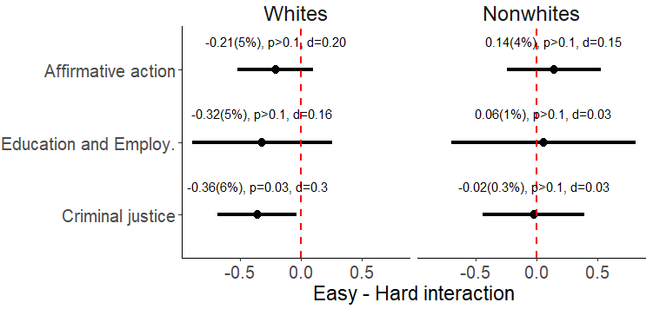
Figure A.2: Political tolerance treatment effects
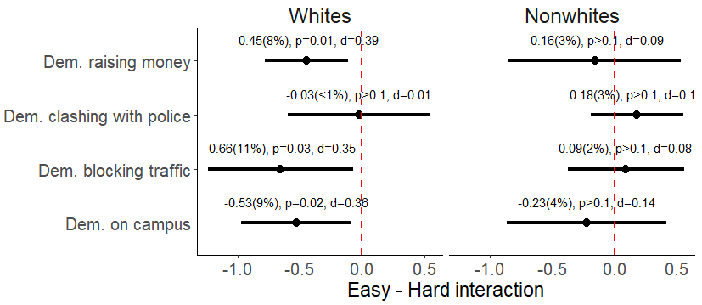
Figure A.3 presents the bootstrapped version of the analyses. As the figure shows, this way of analyzing the data supports the conclusions presented in text. In a few circumstances, some of the comparisons of the easy-to-understand to control (minimal interaction) shift to slightly above the 0.05 level, but in general, these changes are not substantial and support the main analyses.

Figure A.4 presents parallel analyses that bootstrapped while clustering the standard errors based on the session when subjects completed the experiment. These sessions contained between 1 and 5 subjects, all of which received the same treatment.
Figure A.3: Bootstrapped analyses:
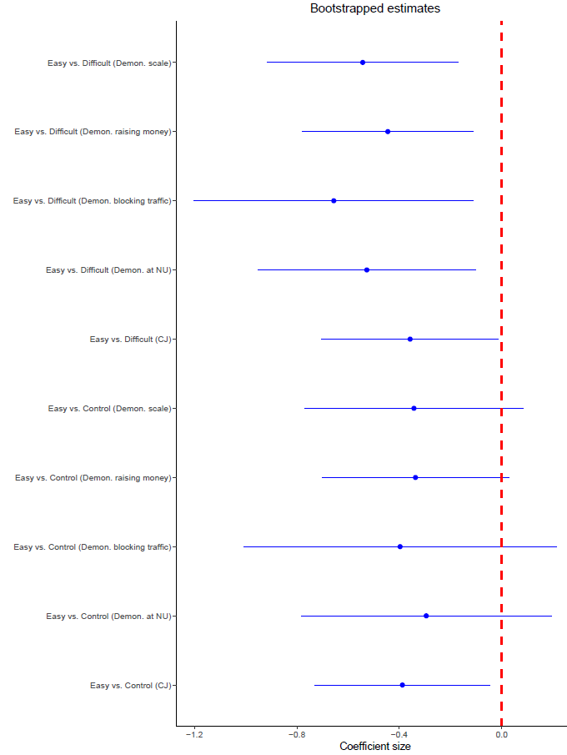

Figure A.4: Bootstrapped analyses with clustered standard errors
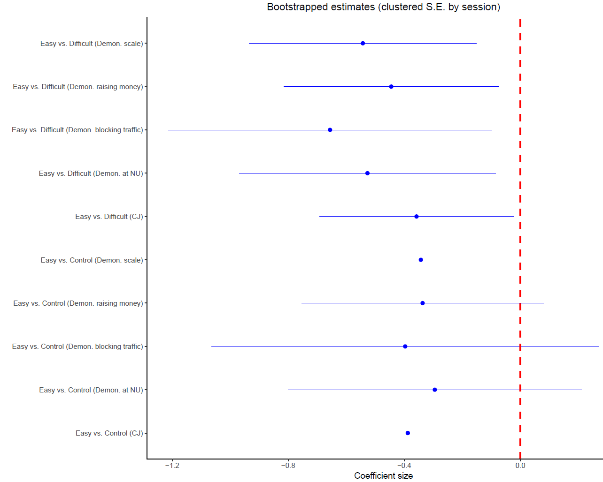

Tables A.1, A.2, and A.3 present the comparisons presented in the main text while controlling for the time period, administrator, or both. These models use OLS regression and a fixed effects approach. The tables present classic standard errors, but the results remain similar if robust standard errors are used. The baseline in these tables is the easy-to-understand interaction – this was chosen solely for presentational purposes.

Table A.1: Robustness checks, time period
 | Criminal Justice | Demon. at NU | Demon. blocking traffic | Demon. raising money | Demon. scale
Intercept | 6.164*** | 5.314*** | 3.644*** | 5.928*** | 4.962***
 | (0.134) | (0.182) | (0.235) | (0.136) | (0.159)
Control | 0.385* | 0.296 | 0.409 | 0.337* | 0.347
 | (0.168) | (0.229) | (0.295) | (0.170) | (0.199)
Hard | 0.365* | 0.541* | 0.672* | 0.456** | 0.556**
 | (0.162) | (0.220) | (0.284) | (0.164) | (0.192)
Winter 2017 | 0.092 | 0.421* | 0.862** | 0.289 | 0.524**
 | (0.156) | (0.212) | (0.274) | (0.158) | (0.185)
Spring 2017 | -0.090 | 0.068 | 0.411 | 0.007 | 0.162
 | (0.179) | (0.243) | (0.313) | (0.181) | (0.212)
N | 259 | 259 | 259 | 259 | 259
R² | 0.030 | 0.037 | 0.057 | 0.044 | 0.060
Adjusted R² | 0.015 | 0.022 | 0.042 | 0.029 | 0.045
Residual Std. Error (df = 254) | 1.090 | 1.481 | 1.910 | 1.104 | 1.292
F Statistic (df = 4; 254) | 1.949 | 2.466* | 3.852** | 2.909* | 4.050**
*p < .05; **p < .01; ***p < .001

Table A.2: Robustness checks, administrator
 | Criminal Justice | Demon. at NU | Demon. blocking traffic | Demon. raising money | Demon. scale
Intercept | 6.384*** | 5.440*** | 3.941*** | 6.049*** | 5.143***
 | (0.186) | (0.255) | (0.333) | (0.190) | (0.225)
Control | 0.379* | 0.303 | 0.387 | 0.363* | 0.351
 | (0.171) | (0.235) | (0.306) | (0.175) | (0.206)
Hard | 0.266 | 0.527* | 0.654* | 0.429* | 0.537**
 | (0.170) | (0.234) | (0.305) | (0.174) | (0.206)
Admin 1 | -0.170 | 0.020 | 0.066 | 0.011 | 0.032
 | (0.185) | (0.254) | (0.331) | (0.189) | (0.223)
Admin2 | -0.274 | 0.016 | 0.092 | -0.096 | 0.004
 | (0.185) | (0.254) | (0.332) | (0.189) | (0.224)
N | 257 | 257 | 257 | 257 | 257
R² | 0.033 | 0.021 | 0.019 | 0.032 | 0.029
Adjusted R² | 0.017 | 0.006 | 0.003 | 0.017 | 0.014
Residual Std. Error (df = 252) | 1.088 | 1.497 | 1.952 | 1.114 | 1.316
F Statistic (df = 4; 252) | 2.124 | 1.372 | 1.202 | 2.114 | 1.897
*p < .05; **p < .01; ***p < .001

Table A.3: Robustness checks, time period and administrator
 | Criminal Justice | Demon. at NU | Demon. blocking traffic | Demon. raising money | Demon. scale
Intercept | 6.334*** | 5.159*** | 3.334*** | 5.855*** | 4.210***
 | (0.211) | (0.289) | (0.372) | (0.214) | (0.260)
Control | 0.401* | 0.349 | 0.460 | 0.402* | 0.300
 | (0.171) | (0.234) | (0.301) | (0.174) | (0.210)
Hard | 0.283 | 0.569* | 0.729* | 0.463** | 0.486*
 | (0.171) | (0.233) | (0.300) | (0.173) | (0.210)
Admin 1 | -0.029 | 0.310 | 0.520 | 0.259 | 0.395
 | (0.209) | (0.286) | (0.368) | (0.213) | (0.257)
Admin2 | -0.303 | 0.026 | 0.174 | -0.105 | 0.167
 | (0.188) | (0.257) | (0.330) | (0.191) | (0.231)
Winter 2017 | 0.146 | 0.531* | 1.050*** | 0.394* | 0.717***
 | (0.171) | (0.234) | (0.301) | (0.174) | (0.210)
Spring 2017 | -0.218 | -0.073 | 0.241 | -0.159 | 0.080
 | (0.198) | (0.271) | (0.348) | (0.201) | (0.243)
N | 257 | 257 | 257 | 257 | 257
R² | 0.041 | 0.042 | 0.065 | 0.056 | 0.061
Adjusted R² | 0.018 | 0.019 | 0.042 | 0.034 | 0.038
Residual Std. Error (df = 250) | 1.088 | 1.487 | 1.913 | 1.104 | 1.336
F Statistic (df = 6; 250) | 1.787 | 1.841 | 2.875** | 2.494* | 2.686*
*p < .05; **p < .01; ***p < .001

Multilevel models:
Additionally, I employed a multi-level model approach to estimate the treatment effects when controlling for the structure of the experiment. These analyses were conducted using the single paper meta-analysis technique developed by McShane and Böckenholt (2017) via the interface at singlepapermetaanalysis.com. The advantage of this approach is that is separates the effects of the treatments from the heterogeneity due to structural factors (such as the time period when the data were collected). It also allows the effect of the treatment to vary for each level of the structural factor (similar to including an interaction term with fixed effect variables). It assumes that the treatment and outcome variables were measured in the same way across structural factors, which is true for my experiments. The complexities of these analyses do not allow for incorporating both time period and administrator structural factors; as a result, I conducted them first for the time period and second for the administrators. These analyses, the details of which are available upon request, suggest that although there are some differences by time period and administrator, there is still an overall treatment effect when accounting for these differences. Further, in most circumstances, differences by time period and administrator are a matter of strength, rather than direction.

Previous contact:
One of the explanations of H_{Majority} is that nonwhites have more extensive contact with whites than vice versa. If this is true, I would expect to find weaker treatment effects among whites with higher amounts of previous contact. The models I used to evaluate this possibility used the following specification, where Control and Hard-to-understand are binary variables representing the different treatments:

$$Outcome=Control+Hard to understand+Previous contact+\left(Control X Previous Contact\right)+(Hard X Previous Contact)$$

These models were estimated using OLS regression on each of the outcomes where I found main treatment effects among white subjects. The models were estimated for both a continuous (ranging from 0 to 5, with 5 indicating the most previous contact) and a binary (with 1 indicating the highest possible category of contact). Differences in operationalization choice do not affect the conclusions of these analyses.

These analyses, available from the authors upon request, indicate that in six out of ten cases previously observed treatment effects are not significant for individuals with the highest level of previous contact with blacks and are significantly negative for individuals with lower amounts of previous contact. By comparison, we would only expect 1 or fewer significant interactions in these models by chance alone. Due to the observational nature of this moderating variable and the small sample size in this experiment, care should be taken in interpreting these findings.

The previous-contact explanation would also suggest that we should see evidence of a treatment effect among nonwhites who report little previous contact with whites. This would suggest a series of analyses similar to those outlined above; however, the overwhelming majority of nonwhite individuals indicated that they had nearly daily contact with whites. Only 25 nonwhite students did not choose the highest response option on this question. This lack of variation makes such analyses statistically unreliable. This problem likely occurs for nonwhite individuals in the population at large, suggesting that researchers should think of alternative strategies to confirm this explanation.

Section 4 Appendix

Experiment 2:

Conversation Script:
“Hello! I’m here asking people some questions about important political issues as part of a student’s research at Northwestern University. You may have received a notice about this a few days ago. May I speak with an adult who lives at this address?

When speaking to the adult resident, ask: Would you be willing to chat briefly with me and fill out a 5 minute survey?”

Pollsters said the following after the subjects indicated they would like to participate.
“Thanks for agreeing to take this survey. They ask us to have everyone look over this form – it’s just a document that says you can stop at any time, everything is voluntary, and has our information on it if you need to contact us. You can keep it (or not) if you like.”

Handed them the consent form.

In both conversation treatment groups, pollsters then said the following:
“Thanks for looking that over. One last thing before we get started - they ask us to introduce ourselves before giving you the survey so that you are more comfortable completing the survey and more familiar with the study. Afterwards, you can get started on the survey.

My name is [Alejandro/Alejandra]. I was hired by a student researcher at Northwestern to help with this study. Like the form said, the research deals with different groups in American society and involves speaking with me and filling out a survey.

The next portion of the script varied, depending on if pollsters were speaking with or without an accent. Bolded text represents phrases that differ across accent vs. no accent.

When speaking with an accent, pollsters said:
As someone who is a recent immigrant and not a U.S. citizen, is Latino/a, was born in Mexico, and whose parents and grandparents still live in Mexico, I’m interested in learning what other people in the U.S. think. There has been a lot of talk these days about the changing demographics of your country, so I think you’ll find it to be interesting as well.

When speaking WITHOUT an accent, pollsters said:
As someone who is a citizen of the U.S., is Latino/a, was born in America, and whose parents and grandparents were also born in the U.S., I’m interested in learning what other people in the U.S. think. There has been a lot of talk these days about the changing demographics of our country, so I think you’ll find it to be interesting as well.

Regardless of accent, the conversation resumed with the following:
This is the first time I’ve spent much time in Wilmette, but it seems like a pretty nice place to live. Have you lived here long?”

Waited for response
“Is it very different from other places where you’ve lived before?”

Waited for response
“Cool. Like I said, I haven’t really spent a lot of time here before, but it seems really nice. It’s interesting to visit the places where they ask us to interview people. We’ve been going to a couple of the suburbs of Chicago so far.”

Pollsters then said: “Thanks for talking with me for a minute – now, please fill out the survey on this tablet. Let me know if you have any problems”

Images of pollsters:
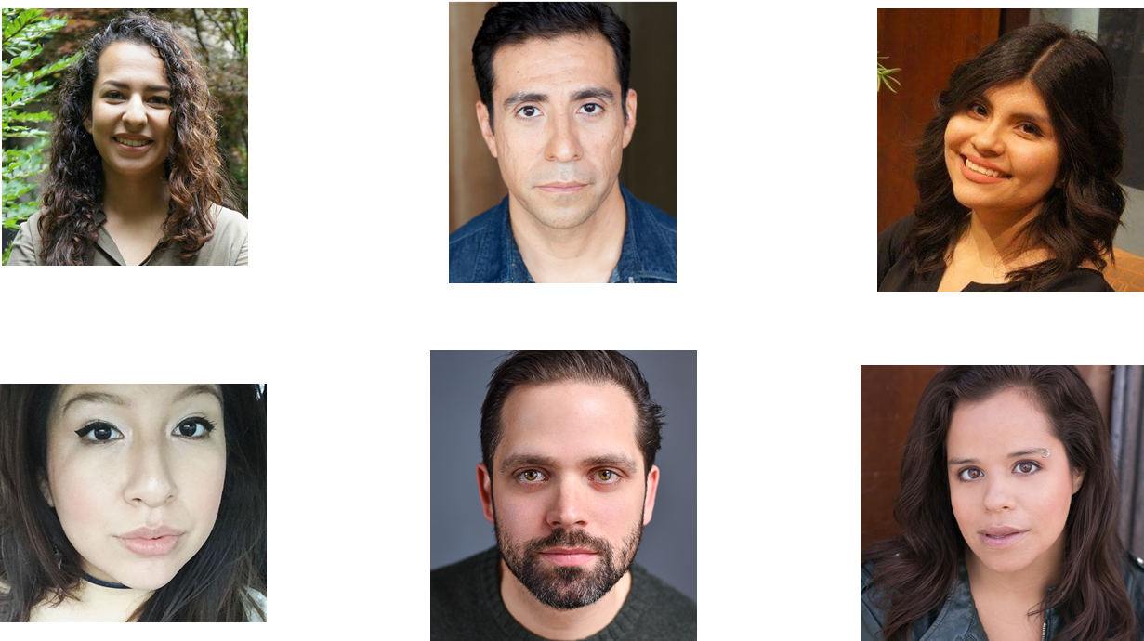

Alternative analyses and robustness checks
As alternatives to the NPC analyses presented in the main text, I also performed these analyses via randomization inference. As indicated by the figures below, this leads to the same conclusion as the NPC method.
Figure A.5: Political support for Latinos
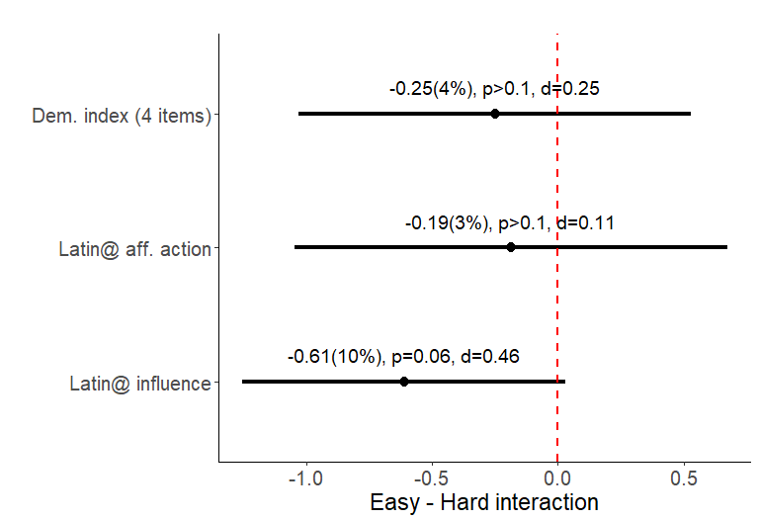
Notes: The graph presents the absolute difference, percent difference, the p-value, and the effect size.

Figure A.6: Political support for immigrants

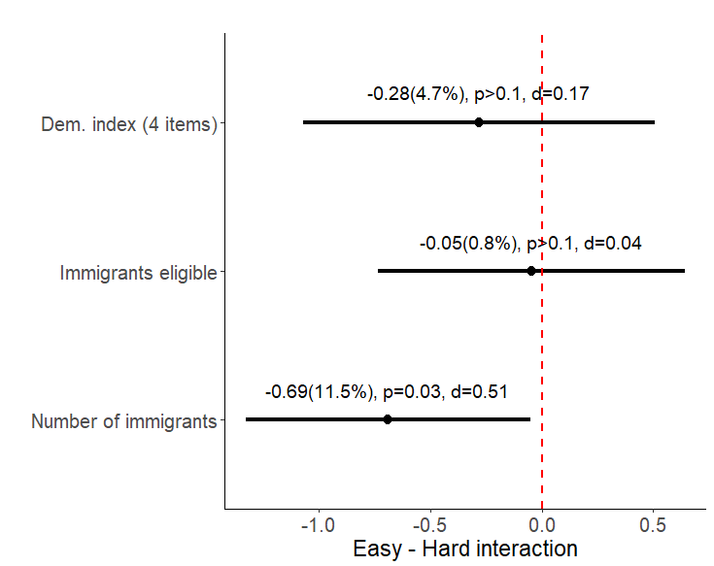
Notes: The graph presents the absolute difference, percent difference, the p-value, and the effect size.

I also conducted the analyses with bootstrapping methods, as shown in the figures below. All of these analyses support the conclusions in the main text.
Figure A.7: Bootstrapped analyses, response rates
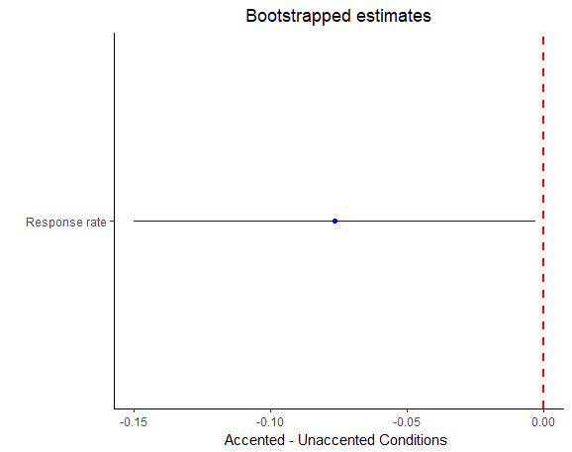
Figure A.8: Bootstrapped analyses, response rates clustered by location
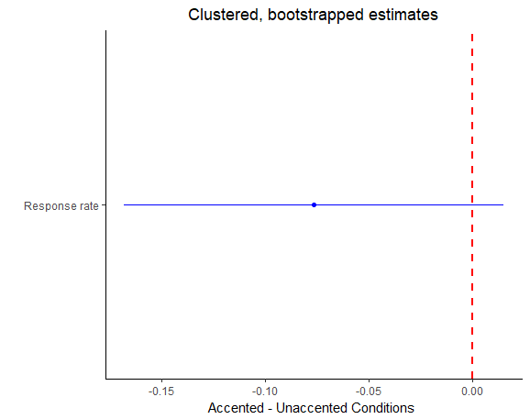

Figure A.9: Bootstrapped analyses, Latinx attitude items
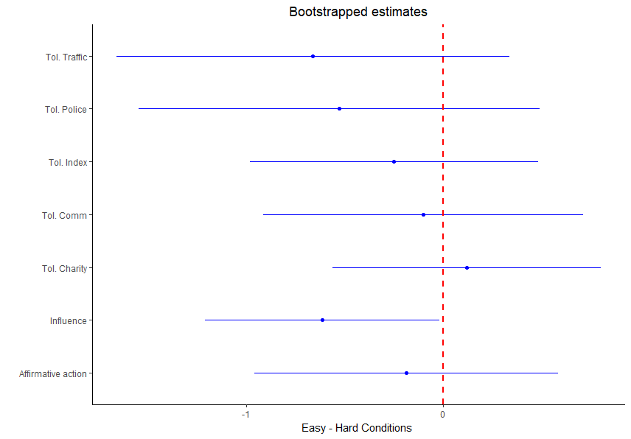
Figure A.10: Bootstrapped analyses, Immigrant attitude items
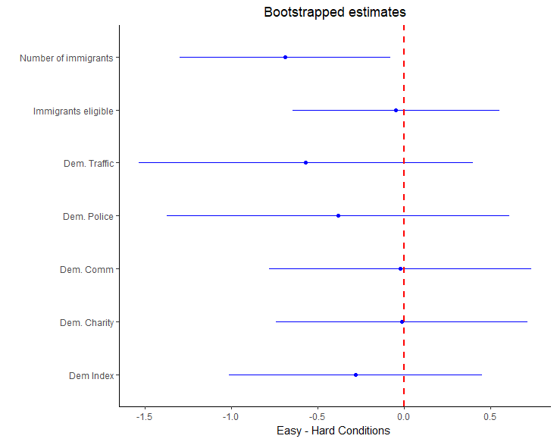
In addition, I explored the gender of the pollster and type of location used in the sampling. Tables A.4 and A.5 below present these analyses. Interactive analyses (incorporating either location type or pollster gender as a moderating variable) do not show reliable signs of an interactive effect. As a result, I rely on non-interactive models and tests.
Table A.4: Robustness checks, Location
 |  | Latin@ influence |  | Affirmative Action |  | Demon. index
Intercept |  | 5.711*** |  | 5.093*** |  | 4.989***
 |  | (0.471) |  | (0.619) |  | (0.596)
Hard |  | -0.571* |  | -0.158 |  | -0.219
 |  | (0.299) |  | (0.391) |  | (0.374)
Train station locations |  | 0.460 |  | 0.479 |  | 0.492
 |  | (0.337) |  | (0.444) |  | (0.424)
N |  | 76 |  | 77 |  | 76
R² |  | 0.077 |  | 0.018 |  | 0.024
Adjusted R² |  | 0.052 |  | -0.008 |  | -0.003
Residual Std. Error |  | 1.287 (df = 73) |  | 1.704 (df = 74) |  | 1.622 (df = 73)
F Statistic |  | 3.045* (df = 2; 73) |  | 0.695 (df = 2; 74) |  | 0.898 (df = 2; 73)
*p < .1; **p < .05; ***p < .01

Table A.5: Robustness checks, gender
 | Latin@ influence |  | Affirmative Action |  | Demon. index
Intercept | 5.795*** |  | 5.188*** |  | 5.068***
 | (0.475) |  | (0.631) |  | (0.600)
Hard | -0.564* |  | -0.131 |  | -0.182
 | (0.303) |  | (0.396) |  | (0.377)
Male Pollster | 0.103 |  | 0.030 |  | 0.060
 | (0.300) |  | (0.394) |  | (0.375)
N | 75 |  | 76 |  | 75
R² | 0.047 |  | 0.002 |  | 0.003
Adjusted R² | 0.020 |  | -0.026 |  | -0.024
Residual Std. Error | 1.296 (df = 72) |  | 1.715 (df = 73) |  | 1.623 (df = 72)
F Statistic | 1.773 (df = 2; 72) |  | 0.057 (df = 2; 73) |  | 0.126 (df = 2; 72)
*p < .1; **p < .05; ***p < .01

Experiment 3:

Scripts and treatments in the video clips:
In the easy and hard-to-understand conditions, subjects watched a video clip of an African American female, giving the following script:
“Hi. My name is Eboni. They asked me to say first thing that you should think about what it would be like if we were sitting across the table from one another in the same room. Think about what you might say, think, or feel if I was actually there with you. I’m sure we’d shake hands or something and get started.

Pause.

I’ll just introduce myself and see how where we go from there. Like I said, my name is Eboni. I have lived in a lot of different cities across the United States and feel at home in urban places. Right now, I live and work in an inner-city area. In my free time, I like to catch up with friends, read a little, and visit new places. Depending on how busy I am, I don’t always have time to do all of those things. That’s how life goes. Pause.
I signed up to help with this video in the because I saw an ad when I was walking around in my neighborhood. I thought the project sounded interesting – it said the project was about how people learn in different settings. I have never done this before, so I’ve learned some things just by making the video. It hasn’t been too hard – they have all the camera equipment and people to tell you how to make the recordings.

Pause

That’s about it for now – I think they’re going to have me make some more recordings, so I have to finish with this one.”

Ease of communication was manipulated by changing nonverbal behaviors that relate to conversational norms and how individuals process social experiences. Specifically, the individual in the video will do the following things:

Table A.6: Treatment operationalizations
Element | Operationalization
Easy-to-understand
Speakers pay obvious attention to the subject | Speaker faces the camera (with face and body).
Speakers make eye contact frequently | Speaker looks into the camera at least four times, and each time, holds the gaze for at least 5 seconds
Speakers rarely pause (no more than once) | Speakers pause in their sentences and script no more than once, and for less than 3 seconds
Speakers speak in an expressive tone | Speaker speaks in a natural way that uses normal inflections and changes in pitch.
Difficult to understand
The speaker pays little attention to the subject | Speaker does not directly face the camera
Speakers rarely make eye contact (once at most) | Speakers only look at the camera once, and for less than 3 seconds.
The speaker pauses frequently (between 5-7 times) | In delivering the script, speakers pause between 5 to 7 times, and each time for at least 5 seconds. One of those pauses should be longer than 5 second.
Speakers speak with a flat tone | The speaker speaks in a monotone voice and does not allow their pitch or intensity to change.

Coding of open-ended responses:

The coding of all open-ended items was performed by the author. The open-ended item explaining subjects’ choice of partner and what the subjects learned from the video will be coded for the themes below with the words list below. These terms came from pilot testing and coding of open-ended responses in those pilots. Stemmed versions of these words (such as “raci” for “racial”) were also included in the coding.

RACE: race, racial, black, african-american, african american, inner city, urban, white, causasian, anglo
ABILITY/QUALIFICATION (ONLY FOR PARTNER SELECTION): education, score, test, ability, performance, qualified, better, best, word task, task, “one out of three”, “two out of three”, “three out of three”, “1 out of 3”, “2 out of 3”, “3 out of 3”, “1/3”, “2/3”, “3/3”, word game, win, success, winning, worse, worst, poorly, lowest, highest
SIMILARITY: similar, same, like me, shared, close to, like I did, as I did, closer, also (in reference to the subject), as well (in reference to the subject), another (in reference to the subject), common
DIFFERENCE: different, not the same, not like me, not shared, far from to, unlike I did,

Instrument and question wording:
Wave 1:
Q2 Thank you for agreeing to participate.
Today, you will be asked to do two things. First, you will be asked to answer some brief questions about yourself. Second, you will participate in a partner-based word task. Both sections relate to the purpose of the study, which is understanding people's thoughts and actions in different environments.
Please click the button below to continue
Q4
Part 1.
First, we will ask you some questions about yourself.
Q5 Please select your current age (in years).
▼ Younger than 18 (83) ... 99 (82)

Q6 What is your gender?
- Male (1)
- Female (2)
- Other (3) ________________________________________________

Q7 Please choose one or more races or ethnicities that you consider yourself to be (mark all that apply)
- White (1)
- Black or African American (2)
- Hispanic/Latino(a) (3)
- Asian or Asian American (4)
- Middle Eastern or North African (5)
- American Indian or Alaskan Native (6)
- Hawaiian or Pacific Islander (7)
- Other (8) ________________________________________________

Q8 On a scale from (1) not at all important to (7) very important, how important is your racial/ethnic background to your identity?
- Not at all important - 1 (1)
- 2 (2)
- 3 (3)
- 4 (4)
- 5 (5)
- 6 (6)
- Very important - 7 (7)

Q9 In a typical week, how often do you have contact with people of other racial or ethnic groups?
- Never (1)
- Once or twice a week (2)
- Three or four times a week (4)
- Five or six times a week (5)
- Every day (7)
- More than once a day (6)

Q12 When it comes to politics do you usually think of yourself as
- Very conservative (1)
- Conservative (2)
- Slightly conservative (3)
- Moderate, Middle of the road (4)
- Slightly liberal (5)
- Liberal (6)
- Extremely liberal (7)
- Don't know (8)

Q13 Generally speaking, do you usually think of yourself as a Republican, a Democrat, an Independent, or some other party?
- Democrat (1)
- Republican (2)
- Independent (3)
- Other (4)
Display This Question:
If Generally speaking, do you usually think of yourself as a Republican, a Democrat, an Independent,... = Independent
Or Generally speaking, do you usually think of yourself as a Republican, a Democrat, an Independent,... = Other
Q14 Do you consider yourself to be closer to the Democratic Party or Republican Party?
- Democratic Party (1)
- Republican Party (2)
- Neither (3)

Display This Question:
If Generally speaking, do you usually think of yourself as a Republican, a Democrat, an Independent,... = Republican
Q15 Would you say that you are a..
- Strong Republican (1)
- Not a strong Republican (2)
Display This Question:
If Generally speaking, do you usually think of yourself as a Republican, a Democrat, an Independent,... = Democrat
Q16 Would you say that you are a..
- Strong Democrat (1)
- Not a strong Democrat (2)

Q17 Here we briefly describe some people. Please read each description and indicate how much these people are like or not like you, on a scale from not at all like you (1) to very much like you (6).
 | Not at all like you  1 | 2 | 3 | 4 | 5 | Very much like you 6
It's very important to them to help the people around them. They want to care for others’ well-being
They think it is important that every person in the world be treated equally. They want justice for everybody, even for people they don’t know.
Being very successful is important to them. They hope people will recognize their achievements.
It is important to them to be in charge and tell others what to do. They want people to do what they say.

Q18 Here we again briefly describe some people. Please read each description and indicate how much these people are like or not like you, on a scale from not at all like you (1) to very much like you (6).
 | Not at all like you  1 | 2 | 3 | 4 | 5 | Very much like you 6
They think that if people were treated more equally in this country, we would have fewer problems. They believe our society should do whatever is necessary to make sure that everyone has equal opportunities to succeed
They believe individuals should have the freedom to be and believe whatever they want. It’s important to them that our country defend civil liberties
They think most people who don’t get ahead should not blame the system. They believe that any person who is willing to work hard has a good chance of succeeding
They think the most important thing for our country is to maintain law and order. It’s important to them that the government takes action to increase security even if it could mean sacrificing the freedom of citizens

Q19 What is the highest level of education you have completed?
- Less than a high school degree (1)
- High school / GED (2)
- Some college (3)
- 2-year college degree (Associate's) (4)
- 4-year college degree (BA, BS) (5)
- Advanced degree (MA, MS. MBA, PhD, JD, MD, etc.) (6)
Q20 Which category best describes the total income of all members of your family living in your house last year before taxes? This figure should include salaries, wages, pensions, dividends, interest, and all other income.
- Under $25,000 (1)
- Between $25,000 and $34,999 (3)
- Between $35,000 and $49,999 (4)
- Between $50,000 and $74,999 (5)
- Between $75,000 and $99,999 (6)
- Between $100,000 and $149,999 (7)
- Between $150,000 and $199,999 (8)
- $200,000 or more (9)
- Don't want to say (10)
- Don't know (11)

Q21
Part 2.
Over the next few minutes you will participate in a study of group dynamics. You will eventually work with a partner. Before that, you will complete a few of the tasks you will do with your partner. The tasks are similar to a crossword puzzle. You will read a short clue and then complete a partially displayed word. You will have 30 seconds to solve each task.
For example, you might get the following clue and partial word:
Clue: Newspapers are usually delivered
D _ _ L Y
The answer is on the next page.
Q22
Part 2.
Over the next few minutes you will participate in a study of group dynamics. You will eventually work with a partner. Before that, you will complete a few of the tasks you will do with your partner. The tasks are similar to a crossword puzzle. You will read a short clue and then complete a partially displayed word. You will have 30 seconds to solve each task.
For example, you might get the following clue and partial word:
Clue: Newspapers are usually delivered
D _ _ L Y
Here the answer is "DAILY"
Please click the button below to begin the word tasks.
Q49 You have 30 seconds to answer.
Q51 Clue: African Vacation
_ _ F _ R _
________________________________________________________________

Q52 You have 30 seconds to answer.
Q54 Clue: Milky Way is one
_ _ L _ X _
________________________________________________________________

Q55 You have 30 seconds to answer.
Q57 Clue: Many are intolerant of it
_ _ _ T _ S E
________________________________________________________________

Q58
You correctly answered ${gr://SC_2ls81Eh0Xc9LmsJ/Score} of 3 tasks.
Correct Answers:
Clue: African Vacation
Your answer: ${Q51/ChoiceTextEntryValue}
Answer: Safari
Clue: Milky Way is one
Your answer: ${Q54/ChoiceTextEntryValue}
Answer: Galaxy
Clue: Many are intolerant of it
Your answer: ${Q57/ChoiceTextEntryValue}
Answer: Lactose
Click the button below to continue with the word task.
Q51
Partner selection
You and some of the other people completing this study will work in pairs. Each pair will discuss what makes someone do well or poorly on the word puzzles and how you felt about your score. You will speak with your partner through a chat window that will pop up on your screen once you have been paired with a partner.
Q55
Please wait while we randomly assign people currently taking the survey to partners. This will not take more than a few moments.
When the partners are assigned, we will automatically take you to the next step.
Q62
We have randomly selected your partner. You may now choose to either talk with this person or be assigned another partner. Below you'll see demographic information (collected at the start of this study) and performance on the three trial tasks for your partner. This is to help you to know a little about this person.
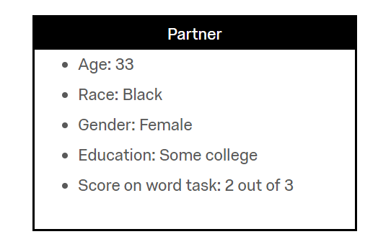
Please indicate if you would like to talk with this person or be assigned another partner.
- I would like to talk with THIS PERSON (1)
- I would like to be assigned ANOTHER PARTNER (2)

Q64 You chose "${Q57/ChoiceGroup/SelectedChoices}".
In a few words can you explain your decision?
________________________________________________________________
________________________________________________________________
________________________________________________________________
________________________________________________________________
________________________________________________________________

Q41
Please wait a moment.
Q68 Unfortunately, too many people dropped out of the study and we can no longer conduct the partner tasks. However, we have a set of survey questions for you to complete instead of the group puzzle task. You will still be compensated as long as you complete the rest of this survey as usual.
Q43 How often do you pay attention to what’s going on in government and politics?
- Never (1)
- Some of the time (2)
- About half the time (3)
- Most of the time (4)
- Always (5)

Q44 On a scale from 0 (coldest) to 100 (warmest) how do you feel about the following people and groups?
 | Coldest | Warmest

 | 0 | 10 | 20 | 30 | 40 | 50 | 60 | 70 | 80 | 90 | 100

Blacks (1) | 
Whites (7)
Republicans (3)
Democrats (4)
Doctors (5)
Car Salesmen (6)

Q45 For each pair of words, think about how you see yourself. Where would you place yourself between the two characteristics, where 1 means agreement with one characteristic, 5 agreement with the other characteristic, and 3 halfway between the two?
 | 1 | 2 | 3 | 4 | 5
 | 1 (1) | 2 (2) | 3 (3) | 4 (4) | 5 (5)
Honest (1) |  |  |  |  |  | Dishonest
Caring (2) |  |  |  |  |  | Uncaring
Unkind (3) |  |  |  |  |  | Kind
Unfair (4) |  |  |  |  |  | Fair
Helpful (5) |  |  |  |  |  | Not helpful
Stingy (6) |  |  |  |  |  | Generous
Compassionate (7) |  |  |  |  |  | Hardhearted
Untruthful (8) |  |  |  |  |  | Truthful
Not hardworking (9) |  |  |  |  |  | Hardworking
Friendly (10) |  |  |  |  |  | Unfriendly
Selfish (11) |  |  |  |  |  | Selfless
Principled (12) |  |  |  |  |  | Unprincipled

Q46 On a scale from disagree strongly to agree strongly, how much do you disagree or agree with the following statements?
 | Disagree strongly (1) | Disagree somewhat (2) | Neither disagree nor agree (3) | Agree somewhat (4) | Agree strongly (5)
Irish, Italians, Jewish and many other minorities overcame prejudice and worked their way up. Blacks should do the same without any special favors (1)
Generations of slavery and discrimination have created conditions that make it difficult for blacks to work their way out of the lower class. (2)
Over the past few years, blacks have gotten less than they deserve (3)
It's really a matter of some people not trying hard enough; if blacks would only try harder they could be just as well off as whites (4)
Wave 2:
Q1 Thank you for taking the second part of our study, “Different Types of Environments”, conducted by James Druckman at Northwestern University. We will ask you to complete a short survey today, which has two sections. Each relates to the purpose of the study, which is understanding people's thoughts and actions in different environments. As before, this survey is completely confidential, voluntary, and anonymous.
First, you will complete a learning task, where you will be asked to view a video clip and answer questions about your reactions to it. Second, you will be asked a series of questions about your general attitudes and beliefs.
Those assigned to the easy or hard video clip see the following:
Q31
Part 1.
First, we'd like you to watch a video clip. Please watch the following video and imagine what it would be like to actually encounter this person. While imaging this, think specifically of when (e.g. next Thursday) and where (e.g. the bus stop) this conversation might occur.
As a bit of background, this individual is in her late twenties, lives in an urban area, and identifies as black and female. We're interested in what you learn from this person and will ask you some questions about them afterwards.
Q32 Please have your volume turned on and click on the following video
Video embedded here
Q34 Were you able to view the video?
- Yes (1)
- No (2)
Display This Question:
If Were you able to view the video? = No
Q35 We're sorry about that - please open a new web browser or window and go to the following link to watch the video. Once you've finished it, return to the survey.
Easy conditions see this link:
Video link: youtu.be/4tg55DOWDA0
Hard conditions see this link:
Video link: youtu.be/VWkuDa9PrQ4
Q36 Now we'd like to ask you some questions about the video clip.
Q37
On a scale from very hard to very easy, how hard or easy was it to understand the person in the video clip (Eboni)?
- Very hard (1)
- Hard (2)
- Somewhat hard (3)
- Neither hard nor easy (4)
- Somewhat easy (5)
- Easy (6)
- Very easy (7)

Q38 On a scale from very different from you to very similar to you, how similar or different is Eboni compared to you?
- Very different (1)
- Different (2)
- Somewhat different (3)
- Neither different nor similar (4)
- Somewhat similar (5)
- Similar (6)
- Very similar (7)

Q39 On a scale from (1) not well at all to (10) extremely well, how well do the following words seem to describe Eboni (the person in the video clip)?
 | Not well at all | Extremely well

 | 1 | 2 | 3 | 4 | 5 | 7 | 8 | 9 | 10

Competent (1)
Warm (2)
Pushy (3)
Anxious (4)
Trustworthy (5)
Aggressive (6)

Q40 What did you learn about Eboni? What made you notice those things? Please write a few sentences in the box below.
________________________________________________________________
________________________________________________________________
________________________________________________________________
________________________________________________________________
________________________________________________________________

Q30
Part 2.
For the final part of our study, we'd like to ask you some questions some questions related to your attitudes more generally.
Click the button below to continue
Q70 What kind of media helps you learn the best?
- Video (1)
- Audio (2)
- Images and diagrams (5)
- Written materials (3)
- Other (4) ________________________________________________

Q71 What kind of media helps you learn the least?
- Video (1)
- Audio (2)
- Images and diagrams (5)
- Written materials (3)
- Other (4) ________________________________________________

Q72 When learning new material, which devices do you prefer to use? Please check all that apply.
- Laptop/Desktop computer (1)
- Tablet (2)
- Smart phone (3)
- Pen and paper (4)
- Whiteboards/chalk boards (5)
- Textbooks (6)

Q73 On a scale from (1) nothing at all to (7) a great deal, how much do you think the federal government should do to make sure members of the following groups are treated fairly when it comes to education and employment opportunities?
 | Nothing at all  1 (1) | 2 (2) | 3 (3) | 4 (4) | 5 (5) | 6 (6) | A great deal  7 (7)
Blacks (2)
Whites (3)
Women (1)
Senior citizens (4)

Q74 On the same scale from (1) nothing at all to (7) a great deal, how much do you think the federal government should do to make sure members of the following groups are treated fairly when it comes to the criminal justice system?
 | Nothing at all  1 (1) | 2 (2) | 3 (3) | 4 (4) | 5 (5) | 6 (6) | A great deal  7 (7)
Blacks (2)
Whites (3)
Women (1)
Senior citizens (4)

Q75 For each of the groups below, do you oppose or favor college admissions programs that give preferential treatment to members of that group?
 | Strongly oppose (1) | Oppose (2) | Neither oppose nor favor (3) | Favor (4) | Strongly favor (5)
Blacks (2)
Whites (3)
Women (1)
Senior citizens (4)

Q76 Next, imagine an organization wants to hold a demonstration advocating for greater government protection for blacks from discrimination. On a scale from (1) definitely oppose to (7) definitely support, would you oppose or support the demonstration if it were to...
 | Definitely oppose  1 (1) | 2 (2) | 3 (3) | 4 (4) | 5 (5) | 6 (6) | Definitely support  7 (7)
Take place in your community (1)
Block traffic around your home (2)
Result in conflict with local police (3)
Raise money for a local charity (4)

Q77
Now, imagine an organization wants to hold a demonstration advocating for greater government protection for whites from discrimination. On a scale from (1) definitely oppose to (7) definitely support, would you oppose or support the demonstration if it were to...
 | Definitely oppose  1 (1) | 2 (2) | 3 (3) | 4 (4) | 5 (5) | 6 (6) | Definitely support  7 (7)
Take place in your community (1)
Block traffic around your home (2)
Result in conflict with local police (3)
Raise money for a local charity (4)

Q78 On a scale from very cooperative (1) to very self-interested (10), how would you rate the following groups?
 | Very  cooperative | Very  self-interested

 | 1 | 2 | 3 | 4 | 5 | 6 | 7 | 8 | 9 | 10

Blacks (1)
Women (3)
Senior citizens (4)
Whites (5)

Q79 If you were the only member of your racial group and you were interacting with blacks (e.g., talking with them, working on a project with them), how would you feel compared to occasions when you are interacting with people from your own racial group?
From not at all (1) to very (5), to what extent would you feel…
 | Not at all  1 (1) | A little  2 (2) | Some  3 (3) | Quite  4 (4) | Very  5 (5)
Happy (1)
Awkward (2)
Self-conscious (3)
Confident (4)
Defensive (5)
Relaxed (6)

Q80 How much do you disagree or agree with the following statements:
 | Disagree strongly (1) | Disagree somewhat (2) | Neither disagree nor agree (3) | Agree somewhat (4) | Agree strongly (5)
If they increase in status, racial minorities are likely to reduce the influence of White Americans in society (1)
Members of other ethnic groups are not displacing members of my ethnic group from their jobs. (2)
The growth of other ethnic groups is undermining American culture (3)
The values and beliefs of other ethnic groups regarding moral issues are not compatible with the values and beliefs of my ethnic group (4)
I am afraid that the economic prospects of American society will get worse because of other ethnic groups (5)

Q83 What would you say is the purpose of this study?
________________________________________________________________
________________________________________________________________
________________________________________________________________
________________________________________________________________
________________________________________________________________

Q84 Please let us know if you have any other feedback
________________________________________________________________
________________________________________________________________
________________________________________________________________
________________________________________________________________
________________________________________________________________

Nonresponse on wave 2
Table A.7: Demographic table for full wave 1 sample
The difference between this table and demographic table in text this table contains all those who completed wave 1, regardless of completion at wave 2.

Age (median) | 44
Income (median) | $50,000 to $75,000
Education (median) | Some college
Percent Female | 49%
Percent conservative | 38%
Percent liberal | 32%
Political interest (mean) | 3.4 out of 5
N | 815

I also explored how nonresponse to wave 2 was related to some of the key variables. Table A.8, below, predicts nonresponse at wave 2 by a number of demographic and attitude variables.

Table A.8: Predicting nonresponse on wave 2
 | Nonresponse at wave 2
Intercept | 1.625*
 | (0.898)
Parner choice | 0.110
 | (0.374)
Racial resentment | 0.079
 | (0.114)
Racial contact | -0.001
 | (0.050)
Racial importance | -0.139***
 | (0.049)
Ideology | -0.063
 | (0.063)
Interest | 0.126
 | (0.094)
Score | 0.067
 | (0.110)
FT: Blacks | -0.011**
 | (0.006)
FT: Whites | 0.013**
 | (0.005)
Age | -0.003
 | (0.007)
Female | -0.478**
 | (0.199)
Income | 0.032
 | (0.045)
Education | -0.057
 | (0.078)
N | 731
Log Likelihood | -351.972
AIC | 731.943
*p < .1; **p < .05; ***p < .01
Coefficients in the table represent changes in logged-odds

Additional analyses on partner rejection/acceptance task
As indicated in the main text, the outrace partner was described in a very specific way to all subjects. This raises the possibility that the outrace partner differed from the subject in nonracial ways. To address this possibility, I estimated a series of models to evaluate the role of these other differences with the partner. This involved a series of linear regression models, regressing a set of racial variables on partner choice and the binary indicators of other differences with the partner. The goal of these regressions is to determine if the relationship between partner choice and the other racial measures persists even controlling for these other differences between the subject and the partner. Stated differently, does the connection between the partner choice and the racial variables disappear once I account for other differences between the partner and the respondent? The results of these analyses are summarized in figures A.11 and A.12. In these figures, all of the dependent variables are rescaled to range from zero to one in order to make the correlations more visually comparable in the figures.
These analyses indicate that acceptance of the outgroup partner is correlated with decreased levels of racial resentment, decreased importance of one’s own white racial identity, and a smaller difference in the feeling thermometer ratings of whites and blacks. Additionally, accepting the outgroup partner is correlated with higher feeling thermometer ratings of blacks, higher levels of prior contact, and more liberal political ideology. In terms of political values, accepting the outgroup partner is correlated with higher support for the values of benevolence, universality, equality, and civil liberties (all of which have been associated with more support for racial minorities in other work). These findings indicate that, even holding nonracial differences with the partner constant, the choice to accept the outgroup partner is reliably related to more positive feelings toward and engagement with blacks. Further, it also correlates with lower levels of racial polarization and ethnocentrism (in the form of white identity importance and net racial feeling thermometers).
Figure A.11: Racial attitudes and partner selection
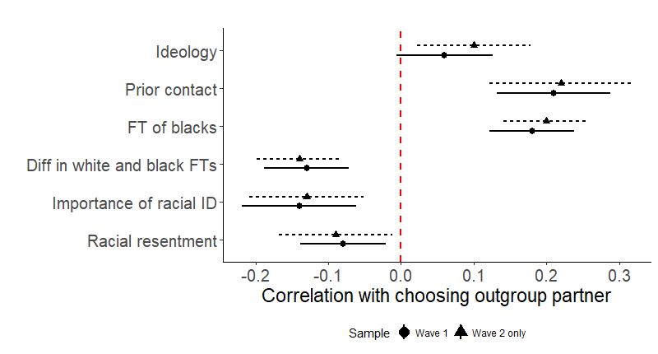

Figure A.12: Values and partner selection
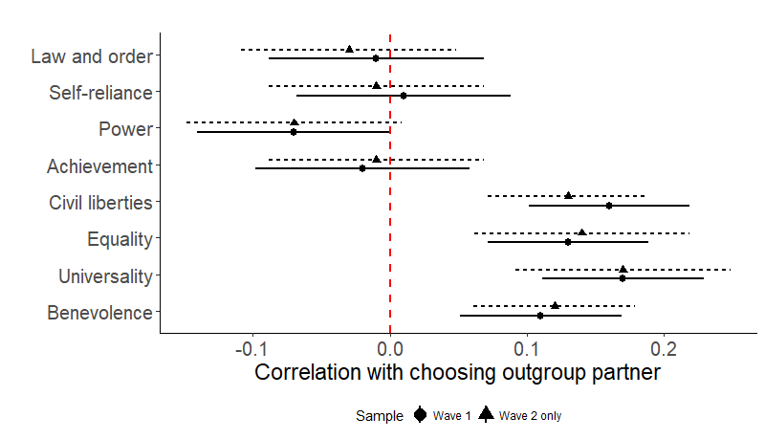
I also asked subjects to explain their choice of partner in an open-ended question, which can serve as a manipulation check of the partner selection task. As explained earlier in the Appendix, these open-ended items were also coded for four themes – ability/qualifications, race, difference, and similarity. Table A.9 displays the differences in these coding schemes by the two group treatments along with the average lengths of these responses. It also contains several measures of the time and effort spent by subjects to complete the partner selection task and explanation. These results indicate that there are not large (nor statistically significant) differences in the explicit reasons given by the subjects for their choices in both cases. Combined with the correlation between rejecting the outgroup member and anti-black attitudes (like racial resentment and feeling thermometer scores), this suggests that subjects may not be willing or able to explicitly mention the racial element of their choice to reject the outgroup partner.

Table A.9: Open-ended manipulation check items
 | Chose outgroup | Did not choose outgroup
Time spent choosing partner (seconds) | 18.3 | 20.8
Length of response (characters) | 42.7 | 31.2
Length of response (seconds) | 31.4 | 27.6
Probability of mentioning racial terms | 0.05 | 0.09
Probability of mentioning qualification-focused terms | 0.10 | 0.05
Probability of mentioning similarity-focused terms | 0.09 | 0.09
Probability of mentioning difference-focused terms | 0.05 | 0.07

Additional analyses
In addition to the NPC results, I also calculated the treatment effects from contact type through randomization inference. Table A.10. below gives these results, which are the same as those presented in the main text.
Table A.10: Ease of Communication effects, by outgroup selection
 | Chose outgroup |  | Do not choose outgroup
 | Easy-hard | p | Easy-hard | p
Criminal Justice | 0.002 | 0.99 | 0.35 | 0.46
Equal opportunity | -0.04 | 0.77 | 0.55 | 0.28
Preferential treatment | 0.01 | 0.89 | 0.11 | 0.75
Demonstration | -0.21 | 0.17 | -0.01 | 0.98
Demonstration blocking traffic | 0.04 | 0.82 | -0.06 | 0.92
Demonstration clashing with police | -0.08 | 0.65 | 0.04 | 0.93
Demonstration raising money for charity | -0.09 | 0.59 | -0.52 | 0.29
Note: p-values are constructed through randomization inference and are two-tailed

Experiment 4:

Survey instrument
Q4
Part 1.
First, we will ask you some questions about yourself.

Q6 When it comes to politics do you usually think of yourself as
- Very conservative (1)
- Conservative (2)
- Slightly conservative (3)
- Moderate, Middle of the road (4)
- Slightly liberal (5)
- Liberal (6)
- Extremely liberal (7)
- Don't know (8)

Q7 Generally speaking, do you usually think of yourself as a Republican, a Democrat, an Independent, or some other party?
- Democrat (1)
- Republican (2)
- Independent (3)
- Other (4)

Display This Question:
If Generally speaking, do you usually think of yourself as a Republican, a Democrat, an Independent,... = Independent
Or Generally speaking, do you usually think of yourself as a Republican, a Democrat, an Independent,... = Other

Q8 Do you consider yourself to be closer to the Democratic Party or Republican Party?
- Democratic Party (1)
- Republican Party (2)
- Neither (3)

Display This Question:
If Generally speaking, do you usually think of yourself as a Republican, a Democrat, an Independent,... = Republican

Q9 Would you say that you are a..
- Strong Republican (1)
- Not a strong Republican (2)

Display This Question:
If Generally speaking, do you usually think of yourself as a Republican, a Democrat, an Independent,... = Democrat

Q10 Would you say that you are a..
- Strong Democrat (1)
- Not a strong Democrat (2)

Q11 Which state do you live in?
(List of US states)
Q12 Which category best describes the total income of all members of your family living in your house last year before taxes? This figure should include salaries, wages, pensions, dividends, interest, and all other income.
- Under $25,000 (1)
- Between $25,000 and $34,999 (3)
- Between $35,000 and $49,999 (4)
- Between $50,000 and $74,999 (5)
- Between $75,000 and $99,999 (6)
- Between $100,000 and $149,999 (7)
- Between $150,000 and $199,999 (8)
- $200,000 or more (9)
- Don't want to say (10)
- Don't know (11)

Q13 Part 2.
Next, we'd like you to watch a video clip on the next screen. As you do so, imagine what it would be like to actually encounter this person.
In our other surveys, we've found that people learn more if they know a little about the person in the video. This individual describes herself as in her late twenties, living in an urban area, black, and an active blogger. She asked that we include part of her latest post, which you can see below.
We're interested in what you learn from this person and will ask you some questions about her after you watch the video clip. Click the button below to proceed to the video.

Subjects are randomly assigned to one of the two images:
Non-threatening:
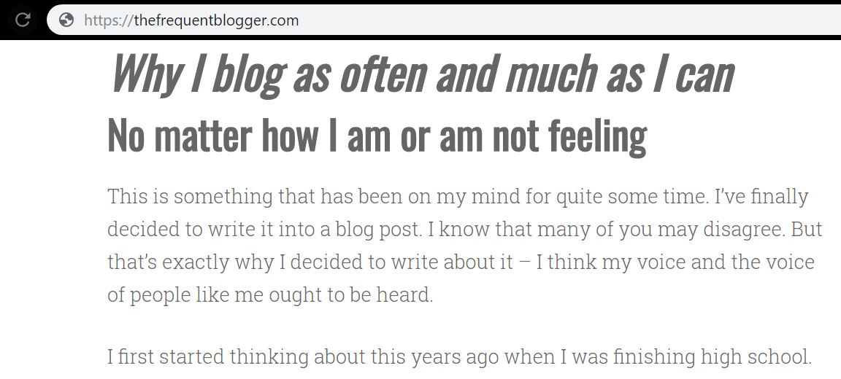
Threatening:
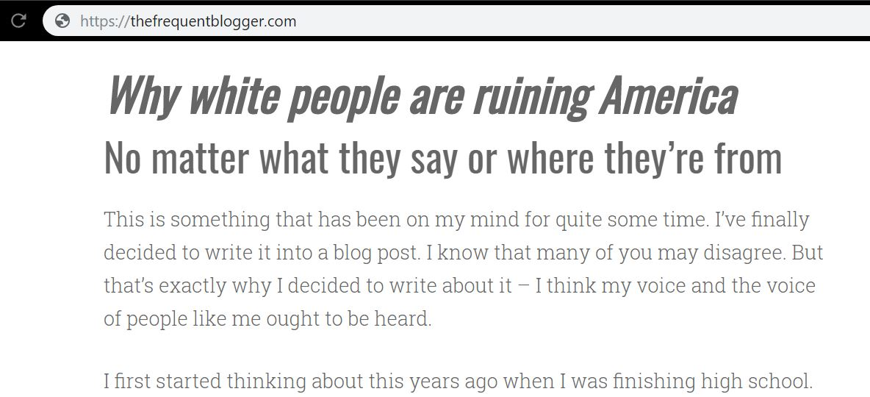

Q15 Please have your volume turned on and click on the following video
Subjects are randomly assigned to see one of the two videos embedded in the survey, which can be found here:
• Easy-to-understand: https://www.youtube.com/watch?v=4tg55DOWDA0&feature=youtu.be
• Difficult-to-understand: https://www.youtube.com/watch?v=VWkuDa9PrQ4&feature=youtu.be
Q17 Were you able to view the video?
- Yes (1)
- No (2)

Display This Question:
If Were you able to view the video? = No

Q18 We're sorry about that - please open a new web browser or window and go to the following link to watch the video. Once you've finished it, return to the survey.
Video link:
(easy to understand shown this link: youtu.be/4tg55DOWDA0)
(hard to understand shown this link: youtu.be/VWkuDa9PrQ4)

Q19 Now we'd like to ask you some questions about the video clip.
Q20
On a scale from very hard to very easy, how hard or easy was it to understand the person in the video clip (Eboni)?
- Very hard (1)
- Hard (2)
- Somewhat hard (3)
- Neither hard nor easy (4)
- Somewhat easy (5)
- Easy (6)
- Very easy (7)

Q21 On a scale from very different from you to very similar to you, how similar or different is Eboni compared to you?
- Very different (1)
- Different (2)
- Somewhat different (3)
- Neither different nor similar (4)
- Somewhat similar (5)
- Similar (6)
- Very similar (7)

Q22 On a scale from (1) not well at all to (10) extremely well, how well do the following words seem to describe Eboni (the person in the video clip)?
 | Not well at all | Extremely well

 | 1 | 2 | 3 | 4 | 5 | 6 | 7 | 8 | 9 | 10

Competent ()
Warm ()
Pushy ()
Aggressive ()

Q24 What did you learn about Eboni? What made you notice those things? Please write a few sentences in the box below.
________________________________________________________________
________________________________________________________________
________________________________________________________________
________________________________________________________________
Q30
Part 3.
For the final part of our study, we'd like to ask you some questions some questions related to your attitudes more generally.
Click the button below to continue.
Q31 What kind of media helps you learn the best?
- Video (1)
- Audio (2)
- Images and diagrams (5)
- Written materials (3)
- Other (4) ________________________________________________

Q32 What kind of media helps you learn the least?
- Video (1)
- Audio (2)
- Images and diagrams (5)
- Written materials (3)
- Other (4) ________________________________________________

Q33 When learning new material, which devices do you prefer to use? Please check all that apply.
- Laptop/Desktop computer (1)
- Tablet (2)
- Smart phone (3)
- Pen and paper (4)
- Whiteboards/chalk boards (5)
- Textbooks (6)

Q34 On a scale from 0 (coldest) to 100 (warmest) how do you feel about the following people and groups?
 | Coldest | Warmest

 | 0 | 10 | 20 | 30 | 40 | 50 | 60 | 70 | 80 | 90 | 100

Blacks
Middle class people
Veterans
Whites
Women

Q35 Would you characterize the relationship between blacks and whites as very negative, slightly negative, neither negative nor positive, slightly positive, or very positive?
- Very negative (1)
- Slightly negative (2)
- Neither negative nor positive (3)
- Slightly positive (4)
- Very positive (5)

Q36 How much do you disagree or agree with the following statement with regards to the groups below:
I have a lot in common with...
 | Disagree strongly (1) | Disagree somewhat (2) | Neither disagree nor agree (3) | Agree somewhat (4) | Agree strongly (5)
Average blacks (1)
Average women (2)
Average middle class people (6)
Average veterans (7)
Average whites (8)

Q44 On a scale from (1) nothing at all to (7) a great deal, how much do you think the federal government should do to make sure members of the following groups are treated fairly when it comes to education and employment opportunities?

 | Nothing at all -1 | 2 | 3 | 4 | 5 | 6 | A great deal - 7
Blacks (1)
Whites (2)
Women (3)
Veterans (4)

Q45 On a scale from (1) nothing at all to (7) a great deal, how much do you think the federal government should do to make sure members of the following groups are treated fairly when it comes to the criminal justice system?

 | Nothing at all -1 | 2 | 3 | 4 | 5 | 6 | A great deal - 7
Blacks (1)
Whites (2)
Women (3)
Veterans (4)

Q46 Next, imagine an organization wants to hold a demonstration advocating for greater government protection for blacks from discrimination. On a scale from (1) definitely oppose to (7) definitely support, would you oppose or support the demonstration if it were to...

 | Definitely oppose -1 | 2 | 3 | 4 | 5 | 6 | Definitely support - 7
Take place in your community
Block traffic around your home
Result in conflict with the local police
Raise money for a local charity

Q47 Now, imagine an organization wants to hold a demonstration advocating for greater government protection for whites from discrimination. On a scale from (1) definitely oppose to (7) definitely support, would you oppose or support the demonstration if it were to...

 | Definitely oppose -1 | 2 | 3 | 4 | 5 | 6 | Definitely support - 7
Take place in your community
Block traffic around your home
Result in conflict with the local police
Raise money for a local charity

Q37 How much do you disagree or agree with the following statements:
 | Disagree strongly (1) | Disagree somewhat (2) | Neither disagree nor agree (3) | Agree somewhat (4) | Agree strongly (5)
When one group gets ahead, the others are held back (1)
Progress for one group does not have to come at the expense of another (2)
Gains for one group mean another group loses (3)
Decreased bias toward one group naturally means another group will experience more bias (4)

Q38 How much do you disagree or agree with the following statement:
"If they increase in status, racial minorities are likely to reduce the influence of whites in society"
- Disagree strongly (1)
- Disagree somewhat (2)
- Neither agree nor disagree (3)
- Agree somewhat (4)
- Agree strongly (5)

Q40 On a scale from "made it much harder" to "made it much easier", do you think your race or ethnicity has made it harder or easier for you to succeed in life?
- Made it much harder (1)
- Made it a little harder (2)
- Not made much difference (3)
- Made it a little easier (4)
- Made it a much easier (5)

Q42 What would you say is the purpose of this study?
________________________________________________________________
________________________________________________________________
________________________________________________________________
________________________________________________________________

Q43 Please let us know if you have any other feedback
________________________________________________________________
________________________________________________________________
________________________________________________________________
________________________________________________________________
________________________________________________________________

Baltimore and Portland were selected because they are approximately the same size, have a similar median income, are a great distance from Northwestern, and are composed overwhelming of the corresponding racial group (Baltimore is 64 percent black while Portland is 72 percent white). These facts come from the 2010 U.S. Census. See https://www.census.gov/quickfacts/table/PST045215/4159000,2404000,00.
Statistically different from those who choose the outgroup in a t-test (p=0.005, two-tailed).

