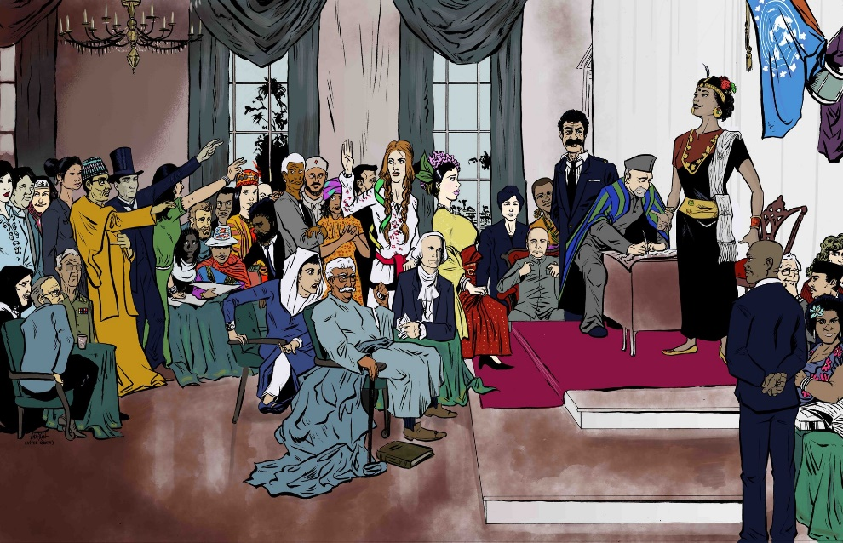

Constitutionalism
in Context
Online Supplement
EDITED BY
David S. Law

Supporting Materials

Information on the main text: www.cambridge.org/9781108699068
Main text’s DOI: 10.1017/9781108699068

Cambridge University Press, the Editor and the Contributors have no responsibility for the persistence or accuracy of URLs for external or third-party internet websites referred to in these supporting materials and do not guarantee that any content on such websites is, or will remain, accurate or appropriate.
These supporting materials are owned by their respective copyright holders.
Cambridge University Press, the Editor and the Contributors do not represent nor claim ownership on these materials. Permission to reproduce these third-party content must be obtained from these third parties directly.
Cover illustration by Chris Anderson

Constitutionalism in Context
Errata and Updates (as of 17 February 2022)

Ch. 4. "Constitutions and Constitutionalism: China"

— p. 64: "Fascism" should be lower case: "fascism"
— p. 66 n 19: "can be made" should read: "could somehow be made"
— p. 67: "Rule of Law" should be lower case: "rule of law"
— p. 68:
(1) "rigorous or substantive" should read: "demanding"
(2) delete "The range of possibilities may be illustrated as follows."
— p. 70 n. 52:
(1) The footnote should begin with the following citation:
Backer, 'The Party as Polity' (n. 49) at 104–105.
(2) The citation at the end of the footnote should be replaced with:
Ibid.

Ch. 10. “Nonjudicial Constitutional Interpretation: The Netherlands”

— p. 232, subheading 3.3.3: “Staten-Generaal” should be hyphenated

Ch. 11. “Transnational Judicial Dialogue: The European Union"

— p. 247: insert "Its" in heading before "Institutions": "European Union and Its Institutions"

Ch. 15. "Citizenship and Nationality: Cyprus"

— p. 338, 2d paragraph, last sentence: "individual's rights under EU Law": "law" should be lower case.

Ch. 16. “Affirmative Action: Brazil"

— p. 355, last sentence: "subject" should read: "subjects"
— p. 360, n. 39: the period after "2017" should be a comma
— p. 361:
(1) last paragraph: "European colonizers saw" should read: "European colonizers depicted"
(2) n. 42: "Emenda Constitucional 45, de 30 de dezembro de 2004, D.O.U. 30.12.2004" should read: "Emenda Constitucional No. 45 de 30 de dezembro de 2004, D.O.U. de 30.12.2004"
— p. 366:
(1) n. 65, first citation: "Apelação Cìvel, No." should read: "Ap. Cív. No."
(2) n. 65, first and second citations: "Orgao" should read: "Órgão"
(3) n. 65, second citation: "T.J.E.S., A.D.I. No." should read: "TJES, ADI No."
(4) n. 67: "T.J.E.S., Ap. Cıv." should read: "TJES, Ap. Cív."
(5) n. 67: the "a" in "2a" should not be in superscript
— p. 368:
(1) n. 69, first citation: "C´iv" should read: "Cív"
(2) n. 69, second citation: "S.T.J., R. Esp. No." should read: "STJ, Resp. No."
(3) n. 69, fourth citation: "T.J.R.J., Ag. Instr. No." should read: "TJRJ, AI No."
(4) n. 71, first and second citations: the letter "a" in "1a" and "3a" should not be in superscript
— p. 369:
(1) n. 72, second citation: the "a" in "11a" should not be in superscript
(2) n. 73, first citation and last citation: the "a" in "11a" and "3a" should not be in superscript
(3) n. 75, first and second citations: the "a" in "13a" and "TRF-4a" should not be in superscript
— p. 370, text box heading: "Orgao" should read: "Órgão"

Ch. 17. “Subnational Constitutionalism: Hong Kong”

— p. 385: “then existing” should read “then-existing”

List of Supporting Documents

Chapter — Authors | Documents
Constitutional History and Constitutional Migration: Nepal  — Mara Malagodi | - Guidance Note of the Secretary-General on United Nations Assistance to Constitution-making Processes (April 2009) [© United Nations] [also included in supporting materials for Sudan chapter]  - Guidance Note of the Secretary-General on United Nations Constitutional Assistance (September 2020) [© United Nations] [also included in supporting materials for Sudan chapter]
International Law and Constitution-Making: Sudan  — Markus Böckenförde | - Guidance Note of the Secretary-General on United Nations Assistance to Constitution-making Processes (April 2009) [© United Nations] [also included in supporting materials for Nepal chapter]  - Guidance Note of the Secretary-General on United Nations Constitutional Assistance (September 2020) [© United Nations] [also included in supporting materials for Nepal chapter]  - Comprehensive Peace Agreement 2004  - Interim National Constitution Sudan 2005  - Constitutional Declaration 2019  - Juba Peace Agreement 2020  - Markus Böckenförde, Simone Malz and Verena Wiesner (eds.), Max Planck Compilation of International Human Rights Treaties: Sudan, 2nd ed. (Max-Planck Institute, 2008) [© Max-Planck Institute for Comparative Public Law and International Law]
Judicial Review of Constitutional Amendments: Taiwan — David S Law & Hsiang-Yang Hsieh | - JY Interpretation No. 499 (2000)
Nonjudicial Constitutional Interpretation: Netherlands  — Maartje de Visser | - Canadian Charter of Rights and Freedoms 1982, ss 1, 24(1) and 33  - UK Human Rights Act 1998, ss. 3, 4, 10, and 19  - New Zealand Bill of Rights Act 1990, ss. 4, 6-7  - Council of State Act arts 16-27  - Advisory opinion W04.20.0135/I of June 15, 2020  - Advisory opinion W11.08.0398/IV of October 20, 2008.  - NIHR Act, art. 5(1)  - Advisory opinion W04.15.0170/I of July 15, 2015
Transnational Judicial Communication: The European Union  — Elaine Mak & David S. Law | - State v. Makwanyane (CCT3/94) [1995] ZACC 3; 1995 (6) BCLR 665; 1995 (3) SA 391.  - Stefano Melloni v. Ministerio Fiscal [2013] ECLI:EU:C:2013:107  - R v. Boyd and others [2002] I ECHR  - Cooper v. United Kingdom [2003] XII ECHR  - SAS v. France [GC], no. 43835/11 [2014] ECHR 695.  - Bosphorus Hava Yollari Turizm Ve Ticaret Anonim Sirketi v. Ireland [GC], no. 45036/98 [2005] ECHR 440.
Subnational Constitutionalism: Hong Kong  — Cora Chan | - Article 104 of the Basic Law  - Excerpt from HKSAR v. Ma Wai Kwan David and others [1997] HKCA 652; [1997] HKLRD 761; [1997] 2 HKC 315; CAQL 1/1997 (29 July 1997)  - Excerpt from Lau Kong Yung and others v. Director of Immigration [1999] HKCFA 5; [1999] 3 HKLRD 778; (1999) 2 HKCFAR 300; [1999] 4 HKC 731  - Excerpt from Democratic Republic of the Congo and Others v. FG Hemisphere Associates LLC [2011] HKCFA 43; (2011) 14 HKCFAR 95; [2011] 4 HKC 151  - Excerpt from Director of Immigration v. Chong Fung Yuen [2001] HKCFA 48; [2001] 2 HKLRD 533; (2001) 4 HKCFAR 211  - Excerpt from Ng Ka Ling and another v. Director of Immigration [1999] HKCFA 72; [1999] 1 HKLRD 315; (1999) 2 HKCFAR 4; [1999] 1 HKC 291  - Excerpt from Master Chong Fung Yuen v. Director of Immigration [2000] HKCA 499; [2000] 3 HKLRD 661  - Excerpt from Yau Wai Ching v. Chief Executive of the Hong Kong Special Administrative Region, Secretary for Justice [2017] HKCFA 57; FAMV 8/2017 (1 September 2017)  - Excerpt from the Interpretation of the Standing Committee of the National People’s Congress of Article 104 of the Basic Law (Adopted by the Standing Committee of the Twelfth National People’s Congress at its Twenty-fourth Session on 7 November 2016) [© The National People's Congress of the People's Republic of China]  - Decision of the Standing Committee of the National People’s Congress on Approving the Co-operation Arrangement between the Mainland and the Hong Kong Special Administrative Region on the Establishment of the Port at the West Kowloon Station of the Guangzhou-Shenzhen-Hong Kong Express Rail Link for Implementing Co-location Arrangement (Adopted at the Thirty-first Session of the Standing Committee of the Twelfth National People’s Congress on 27 December 2017) [© The National People's Congress of the People's Republic of China]  - Decision of the Standing Committee of the National People’s Congress on the Continuing Discharge of Duties by the Sixth Term Legislative Council of the Hong Kong Special Administrative Region (adopted at the Twenty-first Session of the Standing Committee of the Thirteenth National People’s Congress on 11 August 2020) [© The National People's Congress of the People's Republic of China]Excerpt from Decision of the NPCSC on Approving the Co-Operation Arrangement Between the Mainland and the Hong Kong Special Administrative Region on the Establishment of the Port at the West Kowloon Station of the Guangzhou-Shenzhen-Hong Kong Express Rail Link for Implementing Co-Location Arrangement (adopted at the 31st Session of the Standing Committee of the 12th NPC on 27 December 2017) [© The National People's Congress of the People's Republic of China]  - Excerpt from Decision of the Standing Committee of the National People’s Congress on the Continuing Discharge of Duties by the Sixth Term Legislative Council of the Hong Kong Special Administrative Region (adopted at the Twenty-first Session of the Standing Committee of the Thirteenth National People’s Congress on 11 August 2020) [© The National People's Congress of the People's Republic of China]
Fourth-Branch Institutions: South Africa  — Mark Tushnet | - Economic Freedom Fighters v. Speaker of the National Assembly and Others; Democratic Alliance v. Speaker of the National Assembly and Others [2016] ZACC 11  - Glenister v. President of the Republic of South Africa and Others [2011] ZACC 6  - Glenister v. President of the Republic of South Africa and Others; Helen Suzman Foundation v. President of the Republic of South Africa (CCT 07/14) [2014] ZACC 32
Privatization of Constitutional Law: Thailand  — Victor V Ramraj & Thitinant Tengaumnuay | - The Equator Principles IV (July 2020) [© The Equator Principles Association]

