Video transcript:
Public Policy and Universities: the Interplay of Knowledge and Power
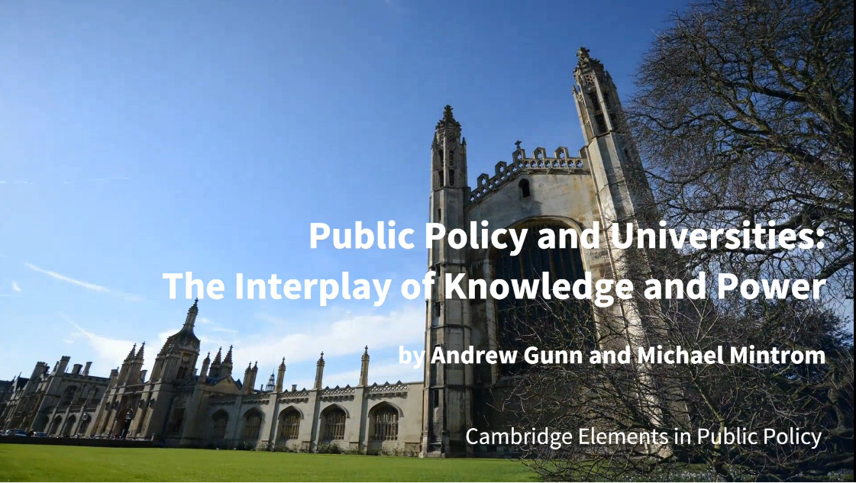
My name is Andrew Gunn, I am co-author, with Michael Mintrom, of the new Cambridge University Press Element Public policy and universities: the interplay of knowledge and power.
What big issues have you addressed in this Element?
As universities experience unprecedented change, we felt it was time to take a look at the relationship between universities and government, so we developed a study themed around the interplay of knowledge and power between the two sides. One thing we wanted to illustrate was the wide range of policy interventions coming from government, that have a bearing on what universities do. We also set out to demonstrate how theories of the policy process are of relevance to higher education research.
How have you organised your thoughts?
As this is an Element in the Public Policy series, we developed a framework that draws on theories in recent public policy literature, and we used this to guide our analysis. Specifically, we took four theories of the policy process: New-Institutionalism, the Advocacy Coalition Framework, the Narrative Policy Framework and Policy Diffusion and Transfer. In addition to this, we developed a structure for the Element where there is a chapter dedicated to each of the three ‘missions’ of the university— this is the two classical missions of teaching and research –and third mission of ‘externally facing’ activities. This is followed by a chapter considering the university as an institution as a whole. I think this provides a clear and original way of organising a study of the university.
What are the key insights readers will gain from your Element?
The Element explores a wide range of debates such as: increased government interest in measuring the performance of universities, particular with metrics; the diffusion of policy ideas between countries; the growing number of university alliances; universities being subject to new regulations to protect national security; and the role higher education in innovation and economic growth; there's also some topical issues, such as how the culture wars have spilled over onto campus, creating headlines of a free speech crisis. In exploring this range of policy activity, we show, that despite the rhetoric of deregulation and internationalisation, there is a continuing role for the nation state in shaping and supporting the university. This highlights the importance of paying attention to national politics and policy making.
How will your Element help readers in a practical way?
We’ve tried to offer a smart synthesis of, what is, a large topic. So we haven’t been able to include everything; but we have provided an overview that the range of readers may find helpful. For example, for those working inside universities, this element will provide some context to their work and help them understand why the government is involved in higher education. It is also of relevance to those in the policy making community who want to learn more about the contemporary university. And for social science researchers we've set out a way a approaching and structuring a study of this topic; as well as pointing to future opportunities for theory informed policy research.

