APPENDIX
Details on conjoint experiments
A conjoint experiment was embedded in representative surveys carried out in seven European countries: Estonia, Germany, Poland, Serbia, Spain, Sweden, and Ukraine. A total of 10 001 respondents were surveyed by Ipsos between October 21, 2021 and November 17, 2021: 2 500 in Germany; 1 500 in Poland, Spain, and Ukraine; 1 000 in Estonia and Sweden; and 1 001 in Serbia. Selection of quotas from the Ipsos Access Panels was based on the following criteria for representativeness: gender, age, region, and education (best effort). A conjoint experiment in Hungary was conducted by the Hungarian polling company, Závecz Research, between June 27, 2023 and July 11, 2023 and had a total of 1014 respondents. Quota selection was done according to the following criteria of representativeness: gender, age, region, and education.

We used a conjoint design with candidate choice experiments to investigate if voters would forgive politicians who transgress democratic principles in exchange for partisan and policy interests. The candidate choice experiments were embedded in representative surveys with standard questions on knowledge of and support for democracy, policy and party preferences, interest in politics, and economic performances. In our experiments, we asked respondents to select between two political candidates in an election, thus simulating a “close to reality” voting scenario.

Experiment Programming and Randomization
Experimental Design: Participants in the study were presented with 20 hypothetical electoral scenarios, divided into two sets of 10, with a series of direct questions administered between the sets. Each scenario featured two candidates, presented in a table format, and respondents were asked to choose the candidate they would most likely vote for if the election were held today. Additionally, respondents rated their likelihood of voting on a scale from 0 (definitely not voting) to 100 percent (definitely voting).

Dependent Variables: In our study, the first, key dependent variable is the candidate choice. Candidate-choices are based on the question "Which candidate do you prefer?" with a forced choice between Candidate 1 or Candidate 2. Most of our analyses focus on this outcome.

Candidate Presentation: Each candidate was described by their political party affiliation and three policy positions (see Figure 1). The order of policy presentation was randomized across scenarios; however, policies from the same area were consistently presented in the same row to maintain uniformity in data collection.

Randomization Procedures: The experimental stimuli included the following elements, randomized per the specifications detailed below:
- Party labels: Each candidate was randomly assigned a distinct party label from a pre-defined list, ensuring no repetition within a given pair.
- Drawing policy positions: Candidates were assigned economic and social policies (see Table 1), with the policies randomly selected to allow for comparability (including potential identical selections across candidates within the same scenario).
- Drawing democracy positions: Five candidate choice scenarios were assigned two neutral positions, i.e., both candidates featured neutral positions (such as “Served on the Committee on European Affairs and International Cooperation”). For these candidate pairs, we drew two distinct neutral democracy positions with equal probability. Furthermore, 15 candidate choice experiments were designed in such a way that one candidate adopted a neutral democracy position while the other a position that violates democratic rules (see Table 2).

Scenario Structuring:
Initial 10 scenarios: "We invite you to choose between hypothetical candidates for [THE COUNTRY’S PARLIAMENT]. Please carefully consider each pair of candidates for at least 20 seconds before making your selection."
Subsequent 10 scenarios: Repeated with a prompt emphasizing careful consideration.

Technical Considerations:
Respondents were unable to proceed to the next scenario until spending a minimum of 20 seconds considering the current pair of candidates, ensuring thoughtful engagement with the experimental materials.

Figure 1: Example of the candidate profile from the survey for Germany

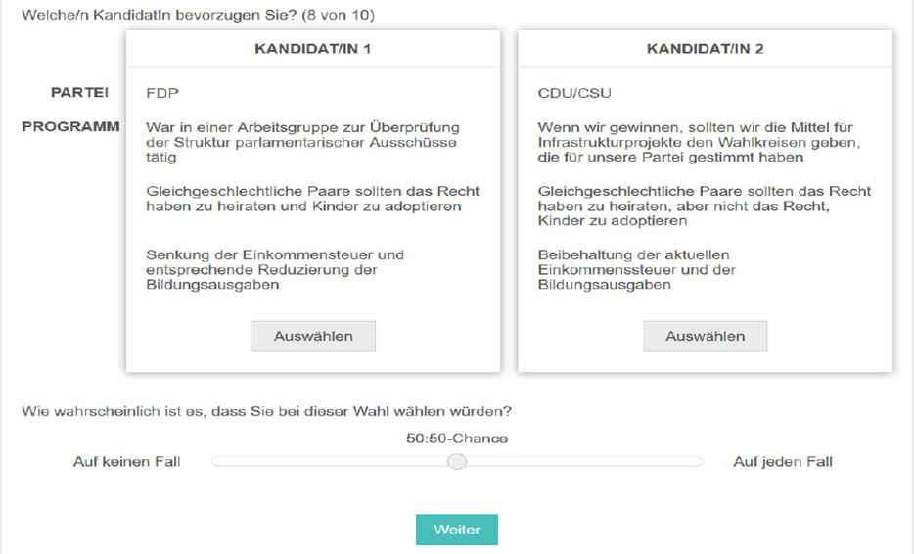

Designing policy and undemocratic positions
When designing political candidates’ policy positions (see Table 1), we followed several criteria: Positions had to be unambiguously classifiable along a single dimension (e.g., economic left-right and pro-/anti-immigration); the anticipated distribution of policies most preferred by respondents had to span all policy positions and reflect the underlying distribution of preferences in the electorate; and the selection and content of the issue areas had to reflect the most prominent contentious public policy issues. In line with this, we selected positions in relation to the following issues: taxes and environment; taxes and education; same-sex couples’ rights; immigration; national vs. EU-level policy on defense that captures preferences regarding sovereignty; the use of a minority language; and pro-EU vs. pro-Russia foreign policy orientation.

Concerning the candidates’ undemocratic positions, we followed Dahl’s (1971) classical work on democratization and included undemocratic positions that violated one of three key tenets of a liberal democracy: electoral fairness, checks and balances, and civil liberties (see Table 2; see also Graham and Svolik, 2020). We furthermore chose practices that approximate those that have been used or attempted by governments and politicians to subvert the democratic process throughout Europe in the recent past. For the sake of comparison, we have chosen the same practices for each country in our sample, while recognizing that seven countries under investigation have experienced different levels of democratic violations by the incumbent, which further means that some respondents may treat some democratic violations more seriously than others. This concretely means that voters in Poland are more likely to be aware of the undemocratic nature of practices such as the suspension of parliamentary debate or the disciplining of judges. In the context of widespread clientelism in Serbia, the same logic applies to Serbian voters with regard to infrastructure spending only in districts that voted for the ruling party.

The chosen positions were furthermore adopted with the intent of staying in or acquiring power (and not for their own sake) and they range from positions that are legal but undemocratic to ones that are both illegal and undemocratic. This mirrors the incremental nature of democratic backsliding. Moreover, all positions are presented in a manner that avoids conspicuousness or normatively leading language (“undemocratic”, “unconstitutional”, “violation”, etc.). We wanted our respondents to decide for themselves whether or not a position violates a democratic principle and thus avoid the objection that respondents are punishing undemocratic positions due to the manner in which they are presented instead of their content.

Following the introduction of the candidates, the respondents were asked to select their preferred candidate and to indicate their likelihood of voting for the chosen candidate in the next election. Through these experiments, we were able to isolate the effects of a candidate’s attempt to subvert democracy on his or her electoral prospects. As the positions and attributes of the undemocratic candidates were assigned randomly, their share of received votes can be compared to those of democratic candidates with otherwise identical characteristics. Thus, a decline in vote share for an undemocratic candidate is a measure of a voters’ punishment for a candidate who transgresses democratic norms (see also Svolik et al. 2023). In this manner, we were able to assess whether voters’ declarative support for democracy was in fact translated into a willingness to vote against undemocratic candidates.

Table 1: Policy positions
Taxes and education | - Raise personal income taxes and use the revenue to increase education budget  - Keep personal income taxes and education budget as they are  - Cut personal income taxes and reduce education budget accordingly
Taxes and environment | - Raise taxes on coal and gas to lower the price of solar and wind energy  - Lower taxes on coal and gas even if it results in lesser use of solar and wind energy
Immigration | - Allow immigration regardless of the country of origin  - Allow immigration from the EU, but only family-based immigration from outside of the EU  - Ban immigration from outside of the EU  - Ban all immigration regardless of the country of origin
The use of minority languages | - Only [MAJORITY_LANGUAGE] should be used when communicating with state offices  - [MINORITY_LANGUAGE] speakers should have the right to use their language when communicating with state offices
Same-sex couples’ rights | - Same-sex couples should have the right to marry and adopt children  - Same-sex couples should have the right to marry, but not adopt children  - Same-sex couples should not have the right to marry or adopt children
National vs. EU-level policy on defense | - Defense policy for [COUNTRY NAME] should be decided at the EU level  - Defense policy for [COUNTRY NAME] should be decided jointly by [COUNTRY ADJECTIVE] and EU institutions  - Defense policy for [COUNTRY NAME] should be decided by [COUNTRY ADJECTIVE] institutions alone
Relations with the EU and Russia | - We should have closer relations with the EU and distance ourselves from Russia  - We should have close relations with both the EU and Russia  - We should have closer relations with Russia and distance ourselves from the EU

Table 2: Undemocratic positions
Electoral fairness | “We should direct infrastructure spending to districts that voted for our party”  Opposition version: “If we win, we should direct infrastructure spending to districts that voted for our party”  Key concept: voter autonomy, the government should not abuse public resources for electoral purposes | “Encouraged their supporters to violently disrupt campaign rallies of their political opponents”  Key concept: freedom of assembly
Civil Liberties | “Said the government should prosecute journalists who accuse the prime minister/president of corruption”  Only plausible for candidates affiliated with the government  Key concept: freedom of speech  “Supported a ban on foreign funding for domestic non-governmental organizations  critical of the government”;  “Supported a ban on foreign funding for labor unions critical of the government”  Key concept: freedom of association, speech | “Said Muslims should not be allowed to pray during their breaks at work”  Key concept: freedom of religion  “Supported a proposal for the government to monitor politically critical posts on social media”  Key concept: freedom of speech, right to privacy
Checks and Balances | “Laws should be passed without parliamentary debate if criticized by the opposition”  Only plausible for candidates affiliated with the government  Key concept: legislative checks on the executive | “Said the government should discipline judges who publicly criticize it”  Key concept: judicial independence

Democratic competence
To verify that the respondents understand that certain positions breach the tenets of democracy in the first place, we evaluated the respondents’ “democratic competence” with a series of standard survey questions (details below) prior to the candidate choice experiments. Respondents were asked to evaluate a series of democratic and undemocratic practices. Respondents were asked to rank these statements on a scale from 1 (not at all democratic) to 10 (completely democratic). These statements were created in such a way that they intentionally mirrored the undemocratic positions held by candidates in our candidate choice experiments; they thus allow us to examine our respondents’ understanding of democracy. A respondent was deemed democratically competent if her mean of assessment of democratic practices was higher than her mean of assessment of undemocratic practices.

1 The country’s high court ruled that a government policy was unconstitutional.
2 The prime minister conceded a narrow election defeat.
3 Journalists frequently disagree with the president’s policies.
4 Opposition parties organize protests against the government.
5 The military removed a corrupt president.
6 Unelected experts govern the country.
7 The government cut spending in regions that supported the opposition in the last election.
8 The president encourages his supporters to disrupt opposition campaign rallies.
9 The government adopts laws without a debate in the parliament.
10 The country’s judiciary is staffed with individuals loyal to the governing party.
11 Journalists are prosecuted for criticizing the government.
12 Muslims are not allowed to publicly celebrate religious holidays.
13 The government banned civil society organizations that receive funds from abroad from operating inside the country.
14 The country’s security agencies collect data on their citizens’ internet activity.

Support for and knowledge about democracy
- ‘How important is it for you to live in a country that is governed democratically?’, by party

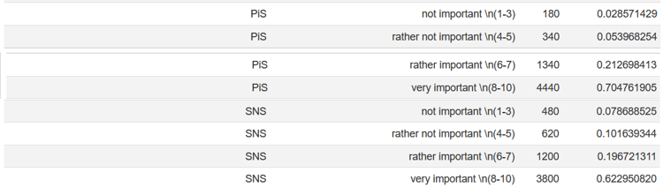

- ‘Democracy may have problems, but it is better than any other form of government.’, by party

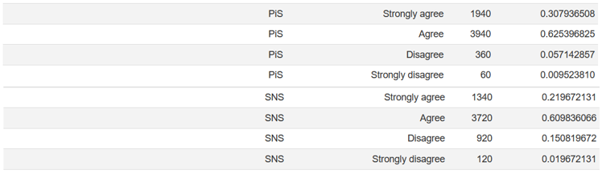

- Share of democratic competence, by party
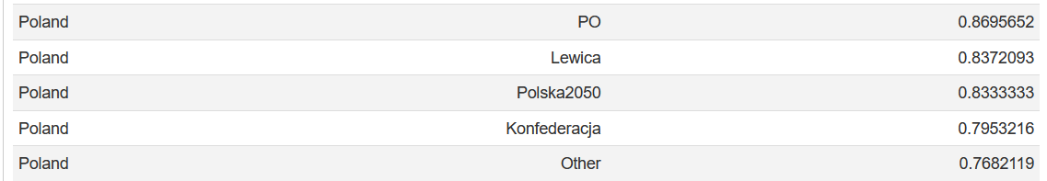
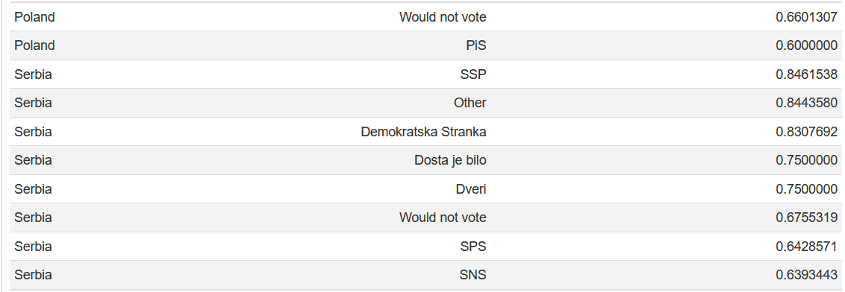

Willingness to trade off democracy
- Change of vote share of undemocratic candidate on LGBT issue (Poland)

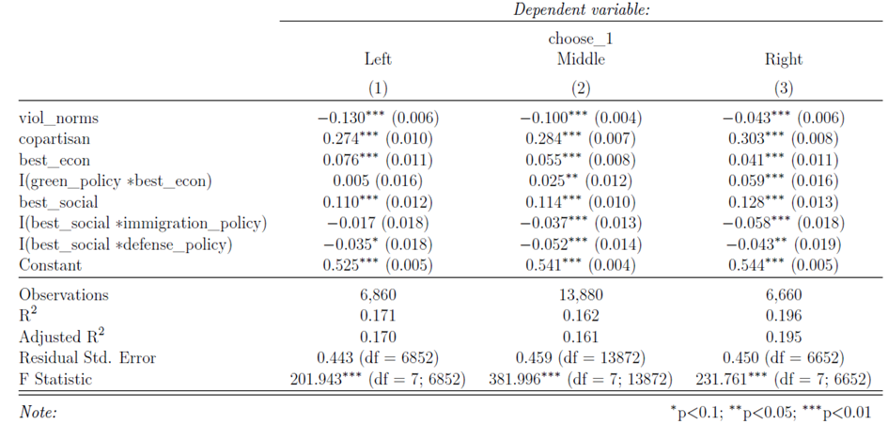

- Change of vote share of undemocratic candidate on EU vs. Russia issue (Serbia)
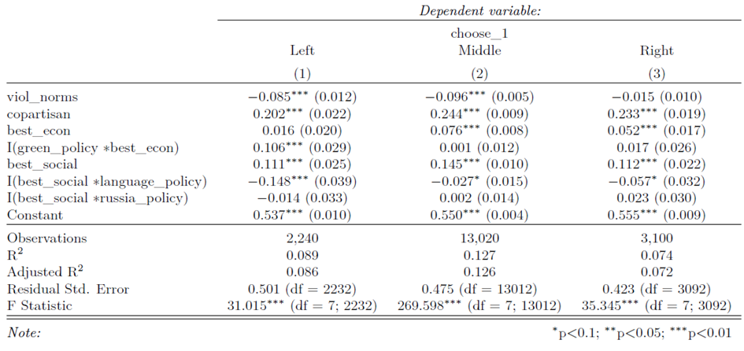

- Change of vote share of undemocratic candidate on LGBT issue (Hungary)
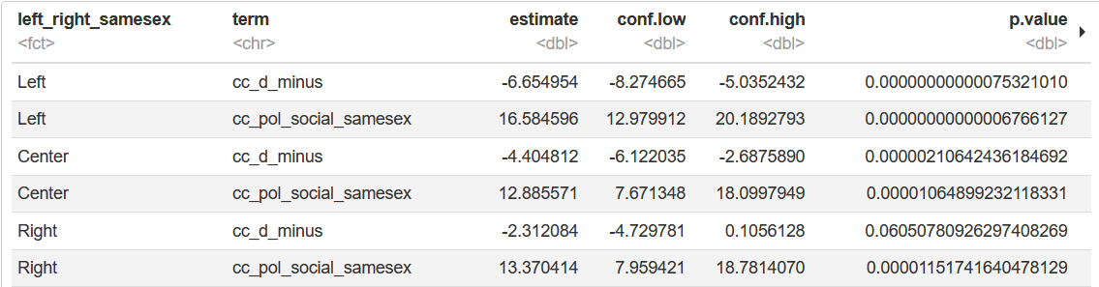
- Change of vote share of undemocratic candidate on immigration issue (Hungary)
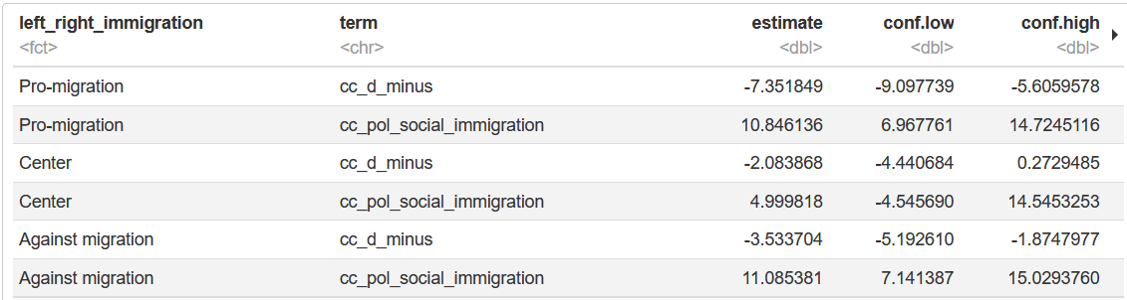

List of interviews
Serbia
Zoran Lutovac, MP and leader of Democratic Party (2018-2024)
Nebojsa Novakovic, MP, Democratic Party
Vukosava Crnjanski, director of NGO CRTA
Igor Bandovic, director of Belgrade Centre for Security Policy
Jovana Radosavljevic, director of New Social Initiative, a North Mitrovica-based CSO
Official of German Foreign Affairs dealing with Serbia (who wishes to remain anonymous)
Zorana Mihajlovic, former deputy prime minister

Poland
Bartosz Machalica, chief strategist of Lewica
Dorota Loboda, MP and spokesperson of PO parliamentary group
Jakub Kocjan, board member at CSO Akcja Demokracja
Kinga Lozinska, vice-president of the Committee for the Defence of Democracy (2020-2024)
Krzysztof Izdebski, board member at Stefan Batory Foundation
Lukasz Jasina, former spokesperson of the Polish Foreign Ministry
Piotr Kolomycki, former spokesperson of PO

Turkey
Yüksel Taskin, MP, CHP
Mahir Polat, CHP candidate for the mayor of municipality Fatih in Istanbul province
Enver Cevik, international secretary of the Kurdish Dem Party
Ulas Tol, director general at the Collective Research Institute

Hungary
Marta Pardavi, director of Hungarian Helsinki Committee
Dalma Dojcsak, director of Hungarian Civil Liberties Union
Zsuzsanna Szelenyi, former MP for Together (2014-2018)
Klara Dobrev, Member of the European Parliament from Hungary, Vice-President of the European Parliament (2019-2022)
Gabor Harangozo, international secretary of Hungarian Social-democratic Party
Miklos Ligeti, head of legal affairs at Transparency International, Budapest
Bence Bauer, Director of the German-Hungarian Institute for European Cooperation at the Mathias Corvinus Collegium in Budapest

Israel
Raluca Ganea, director of CSO Zazim
Eran Schwartz, operation leader of Resistance Headquarters
Yaniv Roznai, professor at Reichman University
Uri Zaki, party official of Democrats and former head of CSO B'Tselem
Maya Sion, Director of the Israel – Europe Relations Program at Mitvim
Dan Sobovitz, co-founder of CSO Demo Crisis

In the case of Serbia and Ukraine, it was not possible to meet the education criterion. Moreover, in both countries, the age category “between 60 and 65 years old” is underrepresented.
We were aware that a total of 20 conjoint tasks might be a lot for respondents. That is why we conducted a pre-test in Germany to see if it was too demanding. The results of the pre-test convinced us to stick to 20 experiments.
We decided to add ‘if we win’ for the undemocratic candidate coming from the opposition party in order to avoid the possible confusion among the respondents since we were not sure if they will see the statement as a campaign promise.
The data about Fidesz have already been published in a report. See https://library.fes.de/pdf-files/bueros/wien/21309.pdf

