The Amarna Letters and the Scribes Who Wrote Them: Appendix

Alice Mandell

Appendix A: Amarna Letter Passages Referenced in the Element

A.1 Sibling Kinship Terminology in EA 19, a Letter from Tušratta of Mitanni to Amenhotep III (Rainey, 2015, 140–47)

EA 19 provides an interesting use of kinship terminology that demonstrates the symbolic nature of the use of the term “brother” in the peer-polity letters. Even though Tušratta is technically Amenhotep’s father-in-law, as the latter has married a Mitanni princess, Tušratta addresses him as a brother:

“[T[o Nimmureya, the Great King, king of the land of Egypt, [my] brother, my [s]on-in-law who loves me and whom I lo[ve], speak; Message of Tušratta, the Great King, your father-in-law who loves you, king of the land of Mittani, your brother…(EA 19:1–8)”

The translation above is by Rainey (2015), which is the standard print translation of the royal letters used today. This translation will be used for the royal letters, unless otherwise stated. Please consult this print edition for access to the full letter. This work also includes a helpful introduction to the Amarna corpus (2015, 1–36). Following scholarly conventions, Rainey uses brackets in his translation to mark broken and reconstructed text.

A.2 EA 73: Parent-Child Kinship Language in a Letter from Rib-Haddi of Byblos to an Egyptian Official (Lauinger and Yoder, 2025, 2015, 115–17; and Oracc EA 73, https://oracc.museum.upenn.edu/aemw/amarna/P270901?srch=s.TlSFRg)

EA 73:1–6: “To Amon-appa, my father, a message from Rib-Addi, your son. I fall at the feet of my father. May The-Lady-of-Byblos grant you dignity (lit. your dignity) before the king, your lord.”

The translation above is from Lauinger and Yoder’s online (and free) edition of the Canaanite Letters The rest of the letter can be read on the Open Richly Annotated Cuneiform Corpus (ORACC) website.

https://oracc.museum.upenn.edu/aemw/amarna/P270901?srch=s.bj4i6z

A.3 EA 20: A Diplomatic Letter as a Proxy for the Pharaoh’s Presence (Rainey, 2015, 149–55)

EA 20, a letter from Tušratta of Mitanni to the pharaoh, articulates the important role that letters played in the relationships between kings. Tušratta writes: “And I read over and over the tablet which he [Mane, the royal envoy] brought, [and] I heard its [w]ords, and they were very sweet; the words of my brother were as if I saw my brother himself. And I rejoiced on that day very much. And I made that day and night a celebration (EA 20:9b–13).”

A.4 EA 1: The Affair of a Missing Princess in a Letter from Amenhotep III to Kadashman-Enlil, King of Babylonia (Rainey, 2015, 58–65)

The presentation below outlines the key sections of the letter. The translation follows Rainey (2015), where readers can find the rest of EA 1 and the rest of the Egyptian and Kassite correspondence.

The introduction (EA 1:1–6) addresses the recipient and offers diplomatic pleasantries:

Speak to Kadashman-Enlil king of the land of Karaduniash, my brother! Thus Nibmuʿareʿa the great king, king of the land of Egypt, your brother: With me all is well; may all be well with you. With your house, with your wives, with your sons, with your senior officials, with your horses and with your chariotry, (and) in the midst of your territories, may all be exceedingly well.

The body of the letter (EA 1:10–45) moves on to the core message. The pharaoh defends himself against the accusation that he has mistreated a Babylonian princess who was sent to the Egyptian court.

^{10–17} Now I have heard the message which you sent to me concerning it, saying: “You seek my daughter for your wife and my sister whom my father gave to you is there with you but no one has seen her now, whether she is alive, whether she is dead.” (This) is what you sent me in your tablet; these are your words. When have you sent your dignitary who knows your sister, who can converse with her and identify her and let him converse with her?

^{18–21} The men whom you send are nonentities. One was the [...] of Zaqara, the other was an ass herd of the land of [...]. There was not one among them who [knows her] who was close to your father and who [can identify her].

^{21–25} Moreover, as for the envoys that re[turned t]o you and [sai]d she is [not] your sister, [there was none a]mong the t[wo that knew her], [and could tell you, m]ore[over, she is well] and alive. Was there given [something] in[to his] hand in order to deli[ver it] to her mother?

^{26–36} And as for your writing, saying “You spoke to my envoys while your wives were assembled, standing before you, saying ‘Behold your mistress who is standing before you,’ while my envoys did not recognize her; was it my sister who is like her?” And now you wrote, saying “My envoys did not recognize her,” and you say, “So who has identified her?” Why don’t you send your dignitary who will tell you the truth, the welfare of your sister who is here? Then you can trust the one who enters in to see(!) her house and her relationship with the king.

^{36–46} And when you write saying: “Perhaps it was the daughter of some lowly person either one of the Kaskeans or a daughter of the land of Khanigalbat or perhaps of the land of Ugarit which my envoys saw. Who can trust those that she is like her? ˹This˺ one did not open her mouth. One can not trust them in anything.” These are your words. And if yo[ur sister is ] dead then why would they conceal [her] de[ath and why] would we present anoth[er? … Surely the great god(?)] Amon [knows your ] sis[ter is alive!]

…
^{62–77}And as for your citing the words of my father, leave it! Don’t speak of his words! Moreover, “Establish friendly brotherhood between us.” This is what you wrote; these are your words. Now, we are brothers, I and you, both of us, but I got angry concerning your envoys because they speak to you, saying, “Nothing is given to us who go to Egypt.” Those who come to me, does one of the two go [without] taking silver, gold, oil, garments, everything nice [more than from] another country, but he speaks untruth to the one who sends him? The first time the envoys went off to your f[ath]er and their mouths were speaking untruths. The second time they went forth [and] they are speaking lies to you. So I myself said, “If [I gi]ve them something or if I don’t give them, they will speak lies likewise, so I made up my mind about them; I did not gi[ve to] them further…”

A.5 EA 3: Complaints about Poor Behavior in a Letter from Kadashman-Enlil, King of Babylonia to Amenhotep III (Rainey, 2015, 68–71)

The excerpt is from Rainey (2015), where readers can find the rest of the letter.

^{1–6} [Sp]eak [to Nibm]uʿareʿa king of the land of Egyp[t m]y [brother]; [thus Kad]ashman-Enlil, king of the land of Karaduniash, your brother. [It is w]ell [with me]. With you, your house, your wives, [with yo]ur [sons,] your land, your chariotry, your horses, your [senior officia]ls, may it be very well.

^{7–8} Concerning the young woman, my daughter, about whom you wrote concerning a marriage relationship, the girl is grown up, she is nubile. Send and let them take (her) away.

^{19–17} In the past, my father used to send an envoy and you would not detain him many days. You used to set him on his way quickly and you used to send a lovely greeting gift to my father. Now, when I sent an envoy to you, six years have you detained him, but in the sixth year you have sent thirty minas of gold that looks like silver for my greeting gift. They melted down that gold in the presence of Kasî, your envoy and he witnessed (it).

^{18–22} When you celebrated a great festival, you did not send your envoy, saying: “Come, [eat] and drink” and a greeting gift of the festival [you did]
no[t send]. These thirty minas of gold which yo[u sent, are not equ]al to the
[gr]eeting gift that I sent to you in any sing[le] year…

A.6 EA 10: A Complaint about Poor Caliber Gold in a Letter from Burnaburiaš II, King of Babylonia to Akhenaten (Rainey, 2015, 96–99)

¹⁻⁷ [To Nap]ḫurar[ey]a, king of the land [Egypt, speak:] [T]hus Burrraburiyaš,
king of the land of Karad[uniyaš]. With me all is well. With you, with
your house, with your wives, wit[h your sons], with your senior officials, with
your infantry, with your chariotry, with your horses and with your land, may
all be very well.

^{8–17} “From the time of Karaindaš, since the envoys of your fathers were coming to my fathers up to now, they have been friends. Now, as for me and you, we are friends. Three times your envoys have come hither, but you have not sent me any really nice greeting gift and I also have not sent you any really nice greeting gift. As for me, there is nothing lacking, and as for you, there is nothing that you lack.

^{18–22} As for the envoy whom you sent, the twenty minas of gold that were sent were not complete. And when they put them in the kiln, not five minas came out! [The gold] which did come out had the look of ashes when it turned dark (cooled).
…
^{29–35} [....] of a wild ox to the land of E[gypt, that they have] reddened
them. When your envoy comes, may he bring (them). And there are capable
carpenters there where you are; so let them fashion animals either terrestrial
or aquatic, as in real life. May the hide be exactly like that of a live animal.
May your envoy bring (them) hither.

^{36–42} And if there are some old ones already made, when Sindišugab, my
envoy, reaches you, let him appropriate chariots with all haste, and may he
come to me. And let them make new ones for the future and when my envoy
and your envoy come hither, may they bring them together.

^{43–49} For our greeting gift I have sent 2 minas of lapis lazuli. And when I
heard concerning your daughter Mayati, a necklace of lapis lazuli crickets,
1048 in number, have I sent as her greeting gift. And when your envoy
[com]es with Šindišugab, I will make ˹her˺ [a greet]ing ˹gift˺(?) and he will
br[ing it to her(?)]…

A.7 EA 7: Observations about the Challenges of Diplomacy in a Letter from Burnaburiaš II, King of Babylonia to Akhenaten (Rainey, 2015, 82–87)

^{1–7} [Speak to Napḫu]rureia, the great king, the king of the land of Eg[ypt, my brother;] thus Burraburiash, [the great king, ki]ng of the land of Karaduniash, [your] bro[ther]. It is very [well with m]e, with my horses and [my ] ch[ariots, with] my [s]enior officials and my land. M[ay it be] exceedingly [well] with my brother and his household, with his horses and [his] c[hariotry] with his senior officials and his land.

^{8–18} From the day that my brother’s envoy re[ached me], my body has been unwell and his envoy has not on any [occasion in] my presence eaten food or drunk spirits. [Whe]n you ask your envoy, he will tell you. Concerning [my] re[covery,] I am [still] not fully re[stored to health].

[And] when my [b]ody was unwell and my brother [did not express
concern] for [me], I (myself) was fi[lled] with anger, saying: “That I am sick,
has my brother not he[ard]? Why has he not shown con[cern] for me? His
envoy, why did he not send and did not lo[ok into my situation]?”

^{19–25} The envoy of my brother said this to me, sa[yi]ng: “It is not a territory close by that your brother should hear and that he should send greeting to you. The land is far away. To your brother, who would tell him that he should send an urgent
greeting to you? If your brother would hear you are sick, would he not send
his envoy to you?”

^{26–30} I thus spoke to him, saying, “Does my brother, the great king, have a distant land or is it close by?” He spoke to me thus, saying “Ask your envoy. Because the land is far distant and your brother has not heard concerning you, (thus) he did not send concerning your [well] being.”

^{31–46} Now, since I asked your envoy and he said to me that it is a long journey, I was not angry against my brother. I kept silent. And in as much as he told me, in the land of my brother there is everything and my brother doesn’t want for anything and in my land everything is found and I myself lack for nothing, it is a beautiful thing that we have received from the past from the hand of the former kings; we sen[d] greetings mutually. May it be this thing that prevails between us. My [gr]eeting [I will send] to you [and you will send your greeting to me].
…

^{49–62} You, no[w, before yo]u escort (him), you have detain[ed] my envoy two [years]. As for your envoy, I have given (him) leave and I have sent (him) [to you]. Grant my envoy leave quickly and let him c[ome hither].

And since the said, “The trip is difficu[lt,] water is scarce and the weather is ho[t],” I have not sent to [you] a nice large greeting gift. Four minas of lapis lazuli have I sent to my brother as a small greeting gift and five teams of horses have I sent to my brother.

When the weather has improved, my next envoy that goes forth, I will have him carry a nice large greeting gift. And whatever that my brother needs, may my brother write to me so they may be taken out of their (store) house…

A.8 EA 12: A Letter from a Babylonian Princess to a Royal Family Member (Rainey, 2015, 106–107)

^{1–12} Speak to my lord; thus the princess: To you, your ch[ariot]s, the [m]en
and [your house] may it be well. May the gods of Burraburiash go with you. Go safely and in peace go forward, see your house.

^{22–26} In the pre[sence of my lord], thu[s,] I [prostrate myself], saying: “Since G[...] my envoy has brought colored cloth, to your cities and your house may it be ‹w›ell. Do not murmur in your heart and impose darkness on me. Your servant, Kidin-Adad, is located with me(?), as the substitute of my lord, I would verily go.”

A.9 EA 14: An Excerpt from an Inventory of Royal Gifts, Sent by the Pharoah

col. II:11–14 (following Rainey, 2015, 112–27).

¹¹ 1 ALAM GAL ša KUG.GI GAR.RA ša LUGAL
¹² ù šu-pá-al GÌR.MEŠ-šu KÙ.BABBAR GAR.RA
¹³ 1 ^{d}LAMMA KUG.GI GAR.RA ša DAM LUGAL
¹⁴ 1 ^{d}LAMMA KUG.GI GAR.RA ša DUMU.MUNUS-ti LUGAL

¹¹ 1 large statuette of the king that is overlaid with gold,
¹² and its feet overlaid with silver.
¹³ 1 female figurine, overlaid with gold, of the king’s wife.
¹⁴ 1 female figurine, overlaid with gold, of the king’s daughter.
The scribe lists the number of objects and then provides a description of the statue, which includes the material out of which it is made and a description of its form. The statues here are figures of the royal family. One possibility is that statues were not merely representations of the pharaoh but were also intended to be used as dedicatory objects placed in a temple.

Here I have provided a transcription of the inventory, along with the translation. The gifts in this excerpt are written using Sumerograms (Sumerian words that are used to represent Akkadian words). Sumerograms are Sumerian words used to spell words in a cuneiform text. They are also known as “logograms” and are mainly used to spell Akkadian words. Following Assyriological conventions, they are written in capital letters, while signs used to represent syllables are written in lower case and italicized. Scribes also used Sumerograms as semantic classifiers—to tag words, typically in a way that specifies the category of word. For example, wooden objects in a list would be tagged with the semantic classifier GIŠ, which identifies the noun as something made out of wood. Yet Akkadian words could also be used as logograms. In Hittite texts, for example, both Sumerian and Akkadian words were used as logograms, and the scribes used syllabic signs to mark these logograms with phonetic complements or to directly write in Hittite.

A.10 EA 17: A Letter from Tušratta king of Mitanni to Amenhotep III Seeking to Renew Diplomatic Relations (Rainey, 2015, 1434–37)

The excerpt here from Rainey (2015) follows the typical letter introduction, with the added clause in which Tušratta adds a greeting to his sister in the letter heading.

^{1–10} To Nibmuʿareya, k[ing of the land of Egypt], my brother, speak: Thus (says) Tušratta, king of the land of [Mi]ttan[n]i, your brother. It is well with me. May it be well with you. May it be well with Kelu-Ḫeba, my sister. With your house, with your wives, with your sons, with your senior officials, with your infantry, with your horses, with your chariotry, and within your land, may it be very well.

^{11–20} When I sat on the throne of my father, and I was young, then Pirḫi did some unseemly deeds in my land and slew his lord. And because of this he was not permitting me friendship with anyone who loved me. But I, moreover, because of these unseemly things that were done in my land, was not remiss and as for the people who murdered Artashumara, my brother, with all that belonged to them, I slew them.

^{21–29} Inasmuch as you were friendly with my father, then because of that I have written and I have spoken to you so that my brother may hear of these things and so that he may rejoice. My father loved you and you, moreover, as for my father, you loved him and my father, because of (that) love, [g]ave to you my sister. And who else was with my father like you?”

^{30–35} [Du]ring the life, moreover, of my brother, when it returned, when the land of Ḫatti in its entirety came as enemies against my land; Tešub, my lord, gave it into my hand and I slew it. Among them there was none that returned to their land.

^{36–38} Now, one chariot, two horses, one lad and one maiden from the spoil of the land of Ḫatti have I sent to you.

^{39–40} For my brother’s greeting gift five chariots, (and) five teams of horses, have I sent to you.

^{41–45} And for the greeting gift of Kelu-Ḫeba, my sister, one set of gold toggle pins, one set of gold earrings, one gold mašḫu ring, and one stone scent container that is full of sweet oil, have I sent to her.

^{46–50} Now, as for Kelia, my chief minister, and Tunip-iwri, I have sent them. May my brother let them go quickly that they may bring back a report to me so that I may hear of the welfare of my brother and rejoice.

^{51–54} May my brother seek friendship with me, and may my brother send his messengers to me so that the greeting of my brother may come to me and I may hear.

A.11 EA 23: 13–25 A Goddess Goes to Egypt (a Letter from Tušratta king of Mitanni to Amenhotep III) (Rainey, 2015, 183––87)

^{13–17} Thus (spoke) Šauška of the city of Nineveh, mistress of all lands: “To the land of Egypt, to the country which I love, I verily would go and then I would verily return.” Now I have sent (her), she has gone forth.

^{18–25} Now, it was in the time of my father that Šauška(!) the lady went forth to that land, and just as formerly she resided there and they honored her, so now, as for my brother, may he honor her ten times more than before. As for my brother, may he honor her; in joy may he release her and may she return.

^{26–32} May Šauška, the mistress of heaven, protect us, my brother and me,
for a hundred thousand years; and may our mistress grant us, to both of us,
great joy and may we act as friends. Is Shaushka my deity and not my brother’s deity?

The tablet is marked with a hieratic inscription that dates the arrival of the tablet to the pharaoh’s court:

[Regn]al year 36, 4th month, [day] 1; One (the king) was in the southern villa of the house of rejoicing....................

A.12 EA 24: A Hurrian Letter from Tušratta of Mitanni to the Pharaoh (following G. Wilhelm’s translation in Rainey, 2015, 188–241)

The translation here and the rest of the letter are in Rainey (2015). This is a multicolumn letter, which is the longest letter and largest of all the Amarna tablets. The letter is divided into two columns on both the obverse and reverse, with each column having multiple sections separated by rulings. EA 25 has over 400 lines of text (the letter is somewhat broken).

^{24: 1: 8: 74–82} As now my brother loves me, as now I love my brother, so may
Teššop, Šauška, Amanu, Šimīge, Eâ-šarri and all the gods love us in their
hearts very, very much so that [we] for long years joyfully. And the things that we desire for ourselves, may we graciously do generously, one for the other, between us.

^{24: 1: 9: 83–102} And Keliya, my enjoy, has spoken the following word, and he had spoken as follows: “Your brother, Nimmureya, the lord of Egypt has made an abli gift and to Ionu(?), the city of Šimīge, he had it come. And to Šimīge, his god, his father, has he conducted (it). And he has joyfully carried out all the gifts of his forefathers.” And the land of your brother was amazed at all the booty objects(?). So the gift was sent and your brother himself was delighted(?) in view of the gifts. And Keliya had observed its departure and he said as follows: “He has from/by means of ten thousand ḫari … Thus has he caused it to reach the city of Šimīge and I...very much.” Thus has he written (literally spoken) his deed. As for the (things which) he is making for himself from the land of my brother as eroški, i.e. the eroški which my brother has made concerning his gifts, may Šimīge, Amon and Eâ-šarri send gloriously, in [...] and in life.
…

^{24:1:15:65–72} And the things which Tešub and Amon have done between us, …love one another, so we between us, and between us, are we one. The Hurrian land and the Egyptian land are therefore between them as one single land and support (?) one another. I am like the l[ord] of the Egyptian land and my brother is like the l[ord] of the Hurrian land.
…
^{24:2:14:57–64} Now, however, may my brother expedite Mane, his envoy. If he would bring here vessels (?), four out of ebony (?), two out of ivory, […] out of gold, in all […], as I have rejoiced exceedingly over the one large dowry…—what my brother will send, regarding this will I [rejoice] (?) exceedingly.
…
^{24:3:21:21–34} And now, when the wife of my brother comes, when she will be shown to my brother, may she be attired as my flesh (?) of my (flesh), and as my flesh may she be shown. And may my brother assemble the entire land and all the other countries and the honored guests (and) all envoys should be present. And may they show his dowry to my brother, and may they spread out everything in the sight of my brother. When it is spread out before my brother’s sight, may they…in one place. And may my brother take all the noble guests and all the envoys and all the other lands and the chariot warriors that my brother desires, and may my brother enter and may he spread out the dowry and may they be suitable (to his wishes).

^{24:3:22:35–43} Now, my father’s daughter, my sister, is herself there, and the tablet of her dowry is itself available; and my grandfather’s daughter, the sister of my father, is herself there. May my brother have the tablets of both of them given to him, and may he hear their words. And the tablet of the dowry that I gave, may he also have given to him, and may my brother listen to it (and learn) that the dowry is extensive, that it is splendid, that it is befitting my brother.

^{24:3:23:44–48} If, on the other hand, the tablets of the dowry of my sister and
my father’s sister are not available,—my brother...himself not (!?), and
there is no one who does not know it, and my brother himself knows that
no (tablet) exists, concerning the kings and he is not informed.
…
^{24:3:25:87–107} And may my brother grant(?) to me much more than my forefathers, and may my brother make (me) very splendid in the eyes (lit. singular) of my lands, and may my brother not distress my heart! Incidentally, I have at one time desired a molten gold image of my daughter. I know that my brother loves me exceedingly, but I also know, for my brother, gold, if it is...in his land, is plentiful; in the eyes of my brother it is not expensive, so may my brother not hold it back, may he not distress my heart, and in the quantity that is available...may my brother give in accordance (with my wishes) And for another(?), may my brother give an ivory image. As I will speak to my deity, Sha(w)oshka of Niniveh, “A golden image should for me as mine...be available!” So shall it be (lit. so it is). Before the Earth and before Heaven are the words spoken(?), as they are spoken, so may it be (lit. so it is)! “This molten image is Taduḫeba, the daughter of Tushratta, the lord of Mittani, that he has given as wife of Immoriya, the lord of Egypt. And Immoriya has made a molten image from gold and he has lovingly sent it to Tushratta.”

^{24:3:26:108–22} And because of all this, we are of one mind with each other and both of us love one another exceedingly. And our lands help (?) one another. If only an enemy of my brother did not exist!

But in case sometime an enemy of my brother invades his land, (and) my brother writes to me and the Hurrian land, armor, weapons and all together everything that pertains to the enemy of my brother will be at his disposition. However, on the other hand, should there be an enemy of mine—if only he did not exist!—I will write to my brother, and my brother will send the Egyptian land, armor, weapons and altogether everything that pertains to my (!) enemy…
…

The letter concludes:

^{24:4:35: 111–130} In my heart I wish to be on the best of terms with my brother and to love one another. And may my brother keep faith perfectly. And we wish
to be friendly (to each other), (and) we would love one another and in our
hearts [...]...[...], therewith my land [...] us [...]in our......As from..., (and)
from your god our life (and) our glory will be desired, may the gods let both
of us be—Teššob and Amanu, our lords, our fathers—(that) we may live.
So be it (lit. so we are)! My we...and may we...! So...we/us, and between
us may we in a brotherly and collegial manner love one another. As man
loves the sun god when he sees him, so do we want, between us, to love
one another, and between us may we desire the glory of one another. All the
lands that exist, which the sun god unites, all of [which] may they serve(?)
us, this...may they...[Bot]h Tušratta, the Hurrian king, [and al]so Immoriya,
the Egyptian king, if they...between them ...as long as they are..., love one another exceedingly.

A.13 EA 22: A Gift Inventory from Tušratta of Mitanni to the Pharaoh (Rainey, 2015, 159–83)

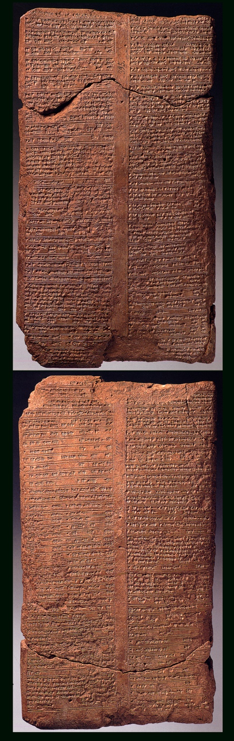

Image © Vorderasiatisches Museum, Berlin, Germany

The passages below are excerpts from this multi-column tablet:

EA 22: Column 1: 1–14 details precious metal and stone horse equipment.
¹ 4 beautiful horses that run (swiftly).
² 1 chariot, its ṭulemu’s, its thongs, its covering, all
³ of gold. It is 320 shekels of gold that have been used on it
⁴ 1 whip of pišaiš, overlaid with gold; its parattitinu,
⁵ of genuine ḫulalu-stone; 1 seal of genuine ḫulalu-stone is strung
on it.
⁶ 5 shekels of gold have been used on it.
⁷ 2 ša burḫi, overlaid with gold. 6 shekels of gold (and)
⁸ 4 shekels of silver have been used on them.
⁹ 2 (leather) uḫatati, overlaid with gold and silver;
¹⁰ their center is made of lapis lazuli. 10 shekels of gold (and)
¹¹ 20 shekels of silver have been used on them.
¹² 2 maninnu-necklaces, for horses; genuine ḫulalu-stone
¹³ mounted on gold; 88 (stones) per string. It is 44 shekels
¹⁴ that have been used on them.

Column 2: 1–22 details finely crafted jewelry and a decorated dagger.

¹ 1 ha[nd-brac]elet, of i[ro]n, [overlaid with gol]d; its mesukku-birds
² (have) an inlay of genuine lapis lazuli. 6 shekels of gold have been
used on it.
³ 1 hand-bracelet, of iron, overlaid with gold; its mesukku-birds
⁴ (have) an inlay of genuine lapis lazuli. 5 shekels of gold have been
used on it.
⁵ 1 anklet, of gold, inlaid. 5 shekels of gold were used on it.
⁶ 1 maninnu-necklace, cut from 35 genuine lapis lazuli stones.
⁷ 35 ḫiliba-stones; in the center, a genuine ḫulalu-stone,
⁸ mounted on gold with a reddish tinge.
⁹ 1 set for the hand, beads of genuine lapis lazuli, 6 per string,
¹⁰ mounted on gold. 6 shekels of gold have been used on it.
¹¹ 1 set of karatnannu, of gold, 2 shekels in weight.
¹² 1 head-binding, of gold,
¹³ twisted like a torque, 14 shekels in weight.
¹⁴ 1 set of arapšanna, 6 iduzzarra,
¹⁵ of gold with a reddish tinge. 12 shekels in weight.
¹⁶ 1 dagger, the blade of which is of iron; the haft has an inlay of
...-st[one],
¹⁷ overlaid with gold; its pommel, of...-stone; its..., mounted in gold;
¹⁸ its maṭru, (with) variegated trim of blue-purple wool, 2 times
¹⁹ overlaid with gold. 14 shekels have been used on it.
²⁰ 1 zallulu, its rettu overlaid with ḫiliba-stones and genuine lapis lazuli.
²¹ the handle, the figure of a woman, of alabaster; the inlay
²² of genuine lapis lazuli. 6 shekels of gold were used on it.

Column 2: 34–44 lists clothing and shoes sent to Egypt, made of different materials and designs.

³⁴ 1 pair of leggings, of shaggy wool.
³⁵ 1 pair of shoes, of colored linen. 1 pair of leggings, of shaggy wool.
³⁶ 1 garment of blue-purple wool. 1 pair of shirts, Hurrian-style, [for] the city.
³⁷ 1 city-shirt, Tukriš-style. 1 pair of s[as]hes,
³⁸ of red wool, adorned.
³⁹ 1 linen garment, aššianni-type. 1 pair of shirts, Hur‹rian›-style, of linen.
⁴⁰ 1 city-shirt, of linen. 1 robe, of linen.
⁴¹ 1 ḫaṣuru-garment. 1 pair of shirts, Hurrian-style, of linen. 1 pair of city-shirts.
⁴² 1 robe and 1 cap, of blue-purple wool.
⁴³ 1 fly-whisk. Its rettu (has) an in[lay]
⁴⁴ of genuine lapis lazuli...ḫiliba-stone. [Its] haft, [overlaid with go]ld…

Column 3:10–17 lists different vessels of precious metals.

¹⁰ 1 set of salt (containers, in the form) of bull-calves and lions, of ḫiliba stone.
¹¹ 1 tr‹a›y, overlaid with silver. 60 shekels of silver used on it.
¹² 1 small trough, overlaid with silver. 40 shekels of silver were used
on it.
¹³ 1 bowl, of gold, 10 shekels [in] weight. 10 bowls, of gold;
¹⁴ 1 bowl, of silver, 10 shekels in weight.
¹⁵ 1 small trough of silver, 10 shekels in weight.
¹⁶ 1 bread shovel; its rettu, of...-stone; its hilt, overlaid with gold,
¹⁷ its pommel, a mesukku-bird, of...-stone. 2 shekels of gold have been used on it.

Column 3: 29–36 lists different unguents and valuable oils and their containers.

²⁹ 1 stone scent container, with myrrh-scented oil. 1 stone scent container
³⁰ with pure oil. 1 stone scent container with iaruttu-oil.
³¹ 1 stone scent container with myrtle oil. 1 stone scent container
³² with kanatku-oil. 1 stone scent container with suʾadi oil.
³³ 1 stone scent container with styrax-oil. 1 stone scent container
³⁴ with peršanti-oil. 1 stone scent container...
³⁵ 1 stone scent container with a mixture (of various oils).
³⁶ 10 kirru-pots, full of “sweet oil.”

Column 4: 6–20 list different household wares and textiles, including gold and silver dog figurines.

⁶ 1 spoon, of elammakku-wood. 1 sumbiru, of jasper.
⁷ 1 set of telannu, of alabaster.
⁸ 5 dogs, of gold, 5 shekels in weight.
⁹ 5 dogs, of silver, 5 shekels in weight.
10 6 sarra, of alabaster.
¹¹ 1 (fabric) with cording above and below.
¹² 3 large blankets.
¹³ 1 long spread, for beds.
¹⁴ 1 short spread, of which the trimmings are many-colored, for a bed.
15 1 wrap, for the head. 1 wrap, for the foot.
¹⁶ 1 bronze helmet as a brazier. 1 set of..., of wood.
¹⁷ 1 ewer, together with its cover, of bronze.
¹⁸ 1 kettle, of bronze. 1 water-dipper, of bronze.
¹⁹ 10 jars, of bronze, 10 stands, of bronze.
²⁰ 1 brazier, of bronze. 10 wutru, of bronze.

EA 22: column 4: 43–49 concludes with short note that the gifts were given in honor of a wedding between the two royal households:

^{43–49} It is all of these wedding-gifts, of every sort, that Tushratta, the king of Mitanni, gave to Nimmureya, the king of Egypt, his brother and his son-in-law. He gave them at the same time that he gave Tadu-Kheba, his daughter, to Egypt and to Nimmureya for marriage.

A.14 EA 19: Treaty Language in a Letter from Tušratta of Mitanni to the Pharaoh (Rainey, 2015, 140–47)

Tušratta writes (see the full letter in Rainey, 2015):

^{9–16} Since (the time of) your fathers, they always loved my fathers very much. You, moreover, did more and always showed even more love to my father. Now, you, inasmuch as we continue to love one another in mutual affection, have increased tenfold greater than to my father. May the gods permit those very things that we have loved here (= up to now). May Tešub, my lord, and Amon, mak[e] it amenable forever just as now.

^{17–24} Inasmuch as my brother sent Mane, his envoy, saying: “Please, my brother, send me your daughter for a wife, to be the mistress of the land of Egypt,” I caused no distress to my brother’s heart but said, “With pleasure! Yes!” And as for the one whom my brother requested, I showed her to Mane, and he saw her. Inasmuch as he saw her and he praised her greatly, I will convey her in safety to the land of my brother. May Šaušga and Amon make her the image of my brother’s desire.

^{25–29} Kelya, my envoy, brought my brother’s words to me. When I heard (them), and they were very pleasing, then I rejoiced exceedingly, and verily I said: “This is it for sure! viz. that which is between us, that which is mutual, that we love one another. Now, with such words let us love one another forevermore.”

^{30–33} When I wrote to my brother, then I verily said: “Let us always love one another very, very much and between us may we be in friendship. And to my brother I said: May my brother always surpass ten times what he did for my father!”

^{34–38}And I requested of my brother much gold, saying: non-matching quotation mark “May he exceed for me what was done for my father; may my brother send to me. And as
for my father, you sent much gold to him: large golden pithoi, large golden jars, you sent to him. Bricks of gold, just like copper ones in size, you se[nt to him].

^{39–42} When I sent Keliya to my brother and I requested gold, I verily said: “May my brother exceed for me by [ten times] what was done for my father, and may he send me much gold that has not been worked.”
…
^{53–58} Now I have written to my brother so may my brother increase
affection much more than for my father. Now I have requested gold of my
brother and as for the gold which I requested of my brother, it will be
expended to meet two requirements; the first (part) is for the mausoleum
and in the second place it is for the bride price.

^{59–70} So, my brother, very much gold that is not worked, may my brother
send to me; and may my brother send gold, more than to my father. And
in the land of my brother gold is plentiful like dirt. May the gods grant it
that just as now gold is plentiful in my brother’s land, may he increase the
gold ten times what it is now. And the gold that I requested, may it not be
distressing to my brother’s heart. And may my brother not cause distress to
my heart. So may my brother send to me very much gold that has not been
worked. And whatever my brother needs for his house, let him write and let
him take and I will verily give ten times what my brother requested. This
land is my brother’s land and this house is my brother’s house.
…
^{80–85} Now for the greeting gift of my brother have I sent: one large gold
cup, its handle inlaid with genuine lapis lazuli, one heavy maninnu necklace
with twenty genuine lapis lazuli stones and nineteen gold ones, its center
piece of genuine lapis lazuli set in gold, one heavy maninnu necklace with
42 genuine ḫulalu stones, 40 gold pubic triangles of Shaushga, of which the
center piece is on genuine ḫulalu stones set in gold, ten teams of horses, ten
wooden chariots with their accoutrements and 30 women (and) men, as the
greeting gift of my brother.

A.15 EA 26: A Letter from Tušratta of Mitanni to Queen Tiye of Egypt (Rainey, 2015, 275–81)

The letter is somewhat broken. The following reconstruction and translation are from Rainey (2015).

^{1–6} [Speak] to [Teye] the mistress of the land of Eg[ypt]: T[hus (says) Tush]ratta king of the l[and of Mitanni. With me] it is [well]; may it be we[ll] with you. May it be well [with your house, with] your son; may it be well with Tadu-Ḫeba your daughter-in-law. May it be very, very [well] with your lands, wi[th your troops] and your property.
…
^{19–29} [And no]w, you [have sp]oken to Keliya, “Speak to your lord: M[im]mureya, my husband continually showed love to your father and for you he maintained it; and toward your father he did not forget his love and the [ca]ravans that he used to send, he did not cut o[ff]. And now you must not forget your [l]ove toward Mimmi[reya], your brother; w[ith] Napḫurreya, increase and keep i[t], and the caravan which you joyfully (?) have been sen[ding], you must not cut off.”

^{30–39} The love towards Mimmureya, your husband, I will not forget. More
than formerly, even now I am [express]ing ten times much more love to
Napḫurreya, your son. But as for the words of Mimmureya, [your] hus[band,
it is you that knows (them), but] my greeting gift which [your husband said]
to s[end], you do not s[end] accordingly, [and the] solid cast [statues of gold
which] I requested [from your husband], saying “[My] br[other, statues of
gold] and of real lapis lazuli [may he send] t[o me].”

^{40–48} But now, as for Nap[ḫurreya, your son], he has plated statues] of wood [and sent (them)]. But in the land of your son] gold is (like) dirt; [w]hy have they distressed the he[art] of your son so that he did not give (them) to me but rather, this, he has given to me? Is this love? I said: “Ten times more than his father, Napḫurre[ia your son] will surpass for me, but now he [did not give me] even what his father used to give.”

^{49–57} As for the words whi[ch you yo]urself spoke, t[o me], then why don’t
you present to Nap[ḫurreia]? If [you] don’t present (them) befo[re h]im,
then who e[lse] knows? So[lid] statues of gold, may [Na]pḫurreya give me.
May he not cause me any distress whatsoever! May [he not...]. Ten times
more than his father may he surpass f[or me] in love and in respect.

^{58–63} [And] may your own envoys c[ome] regularly with the a[mbassadors]
of Napḫurreya, with a g[ift fo]r Yuni my wife; and [may] the envoy[s]
[o]f Yuni my wife go to [you] regularly.

A.16 EA 31: A Hittite Letter Sent from Amenhotep III to Tarḫundaradu of Arzawa (Rainey, 2015, 326–29)

…
^{11–16} Behold, I have sent to you Iršappa, my messenger. Let us see the daughter whom they will bring to My Majesty in marriage. Let him pour oil on her head. Behold, I have sent to you one ḫalaliya of good-quality gold.

^{17–21} As for the operation about which you wrote to me: “Send it to me,” I
will send it to you afterwards. (But first) send back promptly your messenger
and my messenger and let them come (to me).

^{22–27} (When) they return to you they will bring the bride-price for the daughter. My messenger and the messenger of yours, he came and…. Send me people of the land of Gašga. I have heard that everything is finished. And also the land of Ḫattusa is frozen/paralyzed.

^{28–38} Behold, I have sent you a consignment…in the hand of Iršappa, [my] mess[enger]:

One ḫalaliya of gold weighing 20 minas of gold;
3 fine linens; 3 f[ine?] linen coats;
3 linen ḫuzzi;
8 linen mantles;
100 linen walgan;
100 linen ḫapp[a(-);
100 linen sashes; […]
4 kukkubu(-vessels) for/with fine wine;
6 ku[kkubu(-vessels)] for/with fine oil;
3 chairs of ebony overlaid with exquisite leather [and gol]d;
10 chairs of ebony inlaid with ivory; 100 ebony (plates) as a greeting-gift.

A.17 EA 32: A Hittite Letter Sent from Tarḫundaradu of Arzawa to Amenhotep III (Rainey, 2015, 330–31)

^{1–6} Behold, with regard to this matter that Kalbaya said to me, “We should establish a blood-relationship between ourselves,” I do not trust Kalbaya. He said it, but it does not figure on the tablet.
^{7–9} If you really want my daughter, would I not give her to you? I will give
(her) to you.
^{10–13} Send Kalbaya back to me promptly together with my envoy and write
back to me (about) this matter on a tablet.

The letter ends with a separate message addressed to the scribe handling the pharaoh’s correspondence. Tarḫundaradu asks that the scribe reveal their identity and ensure that future letters be written in Hittite.

^{14–20} The scribe who reads out this tablet, let Ea the king of wisdom, and the Sun-god of the gate house protect him in good will! Let them hold the(ir) hands in good will around you! You, scribe, write to me in good will and add (your) name thereafter. The tablets that are brought (here) keep writing (them) in Nešite (i.e. in Hittite).

From this point on in the Element’s Appendix, readers are referred to Lauinger and Yoder’s online edition of the entire corpus of Canaanite Letters: https://oracc.museum.upenn.edu/aemw/amarna/

A. 18. EA 169, A Letter from an Elite of Amurru to Egyptian Officials (Lauinger and Yoder, 2025, 99–101; Oracc, https://oracc.museum.upenn.edu/aemw/amarna/P271104?srch=s.2IoCFn)

^{11–16} You are my lord, and my lord should listen to his servants. Do not delay ʿAḏiri, your servant, there. Dispatch him quickly so he may guard the lands of the king, our lord.

^{17–40} Something else: To Tutu, my lord: Hear the words of the men of the land of Nuhašše: They said to me, “As for your father, you sold him to the king of the land of Egypt for gold. So when will he dispatch him from the land of Egypt?” And all of the lands and all of the Sutuean troops spoke thus: “ʿAḏiri is not going to come out from the land of Egypt.” So the Suteans are now changing allegiance from the lands, and they keep alerting me: “As for your father, he is present [i]n the land of Egypt, [so] we are going to wage war against you.” […] their men, and listen [to me, Tut]u, my lord: [Dis]patch ʿAḏiri [quickly!] […the commi]ssioners […] Nuhašše […]

A. 19. EA 170a, A Letter From Baʿluya and Bet’ilu to Aziru of Amurru (Lauinger and Yoder, 2025, 101–103; Oracc, https://oracc.museum.upenn.edu/aemw/amarna/P271189?srch=s.5K7tFi)

^{1–6} To the king, our lord, a message from Baʿluya and a message from Bet-ʾili. We fall at the feet of our lord. May it be well for our lord. Here, it is very well with the lands of our lord.

^{7–13} Oh our lord, do not become angry! Do not worry! Oh our lord, when you are able, meet them (Hurr. gloss: meet them) so that they will not delay you there.
Something else: Troops of the land of Hatti (under) Lupakku have captured the cities of the land of ʿAmqi by force, and with the cities they have captured Haddumi by force (also). Our lord should know.

^{14–18} Something else: Troops of the land of Hatti (under) Lupakku have captured the cities of the land of ʿAmqi by force, and with the cities they have captured Haddumi by force (also). Our lord should know.

^{19–35} Something else: We have heard as follows: "Zidana came, and (there are) 90,000 footsoldiers who came with him." But we did not confirm the report. If they are truly (there) or they are reaching Nuhašše, then I will send Bet-ʾili to him. When we meet them, I will send my messenger to you quickly so that he may send back a report to you whether it is so or whether it is not.

A. 20 EA 170b: A Letter From ʾAmur-Baʿlu to Rabi-ʾilu and ʿAbdi-URAŠ, to Bin-ʿAnu and Rabi-ṣidqi (Lauinger and Yoder, 2025, 101–103; Oracc, https://oracc.museum.upenn.edu/aemw/amarna/P271189?srch=s.5K7tFi)

^{39–44} May it be well for you. Do not worry, and do not become angry! Here, it is very well with your households. Wish ʿAnatu well.

A. 21 Excerpt from Official Tutu’s Tomb, at Tell el-‘Amarna (Zangani, 2022b, 47).

The entire land shall quiver for you, Kharu and Kush and all the lands, their arms to you in adoration to your ka, as they pray for life in poverty, as they keep (saying): “Give us breath!” May the terror of you block the nostrils, may they swear on their prosperity. Behold! Your power is among them as a repellant (?), after your battle cry has destroyed their limbs like fire that eats wood. The rays of the Aten will rise over you forever...

A. 22 EA 164: Parent-Child Language in a Letter From Aziru, of Amurru to Tutu (Lauinger and Yoder, 2025, 90–92; Oracc, https://oracc.museum.upenn.edu/aemw/amarna/P271182?srch=s.rCgvd0)

^{1–3} To Tutu, my lord, my father, a message from ʿAḏiri, your servant. I fall at the feet of my lord.

^{4–17} Ḥatip has come, and he brought me the favorable and pleasing words of the king, my lord, and I was very very joyful. My land and my brothers, the servants of the king, my lord, and the servants of Tutu, my lord, were very very joyful when the breath of the king, my lord, came to me. I do not deviate from the commands of my lord, my god, my Sun god, and from the commands of Tutu, my lord.
…

A. 23 EA 158: A Letter from Aziru of Amurru to Tutu (Lauinger and Yoder, 2025, 82–83; Oracc, https://oracc.museum.upenn.edu/aemw/amarna/P270988?srch=s.AqQg4x)

^{1–4} To Tutu, my lord, my father, a message from ʿAḏiri, your son, your servant. I fall at the feet of my lord. May it be well for my father…
…

^{10–19} Something else: Look, you are there, my father. Whatever is the request of Tutu, my father, send a message, and I shall give (it). [L]ook, you are my father and my lord, [and] I am your son. The lands of Amurru are your [land]s, and my house is your house. Whatever is your request, [se]nd a message to me, and I shall give [the ent]irety of your request.

^{32–38} I am a servant of the king, my lord, [and] I do not ever deviate from the commands of the king, my lord, [or] from the commands of Tutu, my father. If the king does not love me, but (instead) hates me, as for me, what can I say?

A. 24 EA 166: A Letter of Aziru of Amurru to Ḫaya (Lauinger and Yoder, 2025, 94–96; Oracc, https://oracc.museum.upenn.edu/aemw/amarna/P271183?srch=s.mrJE3W)

^{1–5} [T]o Haya, my brother, a message from ʿAḏiri, your brother. May it be well for you, and may it be very well with the troops (Akk. gloss: the troops) of the regular army of the king, my lord.
^{6–11} What, moreover, do I desire? I desire the favorable face of the king, my lord. I and my sons and my brothers, all are servants of the favorable king, my lord.
^{12–16} Now, Ḥatip and I are coming right now, at once. Oh Haya, your heart should know that I will arrive.
^{17–20} I do not deviate from the commands of my lord nor from your commands. I am a servant of my lord.

^{21–29} The king of the land of Hatti is present in the land of Nuhašše, and I am fearful of him. May it not be that he <co>mes here into the land of Amurru. If he attacks Tunip, it is two one(-day) march(es) into where he is present. So I am fearful of him, and because of that matter I am staying until he goes away.

^{30–32} Now, I am coming at once, I and Ḥatip.

A. 25 A Lexical List form Aphek with a Canaanite Entry

Rainey reconstructs the Aphek text, shown in appendix figure 1, as a list of liquid substances (Rainey, 1978, 137).

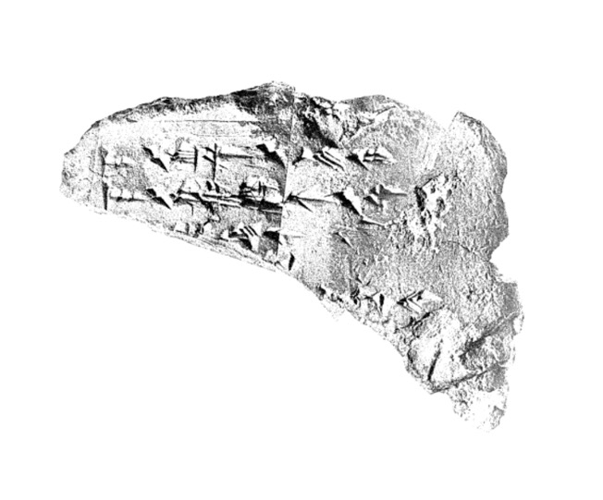

Appendix Figure 1. Aphek Lexical List. Rainey, 1976: plate 9.

Aphek 3:1–5
Sumerograms: Akkadian: Canaanite
1′ …[A].MEŠ : ma-wu : mu-mi
2′ …[GEŠTI]N.MEŠ : ka-ra-nu : ye-nu
3′ ... : [ša?]-am-nu : [blank]
4′ … [: … :]XX
5′ … [: di-iš-pu:] : du#?-uš#?-bu

water
wine
oil
_______
honey

The third column represents the local language, written in syllabic cuneiform.

A. 26 Guidelines in the Canaanite Letters

The examples below show how scribes used guidelines differently. In EA 278 , a letter from EA 278: A Letter from Šuwardata to the Pharaoh, the scribe used guidelines to start the writing process, as shown below in appendix figure 2.

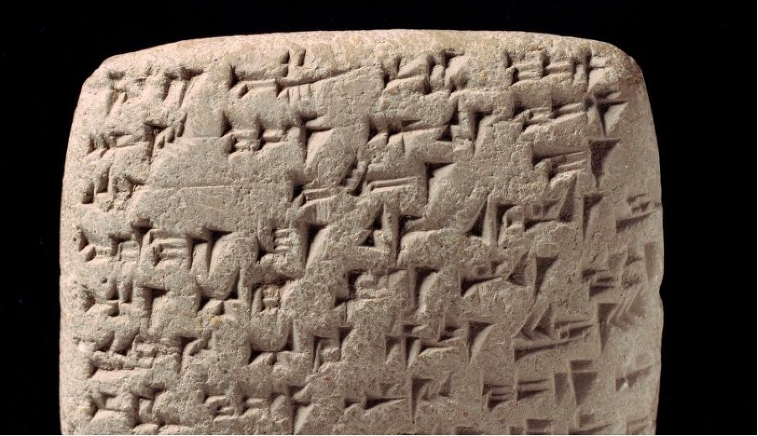A

Appendix Figure 2. Close-up of EA 278, Obverse with Guidelines. © The Trustees of the British Museum

EA 278:1–3
¹ a-na LUGAL EN-ia
² DINGIR.MEŠ––ia ^{d}UTU-ia
³ qí–––––bí-ma

To the king, my lord,
my god, my sun god:
speak!

The remnant of a guideline is visible in the letter heading in lines 2, between the DINGIR.MEŠ and the sign -ia. In line 3, the guideline is visible because the verb of speech, qibīma, is written with the three signs: qí-bí-ma). Other scribes use guidelines more fully.

EA 118: A Letter With Guidelines

In EA 118, the scribe uses guidelines across the tablet surface, as shown in appendix figures 3-4. The lines are slightly deeper, and they are visible where there are spaces between cuneiform signs.

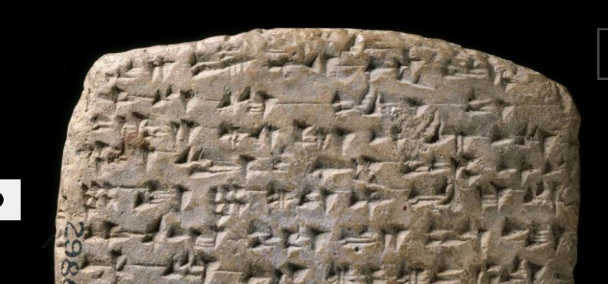

Appendix Figure 3. Guidelines on EA 118 (Obverse). Photo: Vorderasiatisches Museum, Berlin, Germany

Scribes working along the northern coast also used these lines to mark their tablets. For example, a scribe working for an elite based in Tyre uses guidelines in a similar way, to create a clear writing surface before inscription, as shown in figure 22. The guidelines are visible throughout the letter.

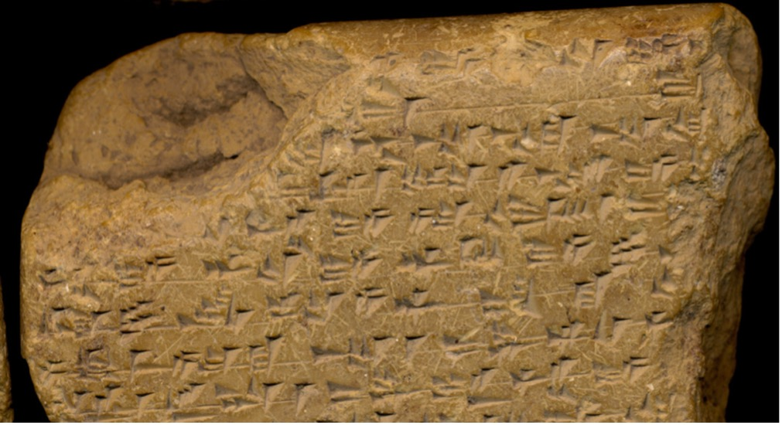

Appendix Figure 4. Guidelines on EA 295, A Letter from Tyre, Written by Scribe 1 of Tyre.
Photo: Vorderasiatisches Museum, Berlin, Germany

A different scribe, who wrote for Abimilki at Tyre, does not use guidelines, as shown in appendix figure 5. The writer of EA 146–55, all letters for Abimilki, either was not trained to use guidelines, or preferred not to use them. We therefore see variation in how scribes prepared the tablet for inscription, even at the same site.

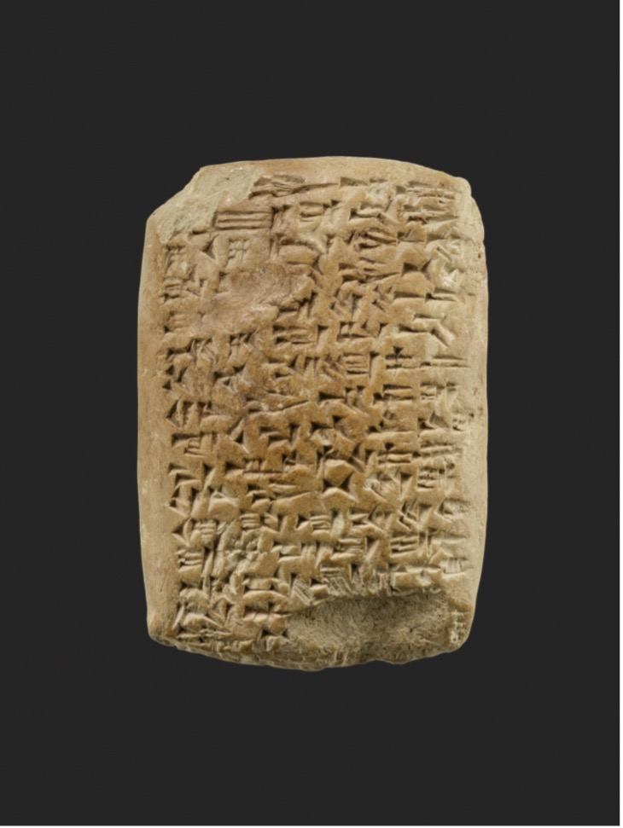

Appendix Figure 5. A Letter without Guidelines: EA 153, Written by Scribe 2 of Tyre. Photo. Metropolitan Museum of Art, New York.

A. 27 Rulings in the Canaanite Letters

A scribe working in the Jezreel Valley used a line ruling at the end of their letters to mark the transition between the letter introduction and the body of the message. This scribe used the same mark in a similar location on EA 258, 259, 261, and 262. Two of these letters were written for a ruler named Baʿlu-mehir (EA 258 and 259) and two for a ruler named Dašru (EA 261 and 262). The clay of EA 258 and 259 were inscribed at Tell Yokneam, while EA 261 was inscribed at Šamḫuna (Tel Shimron). We therefore know that this scribe worked in a circuit in the region of the Jezreel Valley. They also used a similar layout and similar epistolary formulae in their letters. EA 258 (see appendix figure 6 below) is representative of this group of letters. (translation by author)

EA 258
a-na LUGAL EN-ia
um-ma ^{Id}IŠKUR-me-ḫér
ÌR ki-it-ti₇ LUGAL
a-na GÌR.MEŠ LUGAL EN-ia
7-šu ù 7-ta-a-an am-qut
___________________________

Confirmation Formula: Lines 6–9
gáb-bi mi-im-mi₃
ša yi-te-pu-uš
LUGAL EN-ia!(EN) a-na KUR-šu
SIG₅.GA ma-gal

To the king, my lord,
a message of Baʿlu-meher,
the true servant of the king.
To the feet of the king, my lord,
I now fall, seven times and seven times.

Everything that the king,
my lord has done for his land,
is very good.

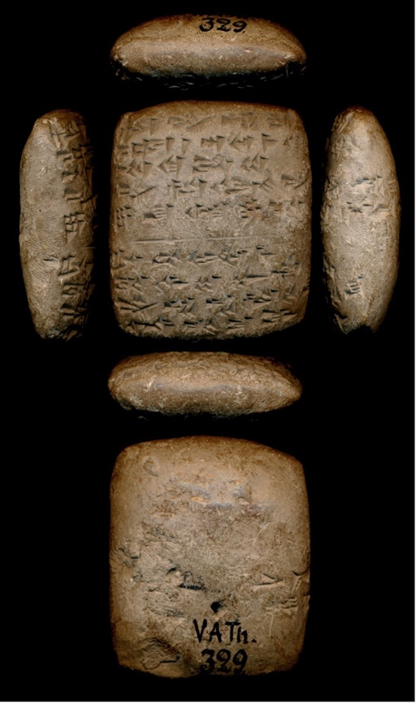

Appendix Figure 6. EA 258, A Letter with a Ruling
Image © Vorderasiatisches Museum, Berlin, Germany

All of these letters follow a similar layout, and all have very short messages (see appendix figure 7 below). They fall into a subgroup of check-in messages that acknowledge a previous order from the pharaoh.

Concluding line rulings are the most common form of ruling. Scribes drew a horizontal line across the tablet surface or left a partial line that communicated that the letter had ended. The mark also communicated that the official message had ended, that nothing more could or should be added to the tablet. It is important to note that not all scribes used line rulings. (translation by author)

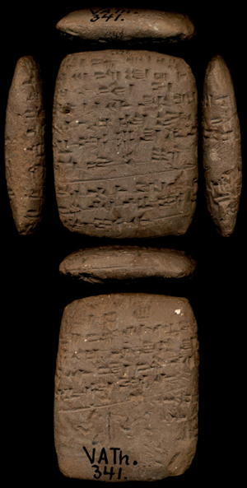

Appendix Figure 7. EA 221, A Letter with a Concluding Ruling

Image © Vorderasiatisches Museum, Berlin, Germany

A different scribe writing in this general region uses scribal marks differently. This writer wrote two letters at Tell Yokneam for a different ruler, Yiqdasu (EA 221 and 222). They also wrote for a ruler identified as Endaruta from the site of Akšapa. Scribal marks are used slightly differently in these letters. Rulings separate the introduction from the letter body in EA 221 and 223, but not in EA 222. This scribe also used rulings at the end of the letters (EA 221, 222, and 223). (translation by author)

A. 28 Wedge Marks in the Canaanite Letters

We will look at several examples of how the scribal wedge mark is used.

In certain cases, glosses are used to indicate a specific technical term or class of object or thing. For example the logogram ^{LÚ}MAŠKIM, which has the general meaning of “commissioner” in Akkadian, is glossed in several different ways in the Byblian Amarna letters.

EA 131:21 ^{LÚ.MEŠ}MAŠKIM: ma-lik^{MEŠ}
EA 262:69 ^{LÚ}MAŠKIM: sú-ki-na
EA 256:9 ^{LÚ.MEš}ra-bi-ṣí :sú-ki-ni
EA 321:15 ^{LÚ}MAŠKIM: ^{LÚ}ra-bi-ṣí (ša šarri) “commissioner (of the king)”

In each case, the title is glossed with a more precise designation for the official.

Some scribes used the wedge mark to signify Canaanite verbs following a Canaano-Akkadian form. For example, in EA 74:20, a scribe working for Rib-Hadda glossed the Sumerogram ḪUR.SAG (“mountain”) with a Canaanite word.

^{19–22} gáb‹-bi› URU.MEŠ-ia ša i-na
ḪUR.SAG : ˹ḫa˺-ar-ri ù i-na a-ḫi a-ia-ab
i-ba-aš-šu in-né-ep-šu a-na ÉRIN.MEŠ GAZ

All of my cities, that are in the mountain: “mountains” or on the sea-coast, have conspired with the ‘Apiru fighters!

In EA 147:12, a scribe writing for Abimilki uses a doubled wedge to mark an Egyptian word: i-na pa-ša-ḫi i-na du-ni ZAG :: ḫa-ap-ši, “by the power of (his) mighty arm.”

The distribution of the letters suggests that such scribal glosses served a more complex function than simply to clarify a term or a logogram or logographic sequence either linguistically or semantically.

In EA 263:24–25 both an Akkadian and a Northwest Semitic gloss are used to clarify Sumerograms.

²⁴ LÚ.MEŠ : ma-ṣa-ar-ta
²⁵ ù ANŠE.KUR.‹RA.›MEŠ : ˹sú˺ ˹ú˺ [-sí-ma

^{23–28} [May my lord send to me] MEN [Sum.], i.e. garrison troops [Akk.] and EQUIDS [Sum], i.e. horses [NWS].

The term ma-ṣa-ar-ta is an Akkadian gloss for the Sumerogram LÚ.MEŠ, specifying that the ruler wants the pharaoh to send him troops (fighting men). In the next clause, the local term for horse (sws) clarifies the Sumerogram ANŠE.KUR.‹RA.›MEŠ.

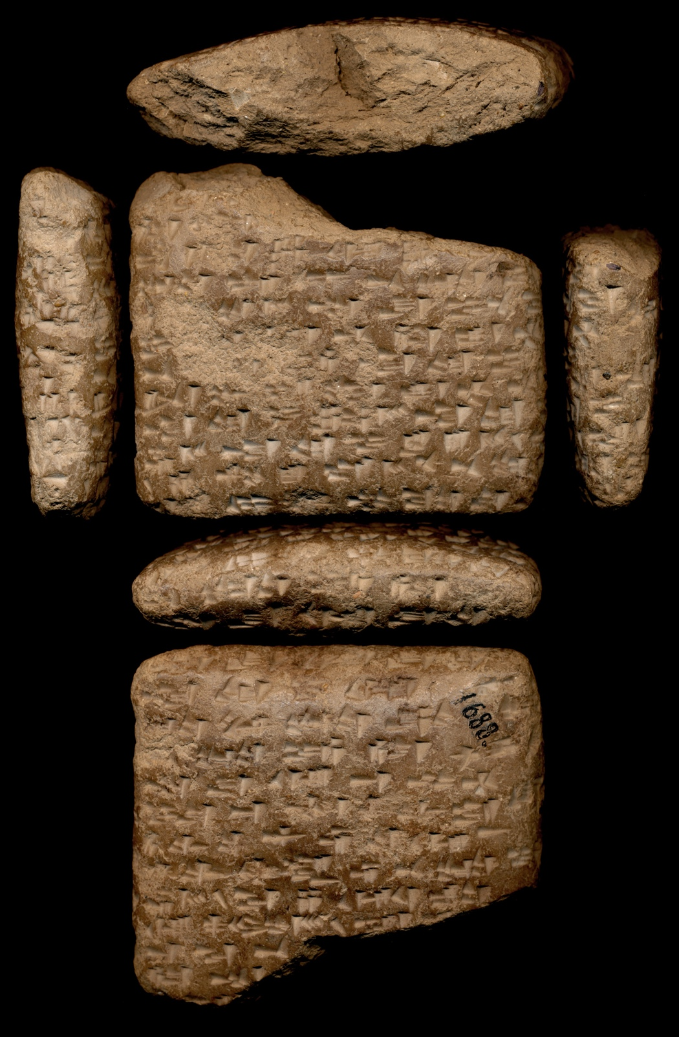
EA 263, A Letter with Scribal Wedge Marks
Image © Vorderasiatisches Museum, Berlin, Germany

A. 29 EA 262, A Letter from the Jezreel Valley from Dašru to the Pharaoh

The first letter, EA 262, was written by a scribe working for an elite named Dašru, who was likely based at Šamḫuna, a site in the Jezreel Valley (Vita, 2015, 64–66). The transcription and translation are both presented here to demonstrate the similarities between the letters. (translation by author)

¹ a-na LUGAL EN-ia
² qí-bí-ma
³ um-ma ^{I}Da-aš-ru
⁴ ÌR ki-it-ti₇ LUGAL
⁵ a-na GÌR.MEŠ LUGAL EN-ia
⁶ 7-šu ù 7-ta-a-an am-qut
________________________(line ruling)
⁷ gáb-bi mi-im-mì
⁸ ša yi-pu-šu
⁹ LUGAL EN-ia a-na KUR-šu
¹⁰ gáb-bu ˹SIG₅˺.GA
¹¹ ma-gal ma-gal

^{1–6} Speak to the king, my lord, a message from Dašru, the king’s loyal servant. I fall at the feet of the king, my lord, seven times and seven times._________________________(line ruling)
^{7–11} As for the entirety of whatever the king, my lord, does for his land, the entirety is very, very good.

The first section, the introduction, is written following normative Akkadian grammar. The verb of prostration, written am-qut (for the 1cs G preterite form of maqātu, “to fall”), is a standard Akkadian verb. Yet the scribe switches to the local scribal code in lines 7–11. For example, the verb yi-pu-šu employs Canaanite morphology, but the core lexeme is from Akkadian. The verb is a 3ms yaqtulu (imperfective) form of the Akkadian verb epēšu (“to do”). Scribes commonly used the more conservative forms that they memorized as part of their training in the introductions of their letters but then shifted to the local scribal code in the body of the letters.

A. 30 EA 221: A Letter from the Jezreel Valley from Yiqdasu to the Pharaoh

We will now look at another letter from this same region that has similar properties. EA 221 was written by a different scribe for a ruler identified as Yiqdasu (Vita, 2015, 62–64). It was inscribed at Tell Yokneam (Goren, Finkelstein, and Na’aman, 2004, 250, 255). The two letters are quite similar, as they are both very formulaic and serve as routine check-in messages. Both scribes employ more local features in the body of the letters. (translation by author)

Praescriptio: Lines 1–7
Obverse
¹ a-na šàr-ri EN-[i]a
² ^{d}UTU iš-tu ša₁₀-me-˹ma˺
³ qí-bí-ma
⁴ um-ma ^{I}Yi-iq-dá-sú
⁵ ÌR-ka a-na GÌR.MEŠ šàr-ri
⁶ EN-ia 7-šu ši-bi-ta-an
⁷ uš-ḫe-ḫi-in

Line Ruling
_____________________________

Letter Body: Lines 8-16
Obedience Formulae: Line 8-10
⁸ iš-te₉-me ša-pa-ar
⁹ šàr-ri EN-ia
¹⁰ ˹a˺-na ia-a-ši

Line ruling: Tablet Edge

Preparation Formulae: Lines 11-16
Reverse
¹¹ a-nu-ma
¹² a-na-ṣa-ru
¹³ URU šàr-ri EN-ia
¹⁴ a-di ti-ik-šu-du
¹⁵ a-wa-at šàr-ri
¹⁶ EN a-na ia-ši

Line Ruling: Conclusion
_________________________

^{1–7} Speak to the king, my lord, the Sun god from {Can. the heavens}, a message from Yiktasu, your servant. I prostrate myself at the feet of the king, my lord, seven times (and) seven times._____________________________
^{8–10} I have obeyed the message of the king, my lord, to me.
^{11–16} Now, I am guarding the city of the king, the lord, until a command from the king, the lord, reaches me. _________________________

A. 31 EA 74: A Letter of Rib-Hadda of Byblos to the Pharaoh (Lauinger and Yoder, 2025, 118–121; Oracc, https://oracc.museum.upenn.edu/aemw/amarna/P270898?srch=s.Ueh5Q4)
…
^{5–18} The king, the lord, should know that Byblos, a loyal maidservant of the king since the days of his forefathers, is intact. But, look now, the king has now abandoned his loyal city from his authority. The king should inspect tablets from (lit. of) his father’s house (to ascertain) whether the man who was present in Byblos was not a loyal servant.

Do not keep silent concerning your servant, since the hostility of the habiru troops towards <me> is severe.

As the gods of your land live, our sons, daughters, (and) the wood of our house(s) are used up in consequence of paying (them) into the land of Yarimmuta in exchange for obtaining provisions for (lit. of) our life. My field is the same as a husbandless wife because (it is) without ploughing.
…

^{28–47} Look now, ʿAbdi-ʾAširte has sent a message to the troops in the temple of NINURTA: “Gather so that we may attack Byblos! Now see, there is [not] a man who can rescue it from our control. We should drive the city rulers out of (lit. away from the interior of) the lands so that all of the lands will ally with the habiru, and an alliance should be m<ade> for all of the lands so that sons and daughters will be at peace for everlasting days. And if, moreover, the king campaigns, then all the lands will be hostile to him, and what will he do to us?” Consequently, they have established an oath among themselves, and, consequently, I am very very fearful, [s]ince there is not a man who can rescue me [fr]om their control. Like birds that are placed inside a bird-snare (Can. gloss: bird-trap), so am I in Byblos.

^{48–58} Why have you kept silent concerning your land? Now, as a result, I have sent messages to the palace, but my words are not heard. Now, Amon-appa is with you. Ask him! He himself knows, and he has seen the dire stra[its] that I am in (lit. against me). The king should hear the words of his servant and give the provisions to (lit. of) his servant and keep his servant alive so that I may guard his loyal [city], together with our Lady (and) our gods, f[or you]. [The king] should pay attention to his land and [his servant and sh]ow concern for [his] land. Pac[ify] your [city]!
…
A. 32 EA 131: A Letter of Rib-Hadda of Byblos to the Pharaoh, Describing the Fall of Ṣumur Pharaoh (Lauinger and Yoder, 2025, 238–241; Oracc, https://oracc.museum.upenn.edu/aemw/amarna/P270910?srch=s.wFpzOH)

1’–23 My lord [us]ed to dispatch troops as a garris[on] to Byblos, but no[w] the city of Ṣumur has been seized. The troops of Byblos have been killed. If the desire of the king, my lord, is for the city of Byblos, then my lord should dispatch 300 troops, 30 chariots, and 100 men from the lands of Cush so that they may guard the city of Byblos, a city of my lord.

If the king does not dispatch the regular troops to the city of Byblos at the time of the {Can. summer} grain, then they will surely capture it, and they will kill me, [your servant], and they will be in complete control. The king, my lord, [should ...] so that they can be near the king’s commissioners (Akk. gloss: advisors), because Piwuru, an advisor of the king and an appointed official, was killed.
…

A. 33 EA 148: A Letter of Abimilki of Tyre, to the Pharaoh (Lauinger and Yoder, 2025, 283–285; Oracc, https://oracc.museum.upenn.edu/aemw/amarna/P270994?srch=s.Csn49b)

^{4–13a} The king, my lord, sent a message regarding the mekku-glass. I give that which is at my disposal to the king, my lord – 100 (shekels) in weight – so the king, my lord, should turn his attention to his servant, and he should give (back) Usu to his servant: A jug {Can: an ʾagn-vessel of water} for him to drink.

^{13b–22} The king, my lord, should provide ten foot soldier(s) in order to guard his city so that I may enter and see the face of the king, my lord. My face will be (as) pleasing to the king, my lord, as when the king, my lord, assigned to me the task of guarding his city.

A. 34 EA 155, A Letter of Abimilki of Tyre, to the Pharaoh (Lauinger and Yoder, 2025, 299–302; Oracc, https://oracc.museum.upenn.edu/aemw/amarna/P270916?srch=s.Lxpzqs)

^{6–33} Look, I am very carefully guarding the king’s city that he assigned to my control (lit. my hand). My intention (lit. my face) is to go in order to see the face of the king, my lord, but I am unable because of the power (lit. the hand) of Zimri-Haddu of Sidon. He heard about me that I was entering (Egypt), so he waged war against me.

The king, my lord, should give 20 men to me in order to guard the city of the king, my lord, so that I may enter into the presen[ce] of the king, my lord, in order to see his pleasing face. I have turned (my attention) to serving (Can. gloss: serving) the king, my lord. The k[ing], my lord, should ask his commissioner [i]f I have turned (my attention) to the presence of the king, my lord.

Herewith, I have dispatched [my] messenger to [the presence of the king], my lord. [The king], my lord, should [dispatch his] mes[senger and] his tablet to [me], so that I may enter into [the presence] of the king, my lord. I have c[ompletely] turned (my attention) [to going] into the presence of the k[ing, in order to see] the face of the king, [my] lord.

^{34–43} The king, [my lord], should not abandon his servant from [his] control. The king, my lord, should turn ([his] attention) and g[ive] water for [his] servant to drink and wood for his servant. The king, my lord, knows that we are stationed in the midst of the sea; we do not have water, and we do not have wood.

A. 35 EA 149: A Letter of Abimilki of Tyre, to the Pharaoh (Lauinger and Yoder, 2025, 285–289; Oracc, https://oracc.museum.upenn.edu/aemw/amarna/P270913?srch=s.ocfetK)

^{6–13} Oh king, my lord, you are like the Sun god (and) like the Storm god in the heavens! The king should show concern for his servant. The king, my lord, assigned me to <gu>ard Tyre, the maidservant of the king, so I sent an urgent tablet to the king, my lord, but he has yet to reply to me.
…
^{30–63} [Zimri-Haddu], {Egy. the magnate}, [heard about] me; he turned around [my ship fr]om the king, my lord, (saying): “[Who] will bring you [to the king?" Lis]ten, my lord, ʿAḏiri, [the son of ʿAbdi]-ʾAširte, the [cri]minal against the king, [has captured Ṣumu]r. Ḥaʿip [b]rought up the traitors, my enemies; [he has] given Ṣumur [t]o ʿAḏiri. So the king should not keep silent regarding his city and regarding his land. When I hear the name of the king and the name of his army, they will be very afraid, and the entire land will be afraid. As for the one who does not follow the king, my lord, the king will know about him, because you appointed me as commissioner in Tyre. Zimri-Haddu captured Usu from <his> servant; I have abandoned it, so there is no water, there is no wood for us, and there is nowhere (that) we can put the dead. So the king, my lord, should show concern for his servant. The king, my lord, sent a message to me by tablet: “Send a message to the king about whatever you hear!” Zimri-Haddu of Sidon and ʿAḏiri, the criminal against the king and the men of Arwada repe<ate>dly swore an oath among themselves, and they have gathered their ships, their chariots, (and) their foot soldiers in order to seize Tyre, the maidservant of the king.

^{64–73} (If) the strong hand of the king arrives, it will kill them. As for Tyre, they are unable to seize (it), but they have seized Ṣumur at the command of Zimri-Haddu, who sends the king’s word to ʿAḏiri. So I sent a tablet to the king, my lord, but he has not sent back word to me, his servant.

^{74–84} There has been hostility towards me [s]ince last year! There is no water, there is no wood. He (i.e., the Pharaoh) should dispatch a tablet to his servant so that may I enter and see his face. The king [should show concern] for his servant (and) for his city; he should not a[bandon] his city (and) his land. Why is [the commissioner of] the king, our lord, depar[ting] from the land? [Zimri-Haddu] will know and the hostile one will know about the king’s strength, that it is not present. No[w], a foot soldier [is bringing] my tablet to the king, the Sun god, [my] lord, so the king should reply to his servant.

A. 36 EA 147: A Poetic Letter of Abimilki of Tyre, to the Pharaoh (Lauinger and Yoder, 2025, 279–283; Oracc, https://oracc.museum.upenn.edu/aemw/amarna/P270914?srch=s.9OcfLd)

^{5–15} My lord is the sun that comes forth over the land (Akk. gloss: the lands) day after day like the mark of the sun, his favorable father (i.e., Amenhotep III), the one who gives life by means of his sweet breath and returns by means of his {Can. north wind}, the one for whom the entire land is stationed in peace by means of the power of a right arm (Egy. gloss: strength), the one who gave his thunder in the heavens like the Storm god, so that the entire land {Can. became afraid} of his thunder.
…
^{41–56} He who has listened to the king, his lord, and served him in his places: The sun co<me>s forth over him, and the sweet breath returns (to him) from the mouth of his lord. But (he who) has not obeyed the command of the king, his lord: His city is lost, his house is lost, his name will not exist in the entire land forever. Look, the servant who has listened to his lord: His city is well, his house is well, his name exists forever. You are the sun who comes forth over me, and the wall of bronze that was erected for me(text: him). Because of the strong right arm of the king, my lord, {Can. I am calm.} {Can. I am trusting.}

A. 37. A Hymn to Aten from the Tomb of Ay (a.k.a. the “Great Hymn to the Aten). (Murnane 1995, 110–114).
…
Adoration of HOR-ATEN, given life forever continually; (and of) the King
of Upper and Lower Egypt NEFERKHEPRURE-WAENRE, the Son of Re
AKHENATEN, long in his lifetime; (and of) the King’s Chief Wife, NEFERNEFRUATEN- NEFERTITI, may she live forever continually: “Adoration to
you when you rise in the horizon, O living Aten, lord of continuity, (and)
kissing the ground when you rise in heaven in order to illuminate every
land with your beauty. Your rays be upon your beloved son, and may your
two hands bear millions of jubilees for the King of Upper and Lower Egypt
NEFERKHEPRURE-WAENRE, your child, who issued from your rays. May
you bequeath to him your lifetime and your years. May you hearken, on his
behalf, to what is in his heart. May you love him and make him be like Aten.

May you rise to give him continuity and set (only) after you have given him
eternity. May you fashion him at dawn like (you do) your aspects of being.
May you construct him in your image like Aten, the ruler of Maat who
issued from continuity—the Son of Re, who lifts up his beauty and administers
the dues of his rays for him: the King of Upper and Lower Egypt, who
lives on Maat, the Lord of the Two Lands, NEFERKHEPRURE-WAENRE,
(and) the King's Chief Wife, NEFERNEFRUATEN-NEFERTITI, <may she>
live forever continually.

The God’s Father, the favorite of the Good God, the fanbearer at the right
hand of the king, the commander of all the horse of his Person, the true
royal scribe, his beloved, Ay. He says: “Hail to you, O living Aten who rises
in heaven as he floods hearts (with light), every land being in festival at his
appearance, their hearts being content with rejoicing when their lord, who
made himself, is risen over them. Your son presents Maat to your benign
countenance while you exult when you see him. He has issued from you—a
continual son, who issued from Aten, effective for the one who is effective
for him, who slakes the heart of Aten when he rises in heaven. He is joyful
on account of his son as he embraces him with his rays and gives him continuity
as king like the Aten—(namely) NEFERKHEPRURE-WAENRE, my
god who made me and brought my Ka into being. May you cause me to be
sated with seeing you without cease. Your nature is like Aten’s, abounding
in property, a high Nile flowing every day, who revives Egypt, (with) silver
and gold like the sands of the sandbank, while the land awakens to jubilate,
being rich through his Ka. (O) one whom the Aten has begotten, you will be
eternal, (O) NEFERKHEPRURE-WAENRE, living and healthy inasmuch as
he (=the Aten) begot you!”

The God’s Father, fanbearer at the right hand of the king, commander of
all the horse of his Person, true king’s scribe, his <beloved>, Ay. He says: “I
am one who is true to the king, one whom he fostered, who is straightforward
to the Lord of the Two Lands, and effective for his lord. As his favorite,
who sees his beauty when he appears in his palace, I follow the Ka of his
Person, while I am in front of the officials and the king’s companions, the
first of all the followers of his Person. He has placed Maat in my innermost
being. My abomination is falsehood, for I know that Waenre, my lord,
rejoices in Maat, he who is knowledgeable like Aten and truly perceptive.
He doubled for me my rewards in silver and gold while I was the first of the
officials in front of the subjects, for my nature and my character were good,
and he made my position there. My lord instructed me just so that I might
practice his teaching. I live by adoring his Ka and I am fulfilled by following
him—(the one who is) my breath, by whom I live, my northwind, my millions
of Niles flowing daily, NEFERKHEPRURE-WAENRE: may you grant
me a lengthy lifetime in your favor.
…
Beautifully you appear from the horizon of heaven,
O living Aten who initiates life—
For you are risen from the eastern horizon,
and have filled every land with your beauty;
For you are fair, great, dazzling and high over every land,
And your rays enclose the lands to the limit of all you have made;
For you are Re, having reached their limit and subdued them <for> your beloved son;
For although you are far away,
your rays are upon the earth and you are perceived.
When your movements vanish and you set in the western horizon,
The land is in darkness, in the manner of death.
(People), they lie in bedchambers, heads covered up, and one eye does not see its fellow.
All their property is robbed, although it is under their heads,
and they do not realize it.
Every lion is out of its den, all creeping things bite.
Darkness gathers, the land is silent.
The one who made them is set in his horizon.
(But) the land grows bright when you are risen from the horizon,
Shining in the orb (=Aten) in the daytime,
you push back the darkness and give forth your rays.
The Two Lands are in a festival of light—
Awake and standing on legs, for you have lifted them up:
Their limbs are cleansed and wearing clothes,
Their arms are in adoration at your appearing.
The whole land, they do their work:
All flocks are content with their pasturage,
Trees and grasses flourish,
Birds are flown from their nests, their wings adoring your Ka;
All small cattle prance upon their legs.
All that fly up and alight, they live when you rise for them.
Ships go downstream, and upstream as well,
every road being open at your appearance.
Fish upon the river leap up in front of you,
and your rays are within the Great Green (sea).
“(O you) who brings into being foetuses in women,
Who makes fluid in people,
Who gives life to the son in his mother’s womb,
and calms him by stopping his tears;
Nurse in the womb, who gives breath to animate all he makes
When it descends from the womb to breathe on the day it is born —
You open his mouth completely and make what he needs.
When the chick is in the egg, speaking in the shell.
You give him breath within it to cause him to live;
And when you have made his appointed time for him, so that he may
break himself out of the egg,
He comes out of the egg to speak at his appointed time,
and goes on his two legs when he comes out of it.
How manifold it is, what you have made,
although mysterious in the face (of humanity),
O sole god, without another beside him!
You create the earth according to your wish, being alone—
People, all large and small animals,
All things which are on earth, which go on legs,
which rise up and fly by means of their wings,
The foreign countries of Kharu and Kush, (and) the land of Egypt.
You set every man in his place, you make their requirements, each one
having his food and the reckoning of his lifetime.
Their tongues differ in speech, their natures likewise.
Their skins are distinct, for you have made foreigners to be distinct.
You make the inundation from the underworld,
And you bring it to (the place) you wish in order to cause the subjects to live,
Inasmuch as you made them for yourself,
their lord entirely, who is wearied with them,
the lord of every land, who rises for them,
The orb (=Aten) of the daytime, whose awesomeness is great!
…

A. 38 EA 252: A Biting Letter of Labʾayu to the Pharaoh (translation by author). See also appendix figures 8 and 9 for the photos of the obverse and reverse of the tablet.

Tablet Obverse

¹ a-na ^{I}LUGAL-ma bé-lí-ia
_________________________
² qí_ -bí -ma
__________________________
³ um-ma ^{I}La-ab-a-yu ÌR-ka
__________________________
⁴ a-na GÌR.MEŠ-˹pí˺ be-lí-ia am-qú-ut

Silence: Omission of Longer Prostration Formula
__________________________
⁵ i-nu-ma šap-ra-ta

Silence: Omission of Obedience Formula
__________________________
⁶ a-na ia-a-ši ú-ṣur-mì
__________________________
⁷ LÚ.MEŠ ša ṣa-ab-tu URU
__________________________
⁸ ki-i uṣ-ṣur-ru-˹na˺ LÚ.MEŠ
__________________________
⁹ i-na nu-kúr-ti₇ ṣa-ab-ta-at-mì URU
__________________________
¹⁰ ki-it-mi ša-li-mì ù ki-it-mì it-˹ta˺-mì
__________________________
¹¹ ^{I}*LÚ *GAL* it-ti-ia
__________________________
¹² ṣa-ab-ta-at-mì URU
__________________________
¹³ ù i-li qa-bi
¹⁴ ka₄-ar-ṣí-ia: ši-ir-ti
__________________________
¹⁵ i-na pa-ni ^{I}LUGAL-ma be-lí-ia

Lower Edge
¹⁶ ˹ša˺-ni-tam ki-i na-am-lu
¹⁷ tu-um-ḫa-ṣú la-a

Tablet Obverse
¹⁸ ti-ka-pí-lu ù ta-an-˹šu˺-˹ku˺
¹⁹ qa-ti LÚ-lì ša yi-ma-ḫa-aš-ši
_____________________
²⁰ ki-i a-na-ku i-ša-ḫa-tu
²¹ ú-ma a-nu-ta₅ ù
_____________________
²² ṣa-ab-ta-at-mì 2 URU-ia
___ __
²³ ša-ni-tam šum-ma ti-qa-bu
²⁴ ap-pu-na-ma
²⁵ nu-pu-ul-mì
²⁶ ta-aḫ-ta-mu ù
²⁷ ti-ma-ḫa-ṣú-ka
²⁸ i-bi ú-ṣur-ru-na
²⁹ LÚ.MEŠ ša ṣa-ab-tu₄ URU ‹ù›
_____________
³⁰ i-li šu-sú-mì a-‹ia›bi-ia
³¹ ù ú-ṣur-ru-šu-nu
____________

Tablet Obverse
To the king, my lord
_________________________
Sp e ak!
__________________________
the message of Labʾayu your servant.
__________________________
I now fall at the feet of my lord.

Silence: Omission of Longer Prostration Formula
__________________________
Regarding what you wrote me:

Silence: Omission of Obedience Formula
__________________________
“Protect the men
__________________________
that captured the city!”
__________________________
How am I to protect the men,
__________________________
(when) the city was taken by force?
__________________________
It is the whole truth and I swear truthfully.
__________________________
The senior official was with me
__________________________
(when) the city was captured.
__________________________
And he can speak of my slander
: (scribal wedge mark) I am slandered! (Canaanite Gloss)
__________________________
before the king my lord.

Lower Edge
New Topic Marker
Does an ant that is smitten not

Tablet Obverse
curl up and bite
the hand of the man who strikes it?
_____________________
So, I am being attacked.
This very day
____________________
a second city has been captured.
___ __
New Topic Marker
If you should say,
“Now fall under them
and let them strike you,”
As for my enemy,
I will indeed protect the men
that captured the city.
_____________
I can expel my enemies, yet, I will
protect them!
____________

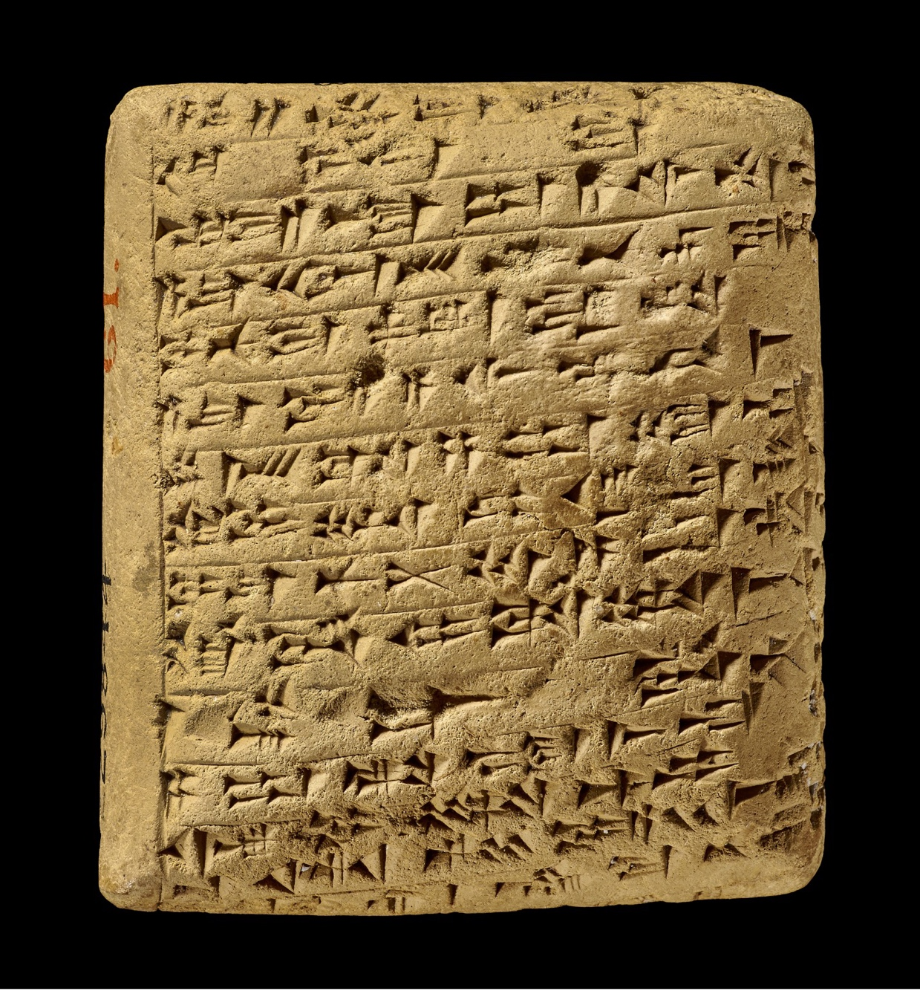
Appendix Figure 8. EA 252 (Obverse). © The Trustees of the British Museum

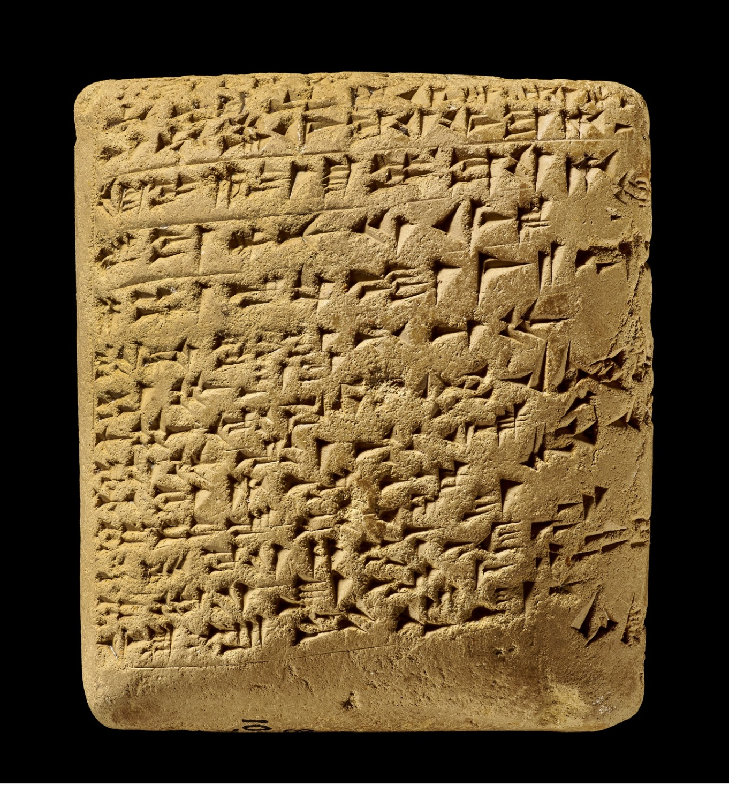

Appendix Figure 9. EA 252 (Reverse). © The Trustees of the British Museum

- 39 EA 316: A Caravan for the Pharaoh’s Scribe

^{obv. 1–9} [To the kin]g, my lord, [my] deity, the sun fr[o]m hea[ven], the [mess]age of Pu-Baʿlu, [your] servant, [and the d]irt at your feet, the [gr]oom of your horses. [A]t the feet of the king, my lord, my deity, my sun god from heaven, seven times and seven times have I fallen on the back and on the stomach.

^{obv. 9–12a} [[N]ow, I am guarding the pl[ace] of the king carefully. {Can. Who} is the dog that would neglect the king’s (oracular?) utterance?

^{12b–15} [N]ow, I am guarding the pl[ace] of the king carefully. {Can. Who} is the dog that would neglect the king's (oracular?) utterance? ______________________________________________________________________________
^{rev. 16–17} [[T]o {Egyp. the scribe} [of my lord], a message from Pu-Baʿlu. I fa[ll] at your feet. There was nothing in my house when I [e]nt[ered] before him (the Pharaoh), and, consequently, I did not dispatch a caravan for you. Now, I am preparing a quality caravan for you.

The three asterisks here indicate three erasure marks on the tablet.
There is no horizonal line between lines 13–14.
There are no line dividers between these lines.
The line divider resumes here, between lines 19 and 20.
There is the faint trace of a line divider just below the ab sign and double vertical wedges that signify the number two.
There is a trace of a line divider here, between lines 29 and 30.
This analysis follows the proposal in Liverani, 1997, 121.
This ruling hugs the lower edges of the last line of text, following the slant of the signs. It signals the end of the text on the tablet.

